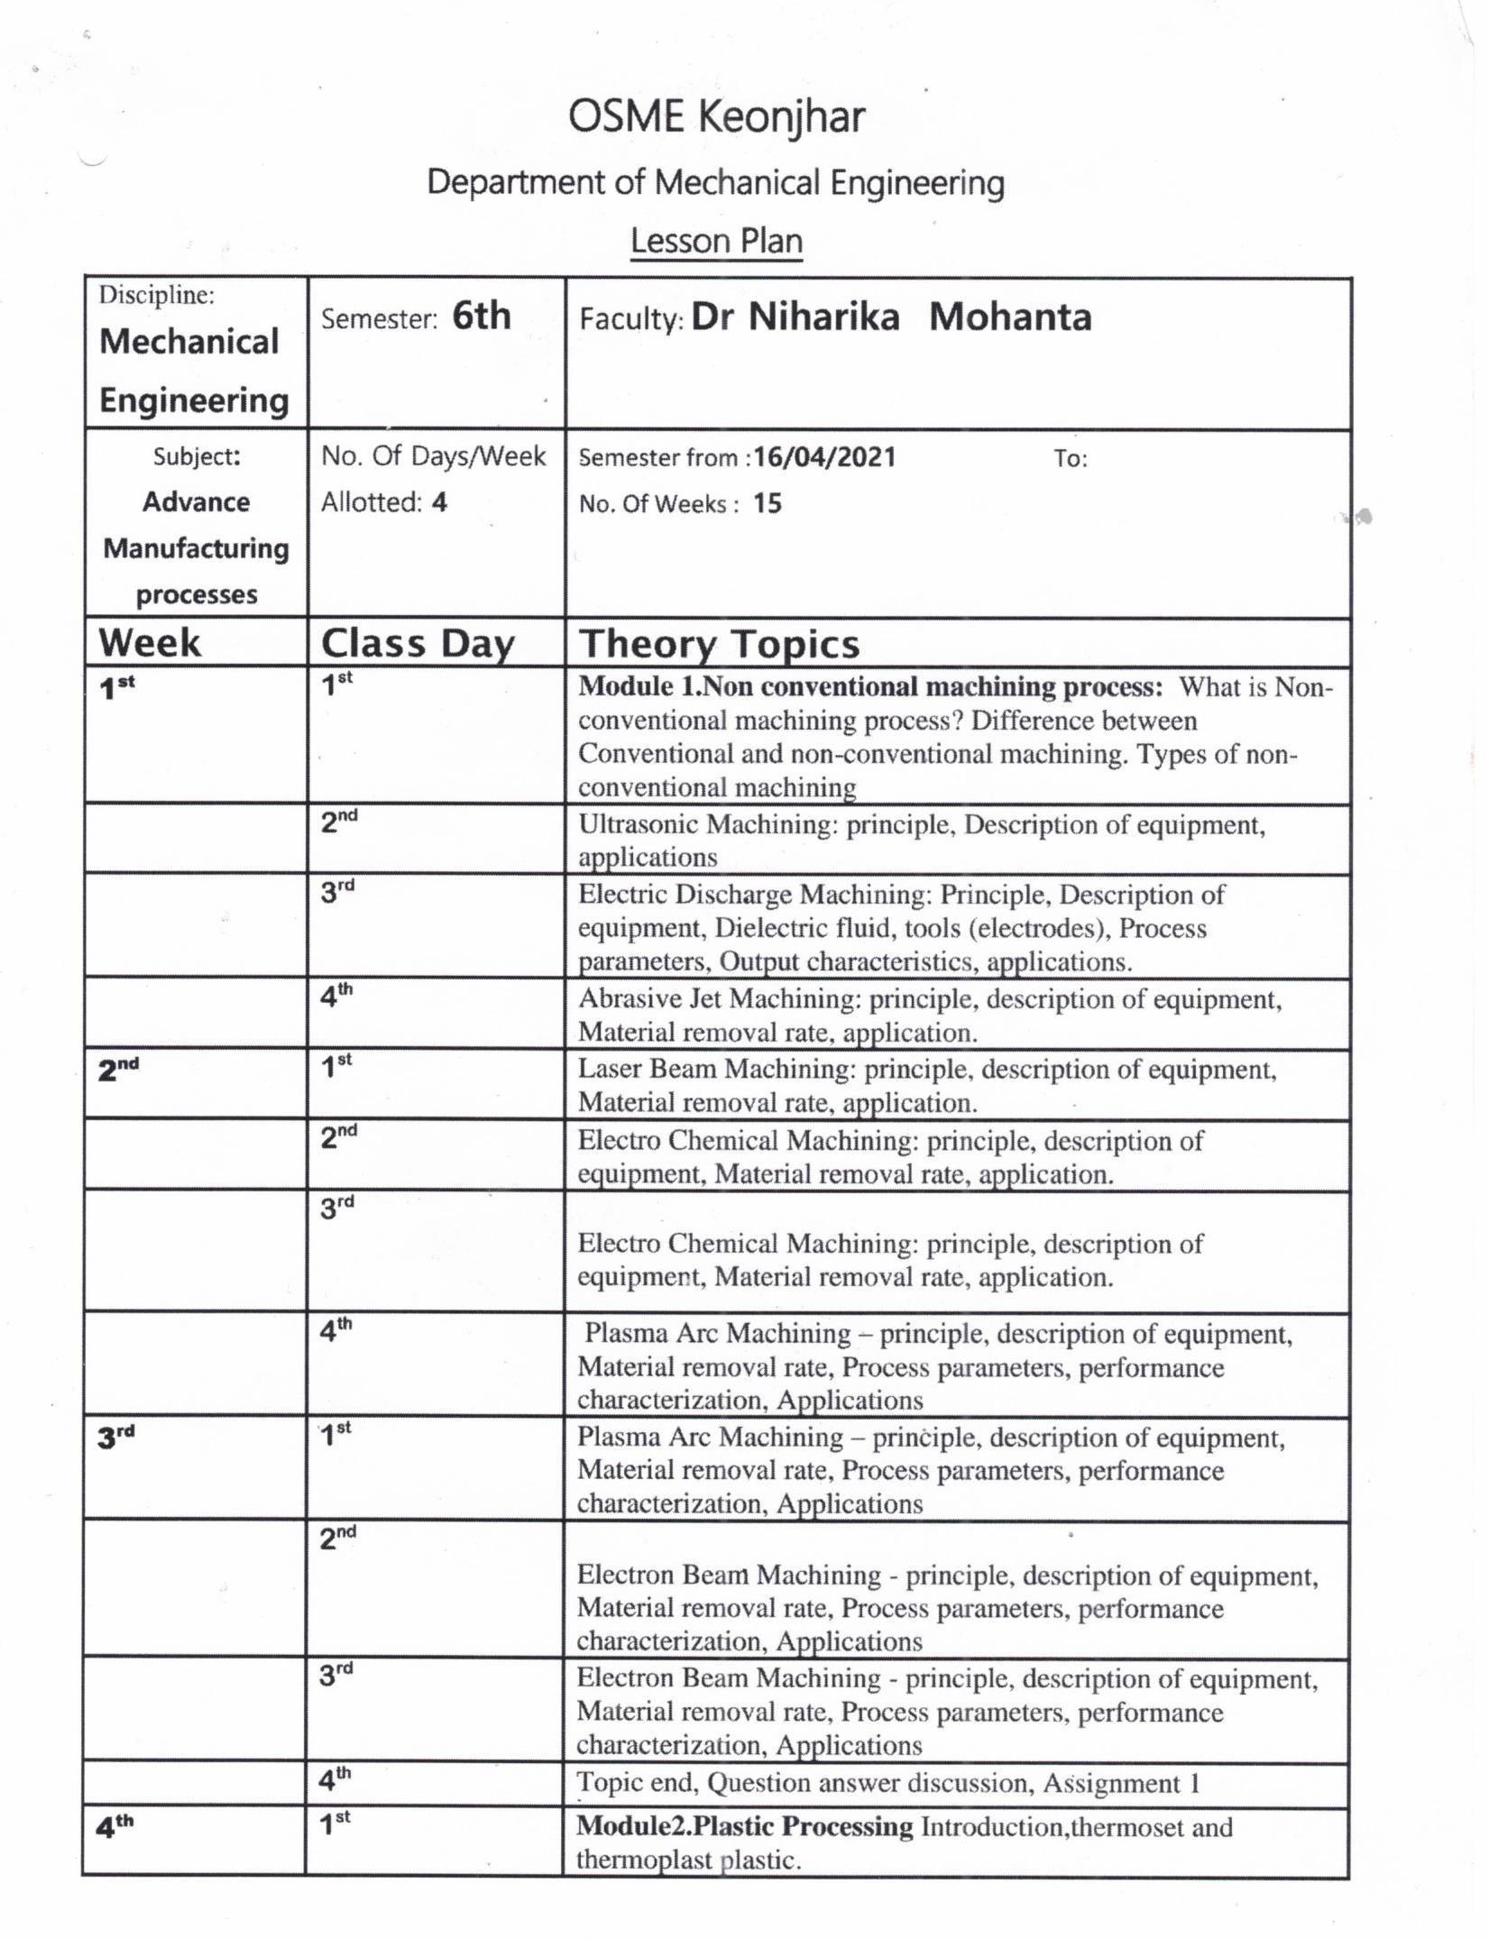

GANDHI ACADEMY OF TECHNOLOGY AND ENGINEERING

FACULTY: Mr. Abinash Samantaray

SESSION- 2023-24

E-MAIL ID- [**simanchal.panda.1@gmail.com**](mailto:simanchal.panda.1@gmail.com)

**10.03.2022**

Subject

**Adv.**

**Manufacturing Process- Th 4b**

