

**LECTURE NOTES**

**ON**

**HIGHWAY ENGINEERING**

**Compiled by**

**Mr. RAJESH KUMAR BEHERDALAI**

**Lecturer, Department of Civil Engineering**

**GANDHI ACADEMY OF TECHNOLOGY AND ENGINEERING**

**CONTENTS**

|  |  |  |
| --- | --- | --- |
| **S. No** | **ChapterName** | **PageNo** |
| 1 | Introduction | 1 –5 |
| 2 | RoadGeometrics | 6 –18 |
| 3 | RoadMaterials | 19– 24 |
| 4 | Road Pavements | 25– 36 |
| 5 | HillRoads | 37– 45 |
| 6 | RoadDrainage | 46– 51 |
| 7 | RoadMaintenance | 52– 59 |
| 8 | ConstructionEquipment | 60– 65 |

# CHAPTER-1

## Introduction

### Historyofhighwayengineering

Thehistoryofhighwayengineeringgivesusanideaabouttheroadsofancienttimes.Roadsin Rome were constructed in a large scale and it radiated in many directions helping them in military operations. Thus, they are considered to be pioneers in road construction. In this sectionwewillseeindetailaboutAncientroads,Romanroads,Britishroads,Frenchroadsetc.

### AncientRoads

The first mode of transport was by foot. These human pathways would have been developed forspecificpurposesleadingtocampsites,food,streamsfordrinkingwateretc.Thenextmajor modeoftransport wastheuseofanimals for transporting bothmenand materials. Sincethese loaded animals required more horizontal and vertical clearances than the walking man, track waysemerged.TheinventionofwheelinMesopotamiancivilizationledtothedevelopmentof animal drawn vehicles. Then it became necessary that the road surface should be capable of carrying greater loads. Thus roads with harder surfaces emerged. These have led to the development of foot-paths. After the invention of wheel, animal drawn vehicles were developed and the need for hard surface road emerged. The earliest authentic record of road was found from Assyrian empire constructed about 1900 BC.

### Roman roads

TheearliestlargescaleroadconstructionisattributedtoRomanswhoconstructedanextensive systemofroadsradiatinginmanydirectionsfromRome.Theywerearemarkableachievement and provided travel times across

Europe,Asia minor, and northAfrica. Romansrecognizedthatthe fundamentalsofgoodroad constructionweretoprovidegooddrainage,goodmaterialandgoodworkmanship.Theirroads wereverydurable,andsomearestillexisting.Romanroadswerealwaysconstructedonafirm

- formedsubgradestrengthenedwherenecessarywithwoodenpiles. Theroadswerebordered onbothsides bylongitudinaldrains.The next stepwastheconstructionoftheagger.Thiswas a raised formation up to a 1 meter high and 15 m wide and was constructed with materials excavatedduringthesidedrainconstruction.Thiswasthentoppedwithasandlevelingcourse. Theagger contributed greatlyto moisturecontrolinthepavement. Thepavement structureon the top of the agger varied greatly. In the case of heavy traffic, a surface course of large 250 mm thick hexagonal flag stones were provided.

### Frenchroads

ThenextmajordevelopmentintheroadconstructionoccurredduringtheregimeofNapoleon. The significant contributions were given by Tresaguet in 1764 and a typical cross section of thisroadisgiveninFigure2:2.Hedevelopedacheapermethodofconstructionthanthelavish and locally unsuccessful revival of Roman practice. The pavement used 200 mm pieces of quarried stone of a more compact form and shaped such that they had at least one flat side whichwasplacedonacompactformation.Smallerpiecesofbrokenstoneswerethen

compactedintothespacesbetweenlargerstonestoprovidealevelsurface.Finallytherunning layer was made with a layer of 25 mm sized broken stone. All this structure was placed in a trenchinordertokeeptherunningsurfacelevelwiththesurroundingcountryside.Thiscreated major drainage problems which were counteracted by making the surface as impervious as possible,camberingthesurfaceandprovidingdeepsideditches.Hegavemuchimportancefor drainage. He also enunciated the necessity for continuous organized maintenance, instead of intermittent repairs if the roads were to be kept usable all times. For this he divided the roads between villages into sections of such length that an entire road could be covered by maintenance men living nearby.

### Britishroads

The Britishgovernment also gave importance to road construction. The Britishengineer John Macadam introduced what can be considered as the first scientific road construction method. Stone size was an important element of Macadam recipe. By empirical observation of many roads,he came to realize that 250 mm layers of well compacted broken angular stone would provide the same strength and stiffness and a better running surface than an expensive pavement founded on large stone blocks. Thus, he introduced an economical method of road construction.

The mechanical interlock between the individualstone pieces provided strength and stiffness to the course. But the inter particle friction abraded the sharp interlocking faces and partly destroytheeffectivenessofthecourse. Thiseffect wasovercome by introducing good quality interstitialfinermaterialtoproduceawell-gradedmix.Suchmixesalsoprovedlesspermeable and easier to compact.

### Modern roads

The modern roads by and large follow Macadam’s construction method. Use of bituminous concrete and cement concrete are the most important developments. Various advanced and cost-effective constructiontechnologiesare used. Development ofnew equipment help inthe faster construction of roads. Many easily and locally available materials are tested in the laboratories and then implemented on roads for making economical and durable pavements.

Scope of transportation system has developed very largely. Population of the country is increasingdaybyday. The lifestyleofpeoplebegantochange. Theneed fortravelto various places at faster speeds also increased. This increasing demand led to the emergence of other modesoftransportationlikerailwaysandtravelbyair.Whiletheabovedevelopmentinpublic transport sector was taking place, the development in private transport was at a much faster rate mainly because of its advantages like accessibility, privacy, flexibility, convenience and comfort. This led to the increase in vehicular traffic especially in private transport network.

Thishasledtotheemergenceoftransportationplanninganddemandmanagement.

### HighwayplanninginIndia

Excavations in the sites of Indus valley, Mohenjo-Daro and Harappan civilizations revealed theexistenceofplanned roadsinIndiaasold as2500-3500 BC. TheMauryankingsalso built verygoodroads.Ancient bookslike ArthashastrawrittenbyKautilya, a greatadministratorof theMauryantimes,containedrulesforregulatingtraffic,depthsofroadsforvariouspurposes, and punishments for obstructing traffic.

DuringthetimeofMughalperiod,roadsinIndiaweregreatlyimproved.RoadslinkingNorth- West and the Eastern areas through gangetic plains were built during this time.

After the fall of the Mughals and at the beginning of British rule, many existing roads were improved. The construction of Grand-Trunk road connecting North and South is a major contributionofthe British. However,the focuswaslatershifted to railways, except forfeeder roads to important stations.

**National highways**

They are main highways running through the length and breadth of India connecting major ports, foreignhighways, capitalsoflargestatesandlarge industrialandtourist centersincluding roads required for strategic movements.

ItwasrecommendedbyJayakarcommitteethattheNationalhighwaysshouldbetheframeon which the entire road communication should be based.

Allthenationalhighwaysareassignedtherespectivenumbers.

Fore.g.thehighwayconnectingDelhi-Ambala-AmritsarisdenotedasNH-1(Delhi-Amritsar), whereasabifurcationofthishighwaybeyondFullundartoSrinagarandUriisdenotedasNH- 1_A.

TheyareconstructedandmaintainedbyCPWD.

ThetotallengthofNationalhighwayinthecountryis58,112Kms,andconstituteabout 2%of total road networks of India and carry 40% of total traffic.

**Statehighways**

They are the arterial roads of a state, connecting up with the national highways of adjacent states, district head quarters and important cities within the state

Theyalsoserveasmainarteriestoandfromdistrictroads.TotallengthofallSHinthecountry is 1,37,119 Kms.

**Majordistrictroads**

Important roads with in a district serving areas of production and markets , connecting those with each other or with the major highways.

India has atotalof4,70,000kms ofMDR.

**Otherdistrictroads**

Roads serving rural areas of production and providing them with outlet to market centers or other important roads like MDR or SH.

**Villageroads**

They are roads connecting villages or group ofvillages with each other or to the nearest road of a higher category like ODR or MDR.

### Modern developments

The first World war period and that immediately following it found a rapid growth in motor transport. So need for better roads became a necessity. For that, the Government of India appointed a committee called Road development Committee with Mr.M.R. Jayakar as the chairman. This committee came to be known as Jayakar committee.

### JayakarCommittee

In 1927 Jayakar committee for Indian road development was appointed. The major recommendations and the resulting implementations were:

* Committee found that the road development ofthe countryhas become beyond the capacity of local governments and suggested that Central government should take the proper charge considering it as a matter of national interest.
* They gave more stress on long term planning programme, for a period of 20 years (hence called twentyyear plan) that is to formulate plans and implement those plans with inthe next 20 years.
* One of the recommendations was the holding of periodic road conferences to discuss about road construc- tion and development. This paved the way for the establishment of a semi- official technical body called Indian Road Congress (IRC) in 1934
* Thecommitteesuggestedimpositionofadditionaltaxationonmotortransportwhichincludes dutyon motor spirit, vehicle taxation, license fees for vehicles plying for hire. This led to the introductionofa development fund called Centralroad fund in 1929. This fund was intended for road development.
* A dedicated research organization should be constituted to carry out research and development work.

ThisresultedintheformationofCentralRoad ResearchInstitute(CRRI) in1950.

### Nagpurroadcongress1943

The second World War saw a rapid growth in road traffic and this led to the deterioration in the condition of roads. To discuss about improving the condition of roads, the government convened a conference of chief engineers of provinces at Nagpur in 1943. The result of the conference is famous as the Nagpur plan.

* Atwentyyear development programme forthe period (1943-1963)wasfinalized. It wasthe first attempt to prepare a co-ordinated road development programme in a planned manner.
* Theroadsweredividedintofour classes:
* Nationalhighwayswhichwould passthroughstates, and placeshaving nationalimportance for strategic, administrative and other purposes.
* Statehighwayswhichwould bethe othermainroadsofa state.
* District roads which would take traffic from the main roads to the interior of the district . Accordingtotheimportance,someareconsideredasmajordistrictroadsandtheremainingas other district roads.
* Villageroadswhichwouldlinkthevillagestotheroad system.
* Thecommitteeplannedtoconstruct2lakhkmsofroad acrossthecountrywithin20years.
* Theyrecommendedtheconstructionofstarandgridpatternofroadsthroughoutthecountry.
* Oneoftheobjectivewasthattheroadlengthshouldbe increasedso astogivearoaddensity of 16kms per 100 sq.km

### Bombayroadcongress 1961

The length of roads envisaged under the Nagpur plan was achieved by the end of it, but the roadsystemwasdeficientinmanyrespects.Thechangedeconomic,industrialandagricultural conditions in the countrywarranted a review of the Nagpur plan. Accordingly a 20-year plan was drafted by the Roads wing of Government of India, which is popularly known as the Bombay plan. The highlights of the plan were:

* It wasthesecond20yearroad plan(1961-1981)
* Thetotalroad lengthtargetedto constructwasabout 10lakhs.
* Rural roads were given specific attention. Scientific methods of construction was proposed fortheruralroads.ThenecessarytechnicaladvicetothePanchayathsshouldbegivenbyState PWD’s.
* Theysuggestedthatthe lengthoftheroadshould be increasedso astogivearoaddensityof 32kms/100 sq.km
* Theconstructionof1600 kmofexpresswayswasalso then includedinthe plan.

### Lucknowroadcongress1984

Thisplanhasbeenpreparedkeeping inviewthegrowthpatternenvisaged invariousfieldsby the turn of the century. Some of the salient features of this plan are as given below:

* Thiswasthethird 20year roadplan(1981-2001).ItisalsocalledLucknowroadplan.
* It aimed at constructing a road length of 12 lakh kilometres by the year 1981 resulting in a road density of 82kms/100 sq.km
* The plan has set the target length of NH to be completed by the end of seventh, eighth and ninth five year plan periods.
* It aims at improving the transportation facilities in villages, towns etc. such that no part of country is farther than 50 km from NH.
* Oneofthegoalscontained in theplanwasthat expressways should beconstructedon major traffic corridors to provide speedy travel.
* Energy conservation,environmental quality of roads androad safety measureswerealso given due importance in this plan.

# CHAPTER-2

## RoadGeometrics

### Pavementsurfacecharacteristics

For safe and comfortable driving four aspects of the pavement surface are important; the frictionbetweenthewheelsandthepavementsurface,smoothnessoftheroadsurface,thelight reflection characteristics of the top of pavement surface, and drainage to water.

### Friction

Friction between the wheel and the pavement surface is a crucial factor in the design of horizontalcurvesandthusthesafeoperatingspeed.Further,italso affectstheaccelerationand deceleration ability of vehicles. Lack of adequate friction can cause skidding or slipping of vehicles.

Skiddinghappenswhenthepathtravelledalongtheroadsurfaceismorethanthe circumferential movement of the wheels due to friction

* Slip occurs when the wheel revolves more than the corresponding longitudinal movement along the road. Various factors that affect friction are:
* Typeofthepavement(likebituminous,concrete,or gravel),
* Conditionofthepavement(dryorwet,hot orcold,etc),
* Conditionofthe tyre(neworold),and
* Speedandload ofthevehicle.

The frictional force that develops between the wheel and the pavement is the load acting multipliedbyafactorcalledthecoefficientoffrictionanddenotedasf.Thechoiceofthevalue offisaverycomplicatedissuesinceitdependsonmanyvariables.IRCsuggeststhecoefficient oflongitudinalfrictionas0.35-0.4dependingonthespeedandcoefficient oflateralfrictionas

0.15.Theformerisusefulinsightdistancecalculationandthelatterinhorizontalcurvedesign.

### Unevenness

* Whiteroadshavegoodvisibilityatnight,butcausedglareduringdaytime.
* Blackroadshavenoglareduringday,buthaspoorvisibilityatnight
* Concreteroadshavebettervisibilityandlessglare

It is always desirable to have an even surface, but it is seldom possible to have such a one. Evenifaroadisconstructedwithhighqualitypavers,it ispossibletodevelopunevennessdue to pavement failures. Unevenness affects the vehicle operating cost, speed, riding comfort, safety, fuel consumption and wear and tear of tyres.

Unevenness index is a measure of unevenness which is the cumulative measure of vertical undulations of the pavement surface recorded per unit horizontal length of the road. An unevenness index value less than 1500 mm/km is considered as good, a value less than 2500 mm.km is satisfactory up to speed of 100 kmph and values greater than 3200 mm/km is considered as uncomfortable even for 55 kmph.

### Light reflection

Itisnecessarythattheroadsurfaceshouldbevisibleatnightandreflectionoflightisthefactor that answers it.

* + Whiteroadshavegoodvisibilityatnight,butcausedglareduringdaytime.
  + Blackroadshasnoglareduringday,buthaspoorvisibilityatnight
  + Concreteroadshasbettervisibilityandlessglare

The pavement surface should be absolutely impermeable to prevent seepage ofwater into the pavement layers. Further, both the geometry and texture of pavement surface should help in draining out the water from the surface in less time.

### Camber

Camberorcant isthecrossslopeprovidedtoraisemiddleoftheroadsurface inthetransverse direction to drain off rain water from road surface. The objectives of providing camber are:

* + Surfaceprotectionespeciallyfor gravelandbituminousroads
  + Sub-grade protectionbyproperdrainage
  + Quickdryingofpavementwhichinturnincreasessafety

Toosteepslopeisundesirableforitwillerodethesurface.Camberismeasuredin*1inn*or*n%*

(Eg.1in50or2%)and the valuedependsonthe typeofpavementsurface.

### Widthofcarriageway

Widthofthecarriagewayorthewidthofthepavementdependsonthewidthofthetrafficlane and number of lanes. Width of a traffic lane depends on the width of the vehicle and the clearance. Side clearance improves operating speed and safety. The maximum permissible widthofavehicleis2.44andthedesirablesideclearanceforsinglelanetrafficis0.68m.This requires minimum of lane width of 3.75 m for a single lane road.

However, the side clearance required is about 0.53m, oneither side and 1.06 minthe centre. Therefore, atwolaneroadrequire minimumof3.5meterforeachlane. Thedesirablecarriage way width recommended by IRC

### Kerbs

Kerbsindicatetheboundarybetweenthecarriagewayandtheshoulderorislandsorfootpaths.

* Lowormountablekerbs:Thistypeofkerbsareprovidedsuchthattheyencouragethetraffic to remain in the throughtraffic lanes and also allow the driver to enter the shoulder area with little difficulty. The height ofthis kerb is about 10 cmabove the pavement edge with a slope which allows the vehicle to climb easily. This is usually provided at medians and channelization schemes and also helps in longitudinal drainage.
* Semi-barriertypekerbs:Whenthepedestriantraffic ishigh,thesekerbs areprovided.Their height is15cmabovethepavement edge.Thistypeofkerbpreventsencroachment ofparking vehicles, but at acute emergency it is possible to drive over this kerb with some difficulty.
* Barrier type kerbs : They are designed to discourage vehicles from leaving the pavement. Theyare provided whenthere is considerable amount ofpedestriantraffic. Theyare placed at a height of 20 cm above the pavement edge with a steep batter.

### Roadmargins

The portion of the road beyond the carriageway and on the roadway can be generally called road margin. Various elements that form the road margins are given below.

Shoulders

Shoulders are provided along the road edge and is intended for accommodation of stopped vehicles, serve as an emergency lane for vehicles and provide lateral support for base and surface courses. The shoulder should be strong enough to bear the weight of a fully loaded truckeveninwetconditions.Theshoulderwidthshouldbeadequateforgivingworkingspace aroundastoppedvehicle.Itisdesirabletohaveawidthof4.6mfortheshoulders.Aminimum width of 2.5 m is recommended for 2-lane rural highways in India.

Parking lanes

Parkinglanesareprovidedinurbanlanesforsideparking.Parallelparkingispreferredbecause it issafe forthevehicles movingontheroad.Theparking laneshouldhavea minimumof3.0 m width in the case of parallel parking.

Bus-bays

Bus bays are provided byrecessing the kerbs for bus stops. Theyare provided so thattheydo not obstruct the movement ofvehicles in the carriage way. Theyshould be at least 75 meters away fromthe intersection so that the traffic near the intersections is not affected bythe bus- bay.

Serviceroads

Service roads or frontage roads give access to access controlled highways like freeways and expressways. Theyrunparallelto the highwayand will be usuallyisolated bya separator and access to the highway will be provided only at selected points. These roads are provided to avoid congestion in the expressways and also the speed of the traffic in those lanes is not reduced.

Cycletrack

Cycle tracks are provided in urban areas when the volume of cycle traffic is high Minimum width of 2 meter is required, which may be increased by1 meter for everyadditional track.

Footpath

Footpaths are exclusive right of way to pedestrians, especially in urban areas. They are provided forthesafetyofthepedestrianswhenboththepedestriantrafficand vehiculartraffic is high. Minimumwidth is 1.5 meter and may be increased based onthe traffic. The footpath shouldbeeitherassmoothasthepavementormoresmootherthanthattoinducethepedestrian to use the footpath.

Guardrails

They are provided at the edge of the shoulder usually when the road is on an embankment. They serve to prevent the vehicles from running off the embankment, especially when the heightofthefillexceeds3m.Variousdesignsofguardrailsarethere.Guardstonespaintedin alternate black and white are usually used. They also give better visibility of curves at night under headlights of vehicles.

### Widthof formation

Width of formation or roadway width is the sum of the widths of pavements or carriage way including separatorsand shoulders. This does not include the extra land in formation/cutting.

### Rightofway

Right of way (ROW) or land width is the width of land acquired for the road, along its alignment. It should be adequate to accommodate all the cross-sectional elements of the highwayand mayreasonablyprovide forfuturedevelopment.Toprevent ribbondevelopment along highways, controllinesandbuilding lines maybeprovided. Controlline is a linewhich represents the nearest limits of future uncontrolled building activity in relation to a road. Building line represents a line on either side of the road, between which and the road no building activity is permitted at all. The right of waywidth is governed by:

* Width of formation: It depends on the category of the highway and width of roadway and road margins.
* Height ofembankment or depthofcutting: It isgoverned bythe topographyand the vertical alignment.
* Sideslopesofembankmentorcutting:Itdependsontheheightoftheslope,soiltypeetc.
* Drainagesystemandtheirsizewhichdependsonrainfall,topographyetc.
* Sight distanceconsiderations:Oncurvesetc.thereisrestrictiontothevisibilityonthe inner side of the curve due to the presence of some obstructions like building structures etc.
* Reservelandforfuturewidening:Somelandhastobeacquiredinadvanceanticipatingfuture developments like widening of the road.

### Sightdistance Overview

Thesafeandefficient operationofvehiclesontheroaddependsverymuchonthevisibilityof the road ahead of the driver. Thus the geometric design of the road should be done such that any obstruction on the road length could be visible to the driver from some distance ahead . This distance is said to be the sight distance.

### Typesofsightdistance

Sight distance available froma point isthe actualdistance along the road surface, over which a driver froma specified height above the carriage wayhas visibilityof stationaryor moving objects. Three sight distance situations are considered for design:

* + Stoppingsightdistance(SSD)ortheabsoluteminimumsightdistance
  + Intermediatesightdistance(ISD)isdefinedastwiceSSD
  + Overtakingsightdistance(OSD)forsafeovertakingoperation
  + Head light sight distance is the distance visible to a driver during night driving under the illumination of head lights
  + Safesightdistancetoenterintoanintersection.

The most important consideration in all these is that at all times the driver traveling at the designspeedofthehighwaymusthavesufficientcarriagewaydistancewithinhislineofvision

to allow him to stop his vehicle before colliding with a slowly moving or stationary object appearing suddenly in his own traffic lane.

Thecomputationofsightdistancedependson:

* *Reaction timeof the driver*

Reactiontimeofadriver isthetimetakenfromthe instant theobject is visibletothedriver to the instant when the brakes are applied. The total reaction time may be split up into four componentsbasedonPIEVtheory.Inpractice,allthesetimesareusuallycombinedintoatotal perception-reaction time suitable for design purposes as wellas for easy measurement. Many ofthestudiesshowsthatdriversrequireabout1.5to2secsundernormalconditions.However, taking into consideration the variability of driver characteristics, a higher value is normally used in design. For example, IRC suggests a reaction time of 2.5 secs.

* *Efficiencyofbrakes*

Thespeedofthevehicleverymuchaffectsthesightdistance.Higherthespeed,moretimewill be required to stopthe vehicle. Hence it is evident that, asthe speed increases, sight distance also increases.

Theefficiencyofthebrakesdependsupontheageofthevehicle, vehiclecharacteristicsetc.If the brake efficiency is 100%, the vehicle will stop the moment the brakes are applied. But practically, it is not possible to achieve 100% brake efficiency. Therefore the sight distance required will be more when the efficiency of brakes are less. Also for safe geometric design, we assume that the vehicles have only 50% brake efficiency.

* *Frictionalresistancebetweenthetyreandtheroad*

Thefrictionalresistancebetweenthetyreandroadplaysanimportantroletobringthevehicle to stop. When the frictional resistance is more, the vehicles stop immediately. Thus sight required will be less. No separate provision for brake efficiency is provided while computing thesightdistance.Thisistakenintoaccountalongwiththefactoroflongitudinalfriction.IRC has specified the value of longitudinal friction in between 0.35 to 0.4.

* *Gradientofthe road*

Gradient ofthe road also affects the sight distance. While climbing up a gradient,the vehicle canstopimmediately. Therefore, sight distancerequired is less. Whiledescendingagradient, gravityalsocomesintoactionandmoretimewillberequiredtostopthevehicle.Sightdistance required will be more in this case.

### Stoppingsightdistance

Stopping sight distance (SSD) is the minimum sight distance available on a highway at any spot having sufficient length to enable the driver to stop a vehicle traveling at design speed, safely without collision with any other obstruction.

*Safestoppingdistance* andisoneoftheimportantmeasuresintrafficengineering.

It is the distance a vehicle travels fromthe point at which a situation is first perceived to the time the deceleration is complete. Drivers must have adequate time if they are to suddenly respondtoasituation.Thus,inhighwaydesign,sightdistanceatleastequaltothesafestopping distance should be provided.

Thestoppingsightdistanceisthesumoflagdistanceandthebrakingdistance.

* + Lagdistanceisthedistancethevehicletravelledduringthereactiontime*t*andisgiven by *vt*, where *v* is the velocity in *m/sec*2.
  + Braking distance isthe distance travelled bythe vehicle during braking operation. For a levelroadthis is obtained byequating the workdone instopping the vehicle and the kinetic energy of the vehicle.

### Overtakingsight distance

The overtaking sight distance is the minimum distance open to the vision of the driver of a vehicle intending to overtake the slow vehicle ahead safely against the traffic in the opposite direction.Theovertakingsight distanceorpassing sight distance ismeasuredalongthecenter lineoftheroadoverwhichadriverwithhiseye level1.2 mabovetheroadsurface canseethe top of an object 1.2 m above the road surface.

Thefactorsthat affecttheOSD are:

* Velocitiesoftheovertakingvehicle,overtakenvehicleandofthevehiclecominginthe opposite direction.
* Spacing betweenvehicles,whichin-turndependsonthe speed
* Skillandreactiontimeofthe driver
* Rateofaccelerationofovertakingvehicle
* Gradient ofthe road

### AnalysisofOSDonatwolane roadwithtwo waytraffic:

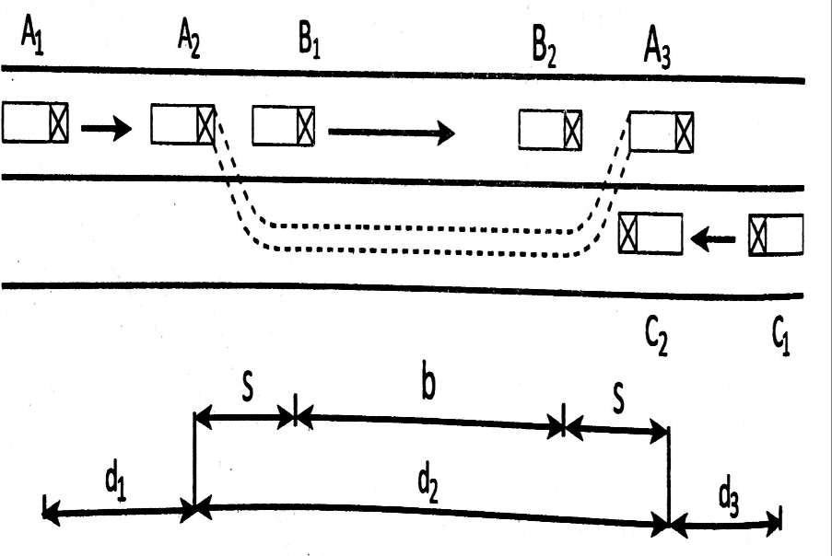

FromA1to A2, thedistance‘d1’(m)travelled by overtaking vehicle Aat reducedspeed ‘vb’ (m/s) during reaction time ‘t’ (sec),

d1=vbXt

* IRCsuggest reactiontimetofdriveras2sec, d1= 2vb
* FromA2toA3,vehicleAstartsaccelerating,shifttoadjoininglane,overtakesvehicleB,and shift back to its original lane during overtaking time ‘T’ (sec) and traveldistance ‘d2’ (m). From A2 to A3, the distance ‘d2’ (m) is further split into three parts viz;

d2=(s+b+s) d2= (b+2s)

* Theminimumspacing‘s’(m)betweenvehiclesdependsontheirspeedandisgivenby empirical formula,

s=(0.7vb+6)

* The distance covered by the slow vehicle Btravelling ata speed of ‘vb’ (m/s)in time ‘T’ (sec) is,

b=vbX T

Theovertakingtime‘T’(sec)iscalculatedas; d2=(b+2s)=(vbT+aT2/2)

b=vbT,2s=aT2/2

* FromC1toC2,distancetravelledbyvehicleC movingatdesignspeed‘v’(m/s)duringtime ‘T’ (sec) is given by,

d3=vXT

Thusovertakingsightdistance(OSD)is, OSD=(d1+d2+d3)

OSD=(vbXt)+ (vbX T+2s)+(vXT)

* Ifspeedis inkmph,

OSD=(0.28VbXt)+(0.28VbXT+2s)+(0.28VXT)

* Incasespeedofovertakenvehicle isnot givenit isassumed16kmphlessthandesignspeed of the highway.

where,

s=spacing of vehicles t=reactiontimeofdriver=2sec v =design speed in m/sec

V=designspeedinkmph

vb=initialspeedofovertakingvehicleinm/sec Vb=initial speed of overtaking vehicle in Kmph

A=averageaccelerationinkmph/sec a=average acceleration in m/sec2

### Overtaking zones

Overtaking zones are provided when OSD cannot be provided throughout the length of the highway. These are zones dedicated for overtaking operation, marked with wide roads. The desirable length of overtaking zones is 5 time OSD and the minimum is three times OSD Overtaking opportunity for vehicles moving at design speed should be given at frequent intervals as possible.

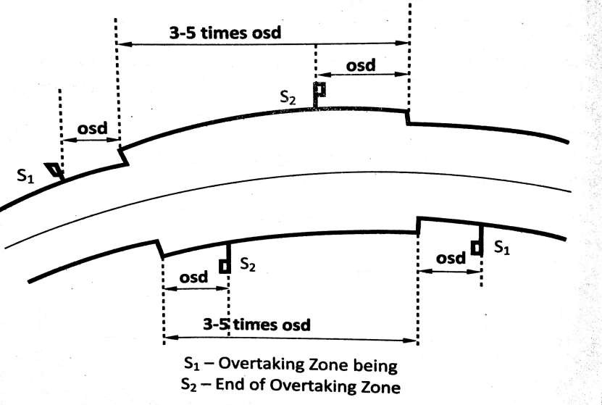

### Sightdistanceatintersections

At intersections where two or more roads meet, visibility should be provided for the drivers approaching the intersection from either sides. They should be able to perceive a hazard and stop the vehicle if required. Stopping sight distance for each road can be computed from the designspeed.Thesight distanceshouldbeprovidedsuchthatthedriversoneithersideshould be able to see each other.

Designofsightdistanceatintersections maybeusedonthreepossible conditions:

* Enablingapproachingvehicletochangethe speed
* Enablingapproaching vehicletostop
* Enablingstoppedvehicletocrossamainroad

### Design ofHorizontalAlignment:

Variousdesignelementstobeconsideredinthehorizontalalignmentare:

* + Designspeed
  + Horizontalcurve
  + Superelevation
  + Typeandlengthoftransitioncurves
  + Widening ofpavementoncurves
  + Set-back distance

### Horizontalcurve

Ahorizontalhighwaycurve isacurveinplanto providechange indirectiontothecentralline of a road.

* Whena vehicletraversesa horizontalcurve, the centrifugalforceacts horizontallyoutwards through the centre of gravity of the vehicle.
* Thecentrifugalforceisgiven bytheequation:P =Wv²∕gR

The presence of horizontal curve imparts centrifugal force which is reactive force acting outward on a vehicle negotiating it. Centrifugal force depends on speed and radius of the horizontalcurve and iscounteractedto a certainextent bytransverse friction betweenthe tyre and pavement surface. Ona curved road,this forcetends to cause the vehicle tooverrunorto slide outward from the centre of road curvature. For proper design of the curve, an understanding of the forces acting on a vehicle taking a horizontal curve is necessary.

where,

P=centrifugal force in kg W=Weight of the vehicle in kg R=radiusofthecircularcurveinm v=speed of the vehicle in m/s

g=acceleration due to gravity=9.8 m/s2 P/Wisknownasthecentrifugalratio orthe

impactfactor.Thecentrifugalratioisthusequaltov²∕gR.

* Thecentrifugalforceactingonavehiclenegotiatingahorizontalcurvehastwoeffects:

1. Tendencytooverturnthevehicle outwardsabouttheouterwheels
2. Tendencytoskidthevehiclelaterally,outwards Super elevation (e):

* Inorderto counteracttheeffect ofcentrifugal forceandtoreducethetendencyofthevehicle tooverturnorskid,theouteredgeofthepavementisraisedwithrespecttotheinneredge,thus providing a transverse slope throughout the length of the horizontal curve.
* Thistransverse inclinationtothepavement surface isknownasSuperelevationorcantor banking.

TheSuper elevation‘e’ isexpressedastheratiooftheheight ofouter edgewithrespecttothe horizontal width.

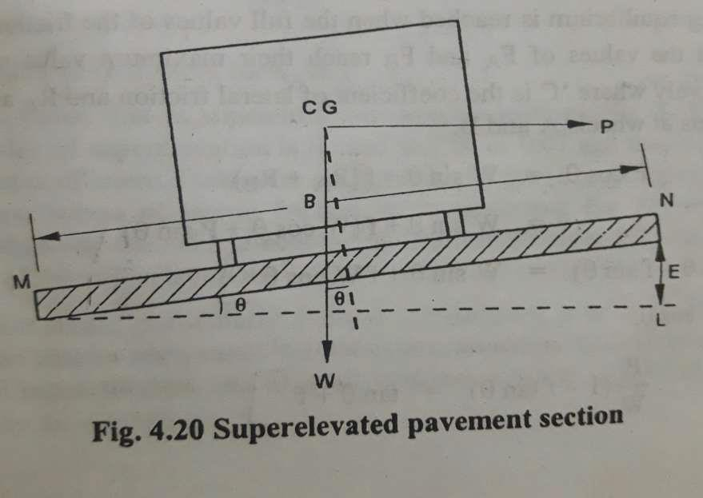

### Analysisof Superelevation:

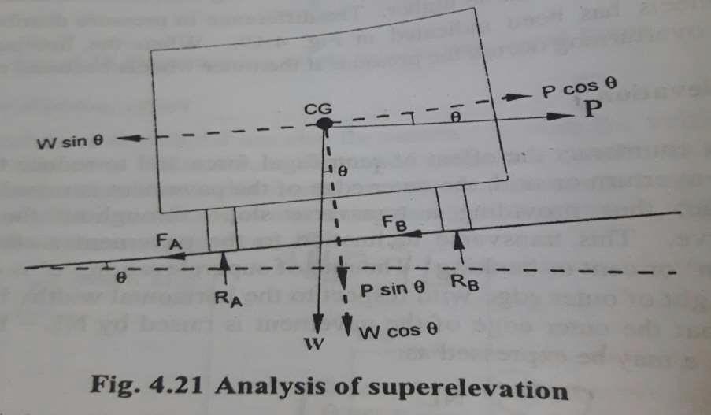

**Forequilibrium condition,**

Pcosө=Wsinө+FA+FB

Pcosө=Wsinө+f.RA+f.RB P cosө=W sinө+f(RA+RB)

Pcosө=Wsinө+f(Wcosө+Psinө) P(cosө – f sinө)=W sinө+f Wcosө

DividingbyWcosө,P/W(1-ftanө)=tanө+f Centrifugal ratio =P/W= tanө+f /(1-f tanө)

Thevalueofcoefficientoflateralfriction‘f’istakenas0.15andtanөi.e.superelevation seldom exceeds 7-10%.

Therefore,Centrifugalratio=P/W=tanө+f P/W = e + f ……(i)

butP/W=v²∕gR ……(ii)

Therefore,thegeneralequationforthedesignofsuperelevationisgivenby, e + f = v²∕gR

If‘V’speedofthevehicle isinkmph, e + f = V²∕ 127R

where,

e=rateof Superelevation=tanӨ

f=designvalueoflateralfriction coefficient = 0.15

v=speed ofthe vehicle,m/sec

R=radiusofthe horizontalcurve,m

g= accelerationdue togravity= 9.81m/sec²

### MaximumSuperelevation

* IndianRoadsCongress(IRC)had fixedthe maximumlimit ofSuperelevationinplanand rolling terrains and is snow bound areas as 7.0 %.
* Onhillroadsnotbound bysnowamaximumSuperelevationupto10% is recommended.
* Onurbanroadstretcheswithfrequentintersections,itmaybenecessarytolimitthemaximum Superelevation to 4.0 %.

### Minimum Superelevation

* From drainage consideration it is necessary to have a minimum cross slope to drain off the surface water. If the calculated superelevation is equal to or less than the camber of the road surface, then the minimum superelevation to be provided on horizontalcurve may be limited to the camber of the surface.

### StepsForSuperelevationDesign

**Step-I:**Thesuperelevationfor75percentofdesignspeediscalculated,neglectingthefriction. e =(0.75v)²∕ gR …..if ‘v’ is in m/sec

e=(V)²∕225R…..if‘V’ isinkmph

**Step-II:**Ifthecalculatedvalueof‘e’islessthan7%or0.07thevaluesoobtainedisprovided. Ifthevalueof‘e’exceeds7%or0.07thenprovidesmaximumsuperelevationequalto7%or

0.07andproceedwithstep-IIIorIV.

**Step-III:** Checkthecoefficient offrictiondevelopedforthe maximumvalueofe=0.07atthe full value of design speed.

f=v²∕gR-0.07…..if‘v’isinm/sec

f=V²∕127R -0.07…..if‘V’isin kmph

Ifthevalueof‘f’thuscalculatedislessthan 0.15,

thesuper elevationof0.07 is safe for thedesign speed. Ifnot, calculatetherestrictedspeedas given in Step -IV.

**Step-IV:** The allowable speed at the curve is calculated byconsidering the designcoefficient of lateral friction and the maximum superelevation.

e+f=0.07+0.15=va²∕gR=Va²∕127R e + f =0.22=va²∕ gR = Va²∕ 127R

Iftheallowedspeed,ascalculatedabove is higherthanthedesignspeed,thenthedesignis adequate and provides a superelevation of ‘e’ equal to 0.07.

Ifthe allowable speed is less than the design speed, the speed is limited to the allowed speed calculated above and appropriate warning signand speed limit regulationsignare installed to restrict and regulate the speed.

### RadiusofHorizontalCurve:

e +f=v²∕gR=V²∕ 127R

* Ifmaxm.allowablesuperelevationratehasbeenfixedas7%andlateralfrictionfis0.15then,

0.07+ 0.15=v²∕gR= V²∕127R

0.22=v²∕gR= V²∕127R

* Ifdesignspeedisdecidedrulingandminimum radius is calculated as,

Rruling=v²∕g(e+f)=V²∕127(e+f) Rmin=v’²∕g(e+f) =V’²∕127(e+f)

where, e=rateofSuperelevationandf=design valueoflateralfrictioncoefficient

=0.15

vorV=designspeedofthe vehicle,m/secorkmph

v’orV’= minimumdesignspeedofthe vehicle, m/secorkmph g = acceleration due to gravity = 9.81 m/sec²

### Wideningofpavement onhorizontalcurves:

Onhorizontalcurves,especiallywhentheyare

Lessthan300mradii,itiscommontowidenthepavementslightlymorethanthenormalwidth.

* Wideningisneededforthefollowingreasons:

1. An automobile has a rigid wheel base and only the front wheels can be turned, when this vehicletakesaturnto negotiateahorizontalcurve, therearwheeldo notfollow thesamepath as that of the front wheels. This phenomenon is called off tracking.
2. While two vehicle cross or overtake at horizontal curve there is psychological tendency to maintain a greater clearance between the vehicle for safety.
3. For greater visibilityat curve, the driver have tendency notto follow the centralpathofthe lane, but to use the outer side at the beginning of the curve.
4. At higher speed superelevation and lateral friction cannot counteract centrifugal force and skidding may occur of extra widening on horizontal curves:

Theextrawidening ofpavementonhorizontalcurvesisdividedintotwo parts:

1. Mechanicalwidening/Offtracking
2. Psychologicalwidening

### Objectsofprovidingtransitioncurve:

Atransitioncurvewhichis introducedbetweenstraightandacircularcurvewillhelpin:

1. Graduallyintroducingcentrifugalforce.
2. Graduallyintroducingdesignedsuperelevation.
3. Graduallyintroducingextrawidening.
4. Toenablethedriver turnsteeringgraduallyforhisowncomfortandsafety.

### VerticalAlignment:

* Theverticalalignmentistheelevationorprofileofthecentrelineoftheroad.
* Theverticalalignmentconsistsofgradesandverticalcurves.
* Theverticalalignment ofahighwayinfluences:
  1. Vehiclespeed
  2. Accelerationanddeceleration
  3. Sightdistance
  4. Vehicleoperationcost
  5. Comfort whiletravellingathighspeeds

### Gradients:

* Gradientisthe rateofrise orfallalongthelengthofroadwithrespecttothehorizontal.
* Itisexpressed asaratioof1innoralsoaspercentagesuchasn%.

### TypesOf Gradients:

* Gradientsaredividedintofourcategories:
  + 1. Rulinggradient
    2. Limitinggradient
    3. Exceptionalgradient
    4. Minimumgradient

1. *Ruling gradient:*

* Ruling gradient is the maximum gradient within which the designer attempts to design the vertical profile of a road.
* Rulinggradientisalsoknownas‘Designgradient’.
* For selection of rulinggradientfactorssuch as type of terrain,length of the grade, speed, pulling power of vehicle etc are considered.

1. *Limiting gradient:*

* Steeper than ruling gradient. In hilly roads, it may be frequently necessary to exceed ruling gradient and adopt limiting gradient, it depends on

1. Topography
2. Costinconstructingtheroad
3. Exceptionalgradient:

* Exceptionalgradientareverysteepergradientsgivenatunavoidablesituations.
* Theyshouldbelimitedforshortstretches notexceedingabout100matastretch.

1. *Minimumgradient:*

* Thisisimportantonlyatlocationswheresurfacedrainageis important.
* Camberwilltakecareofthelateraldrainage.
* But the longitudinal drainage along the side drains require some slope for smooth flow ofwater.
* Thereforeminimumgradient isprovidedfor drainagepurposeandit dependsontherainfall, type of soil and other site conditions.
* A minimumof 1in500 may be sufficient for concrete drain and 1in 200 or 1 in 100 for open soil drains.

### GradeCompensation:

* When sharp horizontal curve is to be introduced on a road which has already maximum permissible gradient, then gradient should be decreased to compensate for loss of tractive efforts due to curve.
* Thisreductioningradient at horizontalcurve is calledgradecompensation. Grade compensation, % = 30+R/R

IRCgavethefollowingspecificationforthegradecompensation:

1. Grade compensation is not required for grades flatter than 4% because the loss of tractiveforce is negligible.
2. The maximum grade compensation is limited to 75/R%. Compensatedgradient=rulinggradient–gradecompensation

# CHAPTER-3

## RoadMaterials

### Differencetypesofroadmaterialsin use:soil, aggregates, andbinders

A wide variety of materials are used in the construction of roads these are soils (naturally occurringorprocessed),aggregates(fineaggregatesorcoarseaggregatesobtainedfromrocks), binders like lime, bituminous materials, and cement, and miscellaneous materials used as admixtures for improved performance of roads under heavy loads and traffic.

1. **Soil:**

Soil constitutes the primary material for the foundation, subgrade, or even the pavement (for low-cost roads with low traffic in rural areas). When the highway is constructed on an embankment at the desired level, soil constitutes the primary embankment material; further, sinceallstructureshavetoultimatelyrestonandtransmitloadsto‘motherearth’,soilandrock also serve as foundation materials.

### Need forSoil Classification:

Soildepositsinnatureareneverhomogenousincharacter;widevariationsareobservedintheir properties and behaviour. Soils that exhibit similar average properties may be grouped as a class. Classificationofsoilis necessarytoobtainanappropriateandfairlyaccurateideaofthe properties and behaviour of a soil type.

* 1. Texturalclassification
  2. PRAsystemofclassification(Groupindexmethod)
  3. UnifiedsoilclassificationSystem
  4. IndianStandardSoilclassificationsystem

### Stone Aggregates:

Stone aggregate,or mineralaggregate, as it is called, is the most important component ofthe materialsusedintheconstructionofroads.Theseaggregatesarederivedfromrocks,whichare formed by the cementation of minerals by the forces of nature.

Stone aggregates are invariably derived by breaking the naturally occurring rocks to the required sizes. They are used for granular bases, sub-bases, as part of bituminous mixes and cement concrete; they are also the primary component of a relatively cheaper road, called water-bound macadam.

**DesirablePropertiesofSandAggregates:**

**Thefollowingpropertiesaredesirableinsoilaggregatesusedtheconstruction ofroads:**

1. **Strength:**

Itistheresistancetocrushingwhichtheaggregatesusedinroadconstruction,especiallyinthe top layers and wearing course, have to withstand the stresses due to wheelloads ofthe traffic in addition to wear and tear.

### Hardness:

Itistheresistancetoabrasionoftheaggregateatthesurface.Theconstantrubbingorabrading action between the tyres of moving vehicles and the exposed aggregate at the road surface should be resisted adequately.

### Toughness:

Thisistheresistancetoimpactduetomovingtraffic.Heavilyloadedtrucksandothervehicles cause heavy impact loads on the road surface while moving at high speeds, and while accelerating and decelerating. Even steel-typed vehicles, though moving slow, cause heavy impact onthe aggregates exposed at the surface. Hence, resistance to such impact forces is a desirable quality.

### Durability:

Itistheresistancetotheprocessofdisintegrationduetotheweatheringactionoftheforcesof nature. The property by virtue of which the aggregate withstands weathering is called soundness. This is also a desirable property.

### Cementation:

It is the ability of the aggregate to form its own binding material under traffic, providing resistance to lateral displacement. Limestone and laterite are examples of stones with good cementing quality. This becomes important in the case of water-bound macadam roads.

### AppropriateShape:

Aggregates maybe either rounded, cubical, angular, flaky, or elongated. Each shape is appropriate for a certain use. Too flaky and too elongated aggregates have less strength and durability; so they are not preferred in road construction.

Rounded aggregatesaregoodfor cement concretebecause ofthe workabilitysuchaggregates provide. Cubical or angular aggregates have good interlocking properties; since flexible pavementsderivetheir stabilitydueto interlocking, suchaggregatesarethepreferredtype for construction. Thus, the appropriate shape for a particular use is also a desirable property.

### AdhesionwithBitumen:

The aggregates used in bituminous pavements should have less affinity to water than to bitumen;otherwise,thebituminouscoatingonthesurfaceoftheaggregatewillgetstrippedoff in the presence ofwater. So, hydrophobic characteristic is a desirable propertyfor aggregates to be used in the construction of bituminous roads.

### Attrition:

Thisismutualrubbingofaggregatesundertraffic;adequateresistancetoattritionisadesirable property.

### Texture:

This is a measure of the degree of fineness or smoothness of the surface of the aggregate. Gravelsfromriverbedsarefairlysmooth;asarule,finegrainedrockishighlyresistanttowear and is preferred for surface courses.

### BituminousMaterials:

Bitumen was used as a bonding and water-proofing agent thousands of years ago. However, the useofbitumenfor road-making picked uponlyinthe nineteenthcentury. As the quest for fuels like petroleum to run automobiles grew and the distillation of crude oil emerged as a major refining industry, the residues known as bitumen and tar found increasing use in constructing bituminous surfaces, which provided superior riding surface.

### ImportantPropertiesofBitumen:

* Predominantlyhydrocarbons,withsmallquantitiesofsulphur,nitrogenandmetals.
* Mostly(upto99.9%)solubleincarbondisulphide(CS2),andinsolubleinwater.
* Softensonheating andgetshardenedoncooling.
* Highlyimpermeable towater.
* Chemicallyinertandunaffectedbymostacids,alkalisandsalts.
* Nospecificboilingpoint,meltingpointorfreezingpoint;aformof‘softeningpoint’is used in their characterisation.
* Althoughgenerallyhydrophobic(waterrepellent),theymaybemadehydrophilic (water liking) by the addition of a small quantity of surface-active agent.
* Mostbitumensarecolloidalin nature.

### DesirablePropertiesofBitumen asa RoadMaterial:

* Workability – Bitumen should be fluid enough at the time of mixing so that the aggregates are fully coated by the binder. Fluidity is achieved either by heating or by cutting back with a thin flux or by emulsifying the bitumen.
* Durability–Thereshouldbelittlechangeinviscositywithintheusualrangeof temperatures in the locality.
* Volatile constituents in bitumen should not be lost excessivelyat higher temperatures to ensure durability.
* Itshouldhaveenoughductilitytoavoidbrittlenessand cracking.
* Strength and adhesion – The bitumen should have good affinityto the aggregates and should not be stripped off in the continued presence of water.
* Cost-effectiveness.

### Afewmoretermsrelatingtobitumen/asphalt are:

**Straight-Run Bitumen:** Bitumen derived from the refining of petroleum for which the viscosityhas not been adjusted byblending with flux oilor bysoftening with any cut-back oil or by any other treatment. It generally has high viscosity.

### AsphaltCement:

Abinderconsistingofbitumen,oramixtureoflakeasphalt andbitumenorfluxoils,specially prepared as per prescribed quality and consistency for direct use in paving, usually in the hot condition.

### OxidisedorBlown Bitumen:

Bitumenobtained by further treatment ofstraight-runbitumenbyrunning it, while hot, into a verticalcolumnandblowingairthroughit.Inthisprocess,itattainsarubberyconsistencywith a higher softening point than before.

### Cut-Back Bitumen:

Asphalt/bitumen dissolved in naphtha or kerosene to lower the viscosity and increase the workability.

### EmulsifiedBitumen:

A mixture in which asphalt cement, in a finely dispersed state, is suspended in chemically treated water.

### LiquidBitumen:

Includecut-backsinnaphthaandkerosene,asalsoemulsified asphalts.

### Cut-Back Bitumen:

Cut-back bitumen is one, the viscosity of which is reduced by adding a volatile diluent. Penetrationgradebitumensrequiretobeheatedtoaspecifiedtemperaturetoloweritsviscosity beforeit isappliedonaroadtofacilitatecoatingthepre-heatedaggregate.Toobviatetheneed for heating the aggregate, cut-backs come in handy. Upon application, the volatiles slowly evaporate, and leave behind the original bituminous binder.

### Therearethreetypesofcut-backsbasedon thediluent (dilutantorsolvent)used:

1. Rapid-curing (RC) cutback – Bitumen blended with gasoline or naphtha, (highly volatile, low viscosity)
2. Medium-curing(MC)cutback–Bitumen blendedwith keroseneorcoal tarcreosote oil (medium viscosity)
3. Slow-curing(SC)cutback –Bitumenblendedwithgasoil(lowviscosity,highly viscous)

### Bitumen Emulsions:

A bitumen emulsion is obtained by blending bitumen with water and an additive called an emulsifier. The emulsified suspensioncontains dispersed minute particles ofbitumen(that is, oilinwater).Inabituminousemulsion,bitumenisthe‘dispersed’phase(minutelysubdivided particles), while water is the ‘continuous’ phase in which it is not soluble. The amount of bitumen to be mixed with water may range from40 to 70% depending upon the intended use of the suspension.

### Bitumen emulsions, like cutback bitumens, are also classified into three types based on their setting times:

1. Rapid-settingemulsions(RS)
2. Medium-settingemulsions(MS)
3. Slow-settingemulsions(SS)

Setting, in this context, means separation of the emulsion. When the water in the emulsion evaporates, the minute bitumen particles in the emulsion coat the surface of the aggregates; curing takes place, by which the compacted layer ofthe emulsion-aggregate mix hardens and attainsstrength. Therefore, rapid-setting emulsionsetsand cures inarelativelyquick manner. “IS:3117-2004:Anionicbitumenemulsions”coversanionicemulsions,while“IS:8887-2004: Cationic bitumen emulsions” covers cationic emulsions.

### Tar:

Tar is a black or brown to black, viscous, non-crystalline material having binding property. This is, therefore, the other category of bituminous materials.

Tar is obtained from the destructive distillation of organic materials such as coal, petroleum, oil, wood and peat, in the absence of air at about 1000°C. It is completely soluble in carbon tetrachloride(CCl4).It containsmorevolatileconstituentsthanbitumenand isthereforemore susceptibletochangeintemperature.Generally,tarisusedforsurfacedressingonthewearing course since it has good adhesion in damp conditions.

### Somemoretermsrelatingtotarare:

* 1. Coaltar–Tarproducedbythe destructivedistillationofbituminous coal.
  2. Coke-oventar–Avarietyofcoaltarobtainedasaby-productfromthedestructive distillation of coal in the production of coke.
  3. Oil-gastar–Apetroleumtarproducedbycrackingoilsathightemperatureinthe production of oil-gas.
  4. Water-gastar–Apetroleumtarproducedbycrackingoilsathightemperatureinthe production of carburetted water-gas.
  5. Refinedtar–Producedfromcrudetarbydistillationtoremovewaterandtoproducea residue of desired consistency.
  6. Roadtar –Atarrefinedinqualityandconsistencyforuse inpaving ofroads.
  7. Pitch – Black or dark brown solid cementitious residue which gradually liquefies whenheated and which is produced by distilling off the volatile constituents from tar. **Specifications for Road Tars:**

Indian Standards classify road tars for paving purposes into five grades— RT1, RT2, RT3, RT4, and RT5, meant for specific purposes.

### LowTemperatureTar:

The coal-tar produced in the manufacture of coking coal requires carbonation at high temperatures above 1000°C. In view ofthe increasing demand for roadtars in recent years, a new technology known as low temperature carbonisation has come into vogue.

In this, the carbonisation of coal is carried out in the temperature range of 600°-750°C in a smokelessfuelprocess. Thecrudetarthusproducedissuccessfullyused for makingroadtars; these are known as low temperature tars.

### BitumenversusTar:

**Acomparison ofbitumen andtarisgivenbelow:**

* + 1. Aggregatescoatedwithtarexhibitlower strippingactionthanthosecoatedwithbitumen.
    2. Tar is more susceptible to temperature than bitumen. It becomes liquid at relatively lower temperature.
    3. Tar is not easilydissolved inpetroleumsolvents;so it canbepreferred for pavingparking areas, where oils might drip from vehicles.
    4. Sincemoresettingtimeisrequiredfortar,itmaybeprocessedatamixingplantandcarried to the construction site.
    5. Inviewofthehigher freecarboncontent,tar ismorebrittlethan bitumen.
    6. Astarshavemore phenolcontent,theycangetmore easilyoxidisedthanbitumen.
    7. Athighertemperatures,tarmaybemoreeasilyaffectedthanbitumen.
    8. As more time is required for tar to set, tar-paved roads need to be closed to traffic for a longer time.

The tests used to evaluate the strength properties of soils may be broadly divided into threegroups:

* + - * Sheartests
      * Bearingtests
      * Penetrationtests

Sheartestsareusuallycarriedoutonrelativelysmallsoilsamplesinthelaboratory.Inorderto find out the strength properties of soil, a number of representative samples from different locations are tested. Some of the commonly known shear tests are direct shear test, triaxial compression test, and unconfined compression test.

Bearing tests are loading tests carried out on sub grade soils in-situ with a load bearing area. The results of the bearing tests are influenced by variations in the soil properties within the stressedsoilmassunderneathandhencetheoverallstabilityofthepartofthesoilmassstressed could be studied.

Penetrationtestsmaybeconsideredassmallscalebearingtestsinwhichthesizeoftheloaded area is relatively much smaller and ratio of the penetration to

thesizeoftheloadedareaismuchgreaterthantheratiosinbearingtests.Thepenetrationtests are carried out in the field or in the laboratory.

### California Bearing Ratio: methods of finding CBR valued in the laboratory and at site and their significance

**CaliforniaBearingRatioTest**

California Bearing Ratio (CBR) test was developed bythe California DivisionofHighwayas a method of classifying and evaluating soil-sub grade and base course materials for flexible pavements. CBRtest, anempiricaltest, has beenused to determinethe materialproperties for pavement design. Empirical tests measure the strength of the material and are not a true representationoftheresilientmodulus.Itisapenetrationtestwhereinastandardpiston,having an area of 3 in (or 50 mm diameter), is used to penetrate the soil at a standard rate of 1.25 mm/minute. The pressure upto a penetrationof12.5 mmand it's ratio tothe bearing value of a standard crushed rock is termed as the CBR.

In most cases, CBR decreases as the penetration increases. The ratio at 2.5 mmpenetration is used as the CBR. In some case, the ratio at 5 mm may be greater than that at 2.5 mm. If this occurs,the ratio at 5mmshould be used. The CBR is a measure ofresistance ofa materialto penetration of standard plunger under controlled density and moisture conditions. The test procedureshouldbestrictlyadhered ifhighdegreeofreproducibilityisdesired. TheCBRtest maybeconductedinre-mouldedorundisturbedspecimeninthe laboratory.Thetestissimple and has been extensively investigated for field correlations of flexible pavement thickness requirement.

# CHAPTER-4

## RoadPavements

A highway pavement is a structure consisting of superimposed layers of processed materials above the natural soil sub-grade, whose primary function is to distribute the applied vehicle loadstothesub-grade.Thepavementstructureshouldbeabletoprovideasurfaceofacceptable ridingquality,adequateskidresistance,favorablelightreflectingcharacteristics,andlownoise pollution. The ultimate aim is to ensure that the transmitted stresses due to wheel load are sufficientlyreduced, sothattheywillnotexceedbearingcapacityofthesub-grade. Twotypes ofpavementsaregenerallyrecognizedasservingthispurpose,namelyflexiblepavementsand rigidpavements.Thischaptergivesanoverviewofpavementtypes,layers,andtheirfunctions, and pavement failures. Improper design of pavements leads to early failure of pavements affecting the riding quality.

### Purposeofa RoadPavement

* + - * The mainpurposeistocarryheavywheelloadsofvehicular traffic.
      * Todistributethevehicularloadover alargeareaoftheunderlyingsub-gradesoil.
      * Generallytoprovideasmoothroadpavementsurface.
      * Topreventilleffectsofweathering agenciesonsub-gradesoil.

### Requirementsofapavement

* + - * Anidealpavementshouldmeetthefollowingrequirements:
      * Sufficientthicknesstodistributethewheelloadstressestoasafevalueonthesub-grade soil,
      * Structurallystrongto withstand alltypesofstressesimposed uponit,
      * Adequatecoefficientoffrictiontopreventskiddingofvehicles,
      * Smoothsurfacetoprovidecomforttoroadusersevenathighspeed,
      * Produceleast noise frommovingvehicles,
      * Dustproofsurfacesothattrafficsafetyisnotimpaired byreducing visibility,
      * Impervioussurface,sothatsub-gradesoiliswellprotected,and
      * Longdesignlifewithlow maintenance cost.

### ComponentPartsofRoadPavement Structure

* + - * Sub-gradeorFormation
      * Sub-base
      * BaseCourseor FoundationCourse
      * BaseCoatorIntermediateCourse
      * WearingCourse

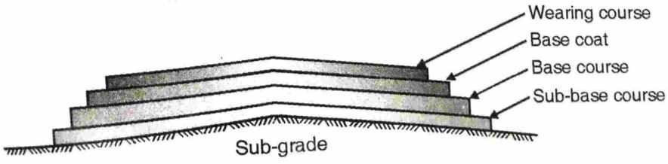

### Sub-grade:

Definition : The finished and compacted earthwork on which a road pavement rests is called as sub-grade or formation.

### Functionsof Sub-grade:

Toprovidesupporttothepavements.

Sub-gradecarriesentireloadofpavementincludingthetraffic.

### Sub-base:

Definition:Alayerofgranularmaterialprovidedinbetweenthesub-gradeandthebasecourse in a road pavement is called sub-base.

### FunctionsofSub-base:

Itimprovesthebearing capacityofsub-grade.

Itimprovesdrainageandkeep check oncapillaryriseofsubsoilwater.

### BaseCourse:

Definition:Alayerofbouldersorbricksprovidedindoublelayeroverthesub-baseor immediatelyoverthesub-gradeintheabsenceofsub-baseinapavementiscalledbasecourse.

### FunctionsofBase Course:

Towithstandhighshearingstressesdevelopduetotheimpactoftrafficonthewearingcourse.

To act as foundation to the pavement, which transfers load over the pavement surface to the sub-base and sub-grade lying underneath.

### Base Coat:

Definition :Thelayerof hardstonesprovidedinbetween thebasecourseandthewearing course in a road pavement is called base coat or bearing course or intermediate coat.

### FunctionsofBase Coat:

Generallytotransmit the loadoverthelargeareaofthe basecourse. To act as layer of transmission material.

### WearingCourse:

The top most layer of pavement directly exposed to traffic is called as wearing course or surfacing.

### FunctionsofWearingCourse:

The main functionofwearing course is to provide impervious layers so that entryofwater to the base course can be prevented.

Moreovertheentiretrafficloadissafelydistributedoverthebasecourse.

Itactsasimperviouslayer,thusavoidsthe entryofwatertothe basecourse.

### TypesofRoadPavement

The pavements can be classified based on the structural performance into two, flexible pavements and rigid pavements. In flexible pavements, wheel loads are transferred by grain- to-graincontactoftheaggregatethroughthegranularstructure.Theflexiblepavement,having lessflexuralstrength,actslikeaflexiblesheet (e.g.bituminousroad).Onthecontrary, inrigid pavements, wheel loads are transferred to sub-grade soil by flexural strength ofthe pavement and the pavement acts like a rigid plate (e.g. cement concrete roads). In addition to these, compositepavementsarealsoavailable.Athinlayerofflexiblepavementoverrigidpavement is an idealpavement with most desirable characteristics. However, suchpavements are rarely used in new construction because of high cost and complex analysis required.

### FlexiblePavement

1. **RigidPavement Flexible pavements**

Flexiblepavementswilltransmitwheelloadstressestothelowerlayersbygrain-to-grain transfer through the points of contact in the granular structure

The wheel load acting on the pavement will be distributed to a wider area, and the stress decreases with the depth. Taking advantage of this stress distribution characteristic, flexible pavementsnormallyhasmanylayers.Hence,thedesignofflexiblepavementusestheconcept oflayered system. Based onthis, flexible pavement maybe constructedina number oflayers and the toplayer has to be ofbest qualityto sustain maximumcompressive stress, inaddition to wear and tear. The lower layers will experience lesser magnitude of stress and low quality material can be used. Flexible pavements are constructed using bituminous materials. These canbeeitherintheformofsurfacetreatments(suchasbituminoussurfacetreatmentsgenerally found on low volume roads) or, asphalt concrete surface courses (generally used on high volumeroadssuchas nationalhighways). Flexible pavement layersreflect thedeformationof thelowerlayersontothesurfacelayer(e.g.,ifthereisanyundulationinsub-gradethenitwill be transferred to the surface layer). In the case of flexible pavement, the design is based on overallperformanceofflexiblepavement,andthestressesproducedshouldbekeptwellbelow the allowable stresses of each pavement layer.

#### TypesofFlexiblePavements

Thefollowingtypesofconstructionhavebeenusedinflexiblepavement:

* + Conventionallayeredflexiblepavement,
  + Full-depthasphaltpavement,and
  + Containedrockasphaltmat(CRAM).

Conventionalflexiblepavementsarelayeredsystemswithhighqualityexpensivematerialsare placed in the top where stresses are high, and low qualitycheap materials are placed in lower layers.

Full-depthasphaltpavementsareconstructedbyplacingbituminouslayersdirectlyonthesoil sub-grade.Thisismoresuitablewhenthereishightrafficandlocalmaterialsarenotavailable.

Containedrockasphalt matsareconstructedbyplacingdense/opengradedaggregatelayersin between two asphalt layers. Modified dense graded asphalt concrete is placed above the sub- grade will significantly reduce the vertical compressive strain on soil sub-grade and protect from surface water.

### Typicallayersofa flexiblepavement

Typicallayersofaconventionalflexiblepavementincludessealcoat,surfacecourse,tackcoat, bindercourse,primecoat,basecourse,sub-basecourse,compactedsub-grade,andnaturalsub- grade .

### SealCoat:

Seal coat is a thin surface treatment used to water-proof the surface and to provide skid resistance.

### TackCoat:

Tackcoat isa verylight applicationofasphalt, usuallyasphalt emulsiondilutedwithwater. It providesproperbondingbetweentwolayerofbindercourseandmustbethin,uniformlycover the entire surface, and set very fast.

### PrimeCoat:

Prime coat is an application of low viscous cutback bitumen to an absorbent surface like granularbasesonwhichbinderlayerisplaced.Itprovidesbondingbetweentwolayers.Unlike tack coat, prime coat penetrates into the layer below, plugs the voids, and forms a watertight surface.

### Surfacecourse

Surfacecourseisthelayerdirectlyincontactwithtrafficloadsandgenerallycontainssuperior quality materials. They are usually constructed with dense graded asphalt concrete(AC). The functions and requirements of this layer are:

It provides characteristics such as friction, smoothness, drainage, etc. Also it willprevent the entrance of excessive quantities of surface water into the underlying base, sub-base and sub- grade,

It must be toughto resist the distortion under traffic and provide a smooth and skid- resistant riding surface,

It must be water proof to protect the entire base and sub-grade from the weakening effect of water.

### Binder course

Thislayerprovidesthe bulkoftheasphalt concretestructure.It'schiefpurpose isto distribute load to the base courseThe binder course generallyconsists ofaggregates having less asphalt and doesn't require quality as high as the surface course, so replacing a part of the surface course by the binder course results in more economical design.

### Base course

The base course is the layer ofmaterialimmediatelybeneaththe surface ofbinder course and it provides additional load distribution and contributes to the sub-surface drainage It may be composed of crushed stone, crushed slag, and other untreated or stabilized materials.

### Sub-Basecourse

Thesub-basecourseisthe layerofmaterialbeneaththebasecourseandtheprimaryfunctions areto provide structuralsupport, improve drainage, and reducethe intrusionof fines fromthe sub-gradeinthepavementstructureIfthebasecourseisopengraded,thenthesub-basecourse withmorefinescanserveasa filler betweensub-gradeandthebasecourseAsub-basecourse is not always needed or used. For example, a pavement constructed over a high quality, stiff sub-grademaynotneedtheadditionalfeaturesofferedbyasub-basecourse.Insuchsituations, sub-base course may not be provided.

### Sub-grade

The top soil or sub-grade is a layer of natural soil prepared to receive the stresses from the layersabove.Itisessentialthatatnotimesoilsub-gradeisoverstressed.Itshouldbecompacted to the desirable density, near the optimum moisture content.

### Failureofflexible pavements

The major flexible pavement failures are fatigue cracking, rutting, and thermalcracking. The fatigue cracking of flexible pavement is due to horizontal tensile strain at the bottom of the asphaltic concrete.The failure criterionrelates allowable number ofload repetitions totensile strain and this relation can be determined in the laboratory fatigue test on asphaltic concrete specimens. Rutting occursonlyon flexible pavementsasindicated bypermanent deformation orrutdepthalongwheelloadpath.Twodesignmethodshavebeenusedtocontrolrutting:one to limit the vertical compressive strain on the top of subgrade and other to limit rutting to a tolerableamount(12mmnormally).Thermalcrackingincludesbothlow-temperaturecracking and thermal fatigue cracking.

### Rigidpavements

Rigidpavementshavesufficientflexuralstrengthtotransmitthewheelloadstressestoawider area below. A typical cross section of the rigid pavement is shown in Figure 3. Compared to flexible pavement, rigid pavements are placed either directly on the prepared sub-grade or on a single layer of granular or stabilized material. Since there is only one layer of material between the concrete and the sub-grade, this layer can be called as base or sub-base course.

In rigid pavement, load is distributed by the slab action, and the pavement behaves like an elastic plate resting on a viscous medium (Figure 4). Rigid pavements are constructed by Portlandcementconcrete(PCC)andshouldbeanalyzedbyplatetheoryinsteadoflayertheory,

assuminganelasticplaterestingonviscous foundation. Platetheoryisasimplified versionof layer theory that assumes the concrete slab as a medium thick plate which is plane before loading and to remain plane after loading. Bending of the slab due to wheel load and temperature variation and the resulting tensile and flexural stress.

### TypesofRigidPavements

Rigidpavementscanbeclassifiedinto fourtypes:

1. Jointedplainconcretepavement(JPCP),
2. Jointedreinforcedconcretepavement(JRCP),
3. Continuousreinforcedconcretepavement(CRCP),and
4. Pre-stressedconcretepavement (PCP).

*JointedPlainConcrete Pavement:*

Theseareplaincementconcretepavementsconstructedwithcloselyspacedcontractionjoints. Dowel bars or aggregate interlocks are normally used for load transfer across joints. They normally has a joint spacing of 5 to 10m.

*JointedReinforcedConcretePavement:*

Although reinforcements do not improve the structural capacity significantly, they can drastically increase the joint spacing to 10 to 30m. Dowel bars are required for load transfer. Reinforcements help to keep the slab together even after cracks.

*ContinuousReinforcedConcrete Pavement:*

Continuouslyreinforcedconcretepavements(CRCP)isatypeofconcretepavementthatdoes notrequireanytransversecontractionjoints.Transversecracksareexpectedintheslab,usually at intervals of 1.5 - 6 ft (0.5 - 1.8 m). CRCP is designed with enough embedded reinforcing steel(approximately0.6-0.7% bycross-sectionalarea) sothat cracksareheld togethertightly. Determining an appropriate spacing between the cracks is part of the design process for this type of pavement.

*Pre-stressedconcretepavement(PCP)*

Completeeliminationofjointsisachievedbyreinforcement.

### DifferencebetweenFlexiblePavementsandRigid Pavements

|  |  |  |
| --- | --- | --- |
| **Sl.**  **No.** | FlexiblePavement | RigidPavement |
| **1** | Itconsistsof aseriesof layerswith thehighestqualitymaterialsatornear  thesurface ofpavement. | ItconsistsofonelayerPortlandcement concreteslaborrelativelyhighflexural  strength. |
| **2** | It reflects the deformations of  subgradeandsubsequentlayersonthe surface. | Itisabletobridgeoverlocalizedfailuresand area of inadequate support. |
| **3** | Its stability depends upon the aggregateinterlock,particlefriction  andcohesion. | Itsstructuralstrengthisprovidedbythe pavement slab itself by its beam action. |

|  |  |  |
| --- | --- | --- |
| **4** | Pavementdesignisgreatlyinfluenced  bythesubgradestrength. | Flexuralstrengthofconcreteisamajor  factorfordesign. |
| **5** | It functions bya wayof load  distributionthroughthecomponent layers | Itdistributesloadoverawideareaof  subgradebecauseofitsrigidityandhigh modulus of elasticity. |
| **6** | Temperaturevariationsduetochange in atmospheric conditions do not producestressesinflexible  pavements. | Temperature changes induce heavy stresses in rigid pavements |
| **7** | Flexiblepavementshave self-healing propertiesduetoheavierwheelloads  arerecoverableduetosome extent. | Anyexcessivedeformationsoccurringdue toheavierwheelloadsarenotrecoverable,  i.e.settlementsarepermanent. |

**Failurecriteriaofrigid pavements**

Traditionally fatigue cracking has been considered as the major, or only criterion for rigid pavement design.Theallowable numberofloadrepetitionsto causefatigue crackingdepends on the stress ratio between flexural tensile stress and concrete modulus of rupture. Of late, pumping is identified as an important failure criterion. Pumping is the ejection of soil slurry through the joints and cracks of cement concrete pavement, caused during the downward movement of slab under the heavy wheel loads. Other major types of distress in rigid pavements include faulting, spalling, and deterioration.

### TypesofFailuresinRigidPavements

Thedifferenttypesofdistressesresponsibleforfailuresinrigidpavements are:

1. Joint Spalling
2. Faulting
3. PolishedAggregate
4. ShrinkageCracking
5. Pumping
6. Punch out
7. LinearCracking
8. DurabilityCracking
9. Corner Break

*Joint SpallinginRigidPavements*

Excessivecompressivestresscausesdeteriorationinthejoints,calledasthespalling.Thismay be related to joint infiltration or the growth of pavement, that are caused by the reactive aggregates. Poor quality concrete or construction technique will also result in joint spalling. Smalledgestolargespallsinthebackoftheslabanddowntothejointscanbeobserved.Main causes of joint spalling in rigid pavements are:

Joints subjectedto excessive stress due to hightraffic or byinfiltrationofany incompressible materials

The joint that are constructed with weak concrete joint that is accumulated with water that results in rapid freezing and thawing

*Main causesof jointspalling inrigid pavementsare:*

* + Jointssubjectedtoexcessivestressduetohightrafficorbyinfiltrationofany incompressible materials
  + Thejointthatareconstructedwithweakconcrete
  + Joint thatisaccumulatedwithwaterthatresultsinrapidfreezingand thawing

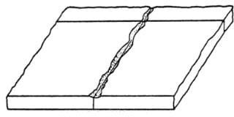

Fig.1:Joint Spalling inRigidPavementSlabs

*Faulting in Rigid Pavements*

Thedifferenceinelevationbetweenthejointsiscalledasfaulting.Themaincausesoffailures in rigid pavements due to faulting are:

Settlementofthepavementthatiscausedduetosoftfoundation

The pumping or the erosion of material under the pavement, resulting in voids under the pavement slab causing settlement

Thetemperaturechangesandmoisturechangesthatcausecurlingoftheslabedges.

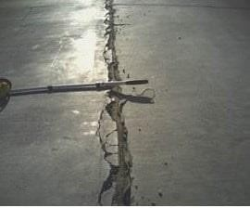

Fig.2:Faultingwithdifferenceinelevationsfoundbetweenthejoints

*PolishedAggregatein RigidPavements*

Therepeatedtrafficapplicationleadstothisdistress. Thesearethefailures inrigidpavements caused when the aggregates above the cement paste in the case of PCC is very small or the aggregatesarenotroughorwhentheyareangularinshape,thatitcannotprovidesufficient

skid resistance for the vehicles. The polishing degree should be specified before the constructioniscarriedout.Thisstudyisincludedintheconditionsurvey,whereitismentioned as a defect.

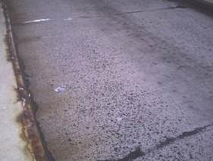

Fig:PolishedAggregates

*ShrinkageCracking inRigid Pavements*

Thesearehairlinecracksthatarelessthan2minlength. Theydonotcrosstheentireslab. The setting and curing process ofthe concrete slabresults insuchcracks. These are caused due to higherevaporationofwaterdueto highertemperaturecracks. Impropercuringcanalso create shrinkage cracks in rigid pavements.Shrinkage Cracking in Rigid Pavements

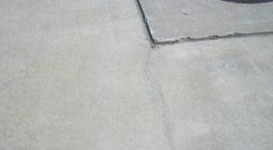

Fig:ShrinkageCracking inPavements

*PumpingEffects*

The expulsion of water from the under a layer of the pavement is called as pumping. This distress is caused due to the active vehicle loads coming over the pavement in a repetitive manner. Thiswillresult inthe fine materialspresent inthesubbaseto movealongwithwater and get expelled out with the water. Larger voids are created under the pavement due to repeated expulsion. The stains on the pavement or on the shoulder surface are the method throughwhichthistypeoffailureofrigidpavement isevidenced. Pumpingcanbeavoidedby thepreventionofwateraccumulationatthepavementsub-baseinterface.Thiscanbeachieved byreducingthedeflectiontoaminimumvalueandbytheprovisionofastrongwell-

constructedsub-base.Theconstructedsub-basemusthaveasufficientdrainagefacilitysothat thesubgradebelowisnotsaturated.Modernpavementconstructionmakesuseofunderground drainage system that is the best solution for pumping distress.

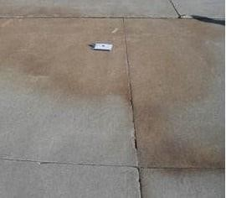

Fig:PumpingEffect

*CornerBreaksinRigidPavements*

Thesearethefailuresinrigidpavementsthatiscausedduetopumpinginexcessiverate.When the pumping completely remove the underlying support that no more support exists below to taken the vehicle load, the corner cracks are created. The repair method is either full slab replacement or the repair for the full depth must be carried out.

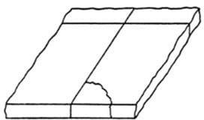

Fig:CornerBreakFailuresinRigidPavement Punch-out in Rigid Pavements

Alocalizedareaofconcreteslabthatisbrokenintopieceswillbenamedaspunchoutdistress. This distress can take anyshape or form. These are mainly defined by joints and cracks. The joints and cracks will mainly keep 1.5m width. The main reason behind punch outs is heavy repeated loads, the slab thickness inadequacy, the foundation support loss or the construction deficiency like honeycombing.

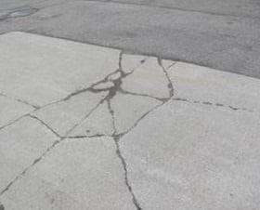

Fig.Punch-outFailuresinRigidPavements

*LinearCrackingin RigidPavements*

Thesetypesoffailuresinrigidpavementsdividestheslabintotwoorthreepieces.Thereason behind such failures is traffic loads at repeated levels, the curling due to thermalgradient and moisture loading repeatedly.

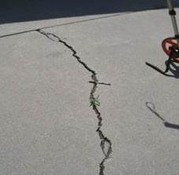

Fig:Linear Cracking

*DurabilityCracking in Rigid Pavements*

Thefreezingandthawingactionwillcreateregularexpansionandcontractionwhichwillresult in the gradual breakdown of the concrete. This type of distress is patterns of cracks on the concrete surface as layers that are parallel and closer to the joints. Joints and cracks are the areas where the concrete seem to be more saturated. Here a dark deposit is found and called the 'D' cracks. This failure of rigid pavement will finally result in the complete disintegration of the whole slab.

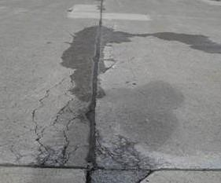

Fig.DurabilityCrackingor'D'CracksFailureinRigidPavements

# CHAPTER-5

## HillRoads

Definition:

The term hill road can be explained with reference to the cross slope, i.e., the slope approximately perpendicular to the centreline of the highway alignment. Thus, a road is termed as a hill road if it passes through a terrain with a cross slope of 25% or more and itis characterized by widely differing elevations, deep gorges, a number of watercourses, and steep slopes. The hill roads are also sometimes referred to as ghat roads.

IMPORTANCEOFHILLROADS

Therearepossiblytwomodesoftransportformountainousorhillyareas,namely,roadsandrailways. Thechoicebetweenthetwoshouldbe basedontherelativeeconomicsandthefollowingfactorsare certainly in favour of hilly roads:

1. Developmentin stages: A road of small width involvingless expenditure can open outthe area of immediate economic development and the improvements in the roadway system can be carried out as and when the traffic develops.
2. Initial cost: There is no doubt that the initial cost of construction of railways is much more than that of roads in hilly areas.
3. Length: The roads can be constructed with comparatively steeper grades which will result in the reduction of the length of road as compared to the length of the railway track required with milder slopes for rail traction for the same height.

The importance of hill roads can be imagined by understanding the following purposes which they serve:

* 1. Economic development: The hilly areas are backward as far as modern civilization, culture and education are concerned and hence, they require tremendous economic development. The main activity of the people in these areas is agriculture. The lands in hills are ideally suited for a variety of crops like the apples, apricots, cherry, etc. among fruits and potatoes, ginger, etc. among the vegetables. If these paying crops are grown in place of maize and other local food-grains and economicallytransportedoutside,theeconomiclifeofthepopulationcanbeconsiderablyimproved.
  2. Forestwealth:Thehillyareascontainhugeforestwealth

in the form of structural and other timbers, minerals,stones, etc. and all these items form the basic valuablesfor developing the country as a whole and the hilly areasin particular,provided there isan efficient transportation system for carrying these valuables to the plains from where they can be processed and sent to the consumers.

* 1. Industrial development: There are certain areas of hills which are ideally suited for growing tea andjuteandforbringingupsilk-worms.Thepresenceofroadscanhelpinsettingup oftheindustries of these products in the hilly areas.
  2. Strategic considerations: In case of an emergency such as war, a well layout system of roads in hilly areas helps considerably for moving the army from one place to the other.
  3. Tourism:Someofthehillyareaspresentimmensenaturalscenicbeautywhich attracts thousands oflocalandforeigntourists.Theconstructionofhillroadsisprobablythemaincontributingfactorfor thedevelopmentof tourismallalong theHimalayasfromGulmargtoDarjeelingandother important hill stations of our country.

**BASICPRINCIPLESOFPLANNINGOFHILLROADS**

Inabroadsense,themainaimofplanningahillroadistoestablishtheshortest,mosteconomicaland saferoutebetweentheobligatorypoints,andtoachievethispurposesuccessfully,thefollowingbasic principles are to be observed in the planning of hill roads:

* + 1. Constructionwork
    2. Existingroutes
    3. Intensityoftraffic
    4. Masterplan
    5. Naturalclimaticconditions
    6. Useof contours.

1. Construction work: The construction of hill roads requires considerable period and greater funds as compared to the roads in plains because it involves items such as parapets to demarcate

the roadway boundary, rock cuttings in difficult regions, provision of erosion control measures, greater number of drainage crossings, etc. It is therefore advisable to plan the construction work in stages over a number of years in such a way that each stage of construction improves upon the previous construction stage so as to bring it upto the requirements of the developing traffic.

1. Existingroutes: The existingpedestrianandmuletracksor goodanimalbeaten trackspresent the mostconvenientroutes for further improvements andextension and hence,itis one of the essential principles in hill road planning that maximum use should be made of such existing routes. They may however be suitably modified as the traffic requirements increase.
2. Intensityoftraffic:Forthepurposeofplanning,thehillroadsmaybecategorizedasjeepableroads and motorable roads from the view point of intensity of traffic. These roads may then be converted intoNationalHighways,StateHighways,etc.dependingupontherelativeimportanceinthewholeset upofplanning.Thejeepableroadsarenarrowinwidth,havecomparativelysharperbendsandsteeper grades and they can be traversed by jeep cars only. The motorable roads can be used by the commercial vehicles in the hilly area. It may be a good policy to aim at jeepable roads first and to providemotorableroadsatalaterstageafterstudyingthepossibilityofprovidingnecessarystandards of geometric design and construction.
3. Masterplan:It isadvisabletodrawamasterplanfor thedevelopmentofthewholehillyareaand work out the priorities instead of starting the work haphazardly. It may avoid the tremendous economic loss in the form of more construction and operation costs due to greater lengths covered by the haphazard planning.
4. Natural climatic conditions: It is necessary to explore the natural climatic conditions of the hilly area before the planning of road alignment. It is observed that the sunny side of the hills above a height of about 4500 m and the shady side of the hills above a height of about 3600 m are covered withsnow.Nowthesnowmeltsquicklyonthesunnysidesascomparedtotheshadysidesofthehills. Itisthereforeadvisable,asfaras possible, toalignthe roadon the sunnyside of thehills.In asimilar

way,theconvenientslopesareavailablealongtherivervalleysanditisthereforeeconomicaltocarry thealignmentalongtherivervalleys,asfaraspossible.Thehillyareassubjectedtoheavywindshaving velocity exceeding 100 km p.h. should also be located and avoided, as far as possible.

1. Useofcontours:Whenavirginhillyareaistobeexplored,theuseofcontourmapsshouldalsobe made. It should always be kept in mind that whatever height has been gained should never be lost. For instances, let us say that a ridge has to be crossed to go to a valley beyond it. It is then essential to touch the most convenient lowest points on the ridge to have the minimum length of road.

**ALIGNMENTOFHILLROADS**

Thesuccessandutilityofahillorghatroaddependonitsproperalignment.Itis,therefore,necessary toexercisegreatcareinfixingthealignmentofhillroads.Agoodalignmenthasthefollowingfeatures:

* 1. Itachievestheminimumcostsofconstructionandmaintenance.
  2. It allows comfortable travel and the expenditures on motive power, as well as wear and tear of vehicles, are also greatly reduced.
  3. Itcontainssharpcurveshavingsmall radius.
  4. Itgivesastableandsaferoad.
  5. Itgrantstheeasiest,shortest,andmosteconomicallineofcommunicationbetweentheobligatory points or important centers to be connected by the hill road.
  6. Ithasthegradientaseasyaspossible.

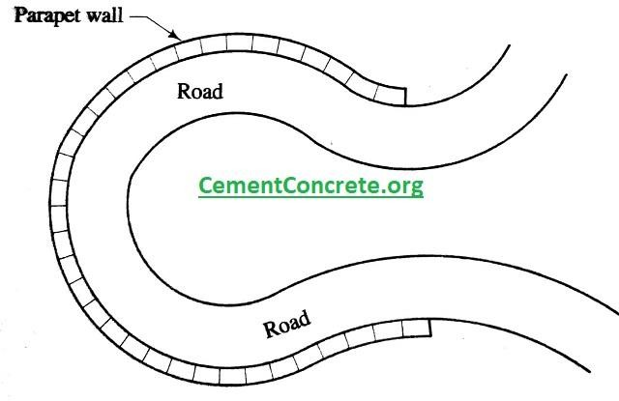

Fig.1.HairpinBendusedforHillroad

In general, it can be stated that the best and most convenient alignment will be the one having the minimum ofcutting and filling;andaminimum ofwalling andbridging. Inmanycases, the alignment of the hill road contains two types of sharp curves known as hairpin bends and corner bends. Fig. 1 shows the hairpin bend and fig. 2 shows the corner bend.

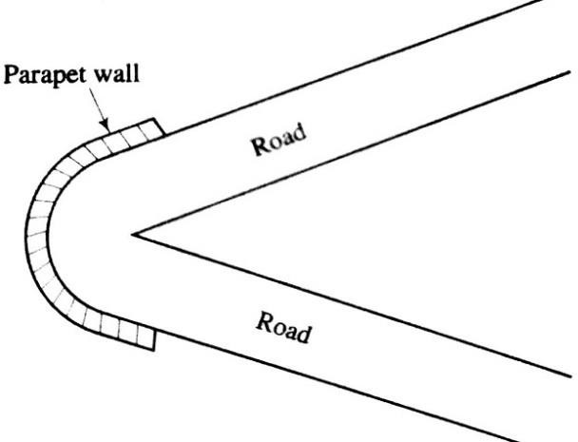

Fig.2.CornerbendusedinHillroaddesign

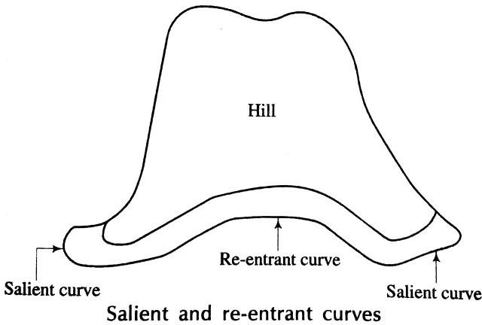

Fig.3.Salientandre-entrantcurveusedinhillroaddesign

If the side of hill contains ridges and valleys, it will have to be provided with salient and re-entrant curves. A salientcurve is a convex curve with its convexity on the outer edge of the road atthe ridge of hillside. A re-entrant curve is a concave curve at the valley of the hillside. Fig. 3 shows the salient andre-entrantcurves.Duetotheseridgesandvalleys,thevisibilityonahillroadislessandthetraffic has to be very careful while negotiating the salient and re-entrant curves in succession. Otherwise, therearechancesoffatalaccidentstooccuratthesepoints.Toimprovethevisibilityatasalientcurve, some portions of the hill may even be cut down.

**PROTECTIVEWORKSFORHILLROADS**

Inordertogivestabilityandasenseofsafetytothehillroads,thefollowingthreetypesofprotective works are provided:

1. Retaining walls
2. Breastwalls
3. Parapetwalls.

**Retainingwalls:**

Theformationof ahill roadisgenerallypreparedbytheexcavationofthehill andthematerialwhich isexcavatedisdumpedorstackedalongthecutportion.Theretainingwallisconstructedonthevalley sideoftheroadwayto preventthe slidingofbackfillingasshowninfig.5.Thus themainfunctionof a retaining wall for hill roads is to retain the back filling and it is provided at the following places:

atallre-entrantcurves;

atplaceswherethehillsectionispartlyincuttingand partlyinembankment;and at places where the road crosses drainage.

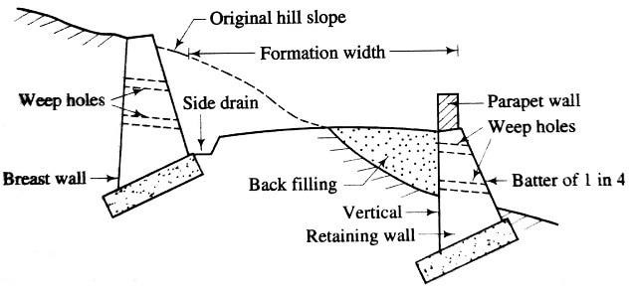

Fig.5.Retainingwallandbreastwallforprotectiveworksforhillroad

Wherestonesareeconomicallyandeasilyavailable,itiscustomarytoconstructtheretainingwallsin drystonemasonryasitpermitseasydrainageofseepingwater.Thedesignofretainingwallsisbased onrules-of-thumbandtheperformancesofsimilarexistingretainingwalls.Theminimumwidthof600 mm is kept at the top. The rear side is kept vertical. The front side is provided with a batter of 1 in 4. If the heightof the retaining wall exceeds6 m or so,the bands of coursed rubble masonry in cement mortaratverticalandhorizontalintervalsofabout3mareconstructedtograntadditionalstabilityto the wall.

Tofacilitatethedrainageofthewaterbehindtheretainingwall,suitableweepholesatverticalheight of 1 m and horizontal spacing of 1.2 m are provided with slope outwards.

**Breastwalls:**

Thecutportionofhillistobepreventedfromslidingandthewallwhichisconstructedforthispurpose is known as breast wall. See fig. 5. The breast walls are provided with a front batter of 1 in 2 and a back batter of 1 in 3. The back batter may be provided either in one straight batter or in the form of projections.Iftheheightofthewallislessthan2m,theentiresectionismadeinrandomrubblestone masonry. If the height of wall exceeds 2 m, the top portion of 2 m height alone is made in random rubble masonry and the remaining portion is constructed in cement mortar of proportion (1:6).

The weep holes, as in case of retaining walls, are provided with slope outwards and sometimes, the vertical gutters connecting the weep holes to the side drain are provided.

**Parapetwalls:**

Theparapetwallsareusuallyprovidedallalongthevalleysideoftheroadexceptwherethehillslope is verygentle. They are constructed immediately above the retaining wall,as shownin fig.5 and they prevent the wheels of the vehicles from coming on the retaining wall. It is to be noted that the constructionofaparapetwallmerelygivesasenseofsecuritytothedriverandthepassengersandit

is very rare unless constructed in stone masonry with cement mortar that they act as protecting structures in the event of an accident.

The parapet walls are usually of wall type with uniform thickness of 600 mm and height of 600 mm abovethebermlevel.Theycanalsobe constructedof R.C.C.postsof 150 mmx150mmsection with 1mheightabovegroundleveland450mmbelowgroundlevelandspacedat1mcentretocentre.In case of hard rocky stratum, the parapet walls may be replaced by the railing of cast-iron.

**DRAINAGEINHILL ROADS**

Therainfallsveryheavilyon thehillsand as theslopes of hillsarequitesteep, the waterreaches the roadsideveryquicklyandcreatesdrainageproblems.Thewaterthuscollectedshouldbedisposed-off in a proper way through the well-planned and designed drainage system.

1. Sub-surfacedrainage:

Theseepageflowofwateronhillscreatesproblemsduringandaftermonsoons.Thelevelofseepage watermaybeat,above,orbelowtheroadleveldependinguponseveralfactorssuchasdepthofhard stratum and its inclination, the quantity of underground flow of water, etc. The seepage flow also causestheweakeningoftheroadbedandthepavementanditalsocausesproblemsofslopestability. It is, therefore, necessary to control the seepage flow by adopting the suitable method of the sub- surface drainage system.

1. Surfacedrainage:

Forcarryingthesurfacewater,thesidedrainsareprovidedonlyonthehillsideoftheroad,asshown infig.5.Thereislimitationintheformationwidthof roadandhence, thesedrainsareconstructedof suchashapethatthevehiclescouldutilizethespaceofsidedrainsincaseofanemergencyforcrossing or parking. The side drains are usually of the following three types:

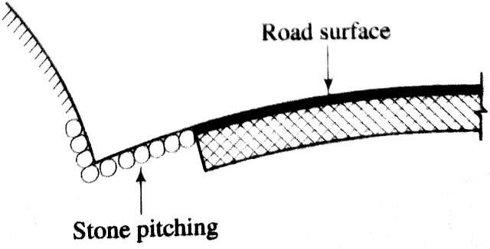

Fig.6.Anglesidedrainforhillroaddrainageworks angle side drains as shown in fig. 6;

kerbandchannelsidedrainasshowninfig.7;and saucer side drain as shown in fig. 8.

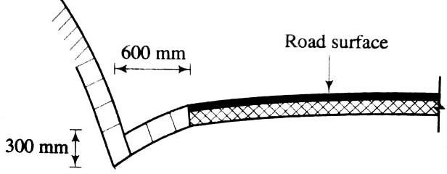

Fig.7.Kerbandchannelsidedrain

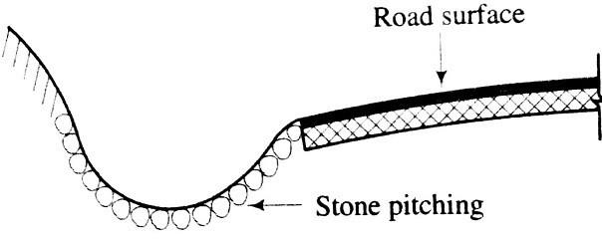

Fig.8.saucersidedrain

In order to prevent the side drains from overloading and thereby causing the road surface flooding, the following two measures are taken:

provisionofcatchwaterdrainorinterceptingditchabovethesidedrain;and

suitablecross-drainageworktodivertthewaterthroughtheroadondownsideofthehill.

Fig. 9 shows the layout plan of catch water drain, sloping drain and cross-drainage work. The water from the hill slope is intercepted and diverted through the catch water drains which are running parallel to the roadway.The catch waterdrains areusuallyprovidedwithagradientof 1 in 50 to 1in 33toavoidhighwatervelocityandpossiblewashout.Thewaterfromthecatchwaterdrainsisledto the cross-drainage works through the sloping drains.

catch water drain and cross-drainage work for hill side roadFig.9.catchwaterdrainandcross-drainageworkforhillside road

The cross-drainage works are in the form of culverts, scuppers or causeways. They are constructed undertheroadandusuallyatrightangletoit.Forcollectingthestonesanddebrisandforpreventing scour,thecatchpitsmaybeprovidedattheheadofsmallcrossdrains.Thefloorlevelofcatchpitmay be kept about 300 mm below the sill of the culvert.

MAINTENANCEOFHILLROADS

Thehillroadsbecauseoftheirpeculiarlocationrequirecarefulattentionintheirmaintenance.Forthe purposeofconvenience,themaintenanceproblemsofthehillroadscanbegroupedintothefollowing four categories:

1. Controlofavalanches
2. Drainagestructures
3. Preventionoflandslides
4. Snowclearance.

Eachoftheabove categorywillnowbebrieflydescribed. Control of avalanches:

An avalanche indicates a large mass of loosened snow, earth, rocks, etc. which suddenly and swiftly slides down a hill. Where there are chances for an avalanche to occur, suitable remedial measures may be adopted so that minimum damage occurs to the road structures. One of such preventive measurewhichiscommonlyadoptedistheconstructionofgalleriesabovetheroadwhichpermitthe avalanche to slide over the gallery roof without inducing impact loads.

Drainagestructures:

The drainage structures such as catch water drains, catch pits, side drains and culverts are to be periodicallyinspectedandcleanedoffallthedebrisandblockageswhichpreventthesmoothflowing of water in such structures during rains.

Asaprecautionarymeasure,theupperslopesareplantedwithtreesto reduce considerablyscouring action of unstable ground due to rains.

Preventionoflandslides:

The term land slide is used to indicate the downward and outward movement of slope-forming materials composed of natural rock soils, artificial fills or combinations thereof. The landslides move along the surface of separation by falling, sliding and flowing.

Whentheshearstressesexceedtheshearstrengthofthesoil,themovementintheformoflandslide occurs. Hence, anything which contributes towards a decrease in shear strength of the soll or an increase in the shear stress can cause a land slide.

Thedecreaseinshearstrengthof thesoiltakesplace mainlyduetothe followingcauses: decrease in inter-granular pressure;

formationoffaultsinbeddingplanesofstrata:

hair-crackingduetoalternateswellingandshrinkageofthesoil structure;

increaseinwatercontentandconsequentswellingandincreasein porewaterpressure; seepage pressure of percolating ground water; etc.

Snowclearance:

Thedepthofaccumulatedcompactedsnowontheroadsurfaceinwinterposesaseriousproblemfor its early removal to restore traffic. In the case of heavily snow bound areas, it becomes difficult for thesnowclearingpartytolocatethepositionof theroadandotherstructuresunder thesnowcover. For this purpose, the snow markers which are in the form of wooden posts with their height marked inmetersarefixedbeforethewinterstartsalongtheroadnexttotheparapetwallstomarktheouter edge of the road.

The snow clearance is done with the help of machines and extreme care is taken to see that the top surfaceoftheroadisnotdamagedbythemovementofsuchmachines.Thecommonlyusedmachines are motor graders, snow blasts, or wheel dozers. If the thickness of snow is more, the blasting by explosivesmayalsobeadopted.Ontheotherhand,ifthethicknessofsnowisless,thesnowclearance can be carried out by manual labor only.

# CHAPTER-6

## RoadDrainage

**ImportanceofHighwayDrainage:**

HighwayDrainageisrequiredtomitigatetheeffectsduetowaterand moisturevariationthatare listed below as:

* Roadsurfacebecomessoftandlosesitsstrength.
* Roadsubgrademaybesoftenedanditsbearingcapacityisreduced.

Variationinmoisturecontentinexpansivesoilcausesvariationinthevolumeofsubgrade and thus failure of road.

* Presenceofmoistureatfreezingtemperaturemaydamageroadduetofrost action.
* Erosionofsideslopes,sidedrainsandformationof gulliesmayresultifproperdrainage conditions are not maintained.
* Flexiblepavement’sfailurebyformationofwavesandcorrugationsisduetopoor drainage.
* Formationofpotholes.
* Failureofrigidpavementbymudpumping.

**RequirementsofHighwayDrainageSystem:**

* Surfacewaterfromthe carriagewayandshouldershouldbeeffectivelydrainedoffwithout allowing it to percolate to the subgrade.
* Surfacewaterfromtheadjoininglandshouldbepreventedfromenteringtheroadway.
* Thesidedrainshouldhavesufficientcapacityand longitudinalslopetocarryawayallthe surface water collected.
* Seepageandothersources ofundergroundwatershouldbedrainedoffbythe sub-surface drainage system.
* Highestlevel ofgroundwatertableshouldbekeptwell belowthelevel ofsubgrade, preferablyby at least 1.20m.

**ComponentsofHighwayDrainageSystem**

* 1. SurfaceDrainageSystem
  2. SubsurfaceDrainageSystem

**SurfaceDrainageSystem**

A part of rainwater falling on the road surface and adjoining area, is lost by evaporation and percolation. The remaining water is known as surface water. Removal and diversion of this surface waterfromhighwayandadjoininglandisknown assurfacedrainage.Thewaterfromthepavement surface is immediately removedby providing camber andcross slope tothe pavement. The camber and slope depend upon the type of the pavement and the intensity of rainfall. The road surface is made impermeable to prevent infiltration of water.

**CollectionofSurfaceWater**

Thesurfacedrainagemaybedividedintothreecategoriesas:

1. Drainageinruralhighway

There is the provision of side drains in these areas which are generally open, unlined and trapezoidal cut to suitable cross section and longitudinal slopes. Camber is applied to the pavement to drain the surface water and has to drain across the shoulders which are provided with more cross slope. Usually, drains are provided on one or both sides in embankmentswhiledrainsareprovidedonbothsidesincaseofroadswith cutting.Open drainsaredangerousintheplaceswherespaceisrestrictedincutting andhencecovered drains are used with layers of coarse sand gravel.

1. DrainsinUrbanStreet

Inurbanroads,undergroundlongitudinaldrainsareprovidedduetothelimitationofland width, the presence of foot path, dividing island and other road facilities. This is provided where there is lesser number of natural water courses and in the presence of impervious surfaces. Water is collected in the catch pits at suitable intervals and lead through underground drainage pipes.

1. Drainageinhillroads

In hill roads, there are complex drainage problems. Water flowing down the hill has to be efficiently intercepted and disposed of downhill side by constructing suitable cross drainage works. Catch water drains at the upper hill side, sloping drains and cross slopes areprovidedtodrainout thewaterwhereassidedrainsareprovidedonlyatthehill side. If hill roads are not properly drained,rockslides and slipsmay occur blocking the road during monsoon season. The shape of the side drains is made in such a way thatvehicles can park

atthatspaceduringemergency,crossingorparking.

**Differenttypesofroadsidedrain**

Onthebasisof theshape ofdrain,theroadsidedrain mayberectangular,trapezoidal,triangular or semi-circular. The type of drain may be angle drain, saucer drain or kerb and channel drain as mentioned earlier.

*CrossDrainageStructures*

Crossdrainagestructuresarethosestructureswhichareprovidedwheneverstreamshavetocross the roadway facility. The water from the side drains is also often taken across these structures in order to divert the water away from the road to a water course or a valley.

*Culverts*

A closed conduit placed under the embankment to carry water across the roadway is termed as culverts.InNRS2070,culvertsarethebridgingstructuresoflinearwaterwayspanlessthanabout 6m. It is extensively used in road drainage system. In fact, more than 75% of the cross-drainage structures are culverts. A culvert is more hydraulically efficient than minor bridge and discharge through a culvert is more than a minor bridge

Functionsofculverts

Thefunctionsofculvertare:

* Collectionandtransportof wateracross theroad so astonotcause damagetotheroad bank or the stream bed by scouring.
* Toprovidesufficientwaterwaytopreventheadingupofwaterabovetheroadsurface.

*Bridge*

Abridgeisastructureconstructed overwatercourse tocarrytrafficoverit.InNRS2070,bridges are the structures having linear waterway span more than about 6m.

Onthebasisofconstructionmaterials

* Steelbridges
* Concretebridges
* Timberbridges,etc.

Onthebasisofstructuralpointof view

* Cantileverbridges
* Suspensionbridges
* Movingbridges,etc.

**Causeway**

Theyareconstructedinstead ofculvertsonlessimportantroadswherethe maximumflowofdepth does not exceed 1.5m which saves the construction cost. During the flood, the water flows over

theroadand trafficon both sidesisstoppedbutassoonastheflood recedes,thetrafficflowis resumed.

Bed slope of the causeway in estimating the span should not generally exceed (4-5) % in order to preventthevehiclesfromskiddingandoverturningdownstream.Thedepthofflowinmostofthe period of the year should not exceed 30cm.

**InvertedSiphon**

Theinvertedsiphonisastructurewhichlowerstheinvertleveloftheconduitto thedesiredlevel and both inletand outletpits are provided to receive flow from the drain and discharge water to the downstream drain respectively. . It is generally provided when the provision of culvert and aqueduct is not possible.

**Sub-SurfaceDrainageSystem:**

* Stabilityandstrengthoftheroadsurface dependsuponthestrengthofsubgrade.
* Withincreaseinmoisturecontentthestrengthofthesubgradedecreases.

The variation in moisture content of subgrade is caused by the free water and the ground water. Everyeffortisneededtoreducethemoisturecontent toaminimum.Fromusualdrainagesystem, only gravitational water can be drained by the provision of subsoil drainage.

**Drainageofinfiltratedwater**

* During rainy seasonandsnow melting season,water will findits way tothe subgrade soil throughthepermeablesurfaceof theadjoiningland,carriageway,shoulder,sideslopeand cracks.
* Removal of such infiltrated water from the subgrade may be accomplished by the arrangementsshowninfiguresbelow.Thecontrol ofsubsurfacewaterisclassifiedunder three headings:
  1. Controlofseepage flow
  2. Loweringofwater table
  3. Controlofcapillaryrise Control of seepage flow
     + Seepagemayoccurfromthehighergroundinhillytopographyorinroadcuttingswherea layerof permeable soil overlies an impermeable stratum which affects the strength characteristics of the subgrade.
     + Thebestsolution to thistypeofproblemwouldbetointercepttheseepagewateronthe uphill side of the road.
     + Iftheseepagelevel reachesadepthlessthan 60-90 cmfromtheroad subgrade,itshould be intercepted to keep seepage line at a safe depth below the road subgrade.

**Loweringofwatertable**

* + - Thewatertablemayriseandmaycomeup tothepavementlayersinlowlyingareasduring rainy

seasonswhichbecomeveryharmfultothepavementandthesubgradeespeciallywhen the

subgradeismadeoffinegrainedsoils.Therefore,it becomesnecessarytolowerthewatertable safely below the pavement.

* + - Iftheundergroundwater tableis morethan1.2mbelowthesurfaceof theroad,itdoes not require any subsurface drainage but when it is less than 1.2m the best measure would be to raise the road formation.
    - Thewatertableisloweredtothedesireddepthbyprovidingsubdrainsoneithersideof the road. It may be possible to lower the water table by merely constructing longitudinal drainage trenches with drain pipes and filter sand if the soil is relatively permeable.
    - Butifthesoil isrelativelylesspermeable,thewatertableloweredatthecentreof thepavement orbetweenthe two longitudinal drainsmay notbeadequate. Thus, transversedrainsmayhave to be provided in order to effectively drain off the water and lower the water table.
    - Thedepth towhich thedrainsshouldbe laiddependsuponthe widthof theroadway,amountof water table to be lowered, type of subgrade soil and lateral distance between the trenches.
    - Thepipeinthedrainagesystemshouldbelaidsuchthatsiltingandscouringdonotoccur.
    - Formaintenanceofthesesystems,manholesandinspectionchamberscanbeprovided.

**Controlofcapillaryrise**

In water logged sections, there will be possibility of rising of water to the subgrade level due to thephenomenonof capillaryactionwhichaffectsthe strengthofthe subgrade.Thus,capillarycut

offmeasuresneedstobeprovidedto freethesubgradefromtheexcessivemoisture.Ifthesubgrade soil is of permeable type, the lowering of water table is economical but in case of retentive type of soil, drainage becomes very difficult and costly. In these cases, capillary cut offs become more economical. There are two types of capillary cut off:

1. Granularcapillarycutoff:
   * Provisionofgranularmaterialofsuitablethicknessbetweenthesubgradeandthe

highestlevelofsubsurfacewatertableduringtheconstructionofembankment.

* + Thegranularcapillarycutofflayer’sthicknessshould besufficientlyhigherthan the anticipated capillary rise within the granular layer so that the capillary water cannot rise above the cut off the layer.
  + Suitablesandblanketandgravelblanketcanbeusedforcutoff.

1. Impermeablecapillarycutoff:
   * Provisionofimpermeablemembranesuchasprefabricatedbituminizedsurfacing is used instead of granular blanket.
   * Bitumenstabilizedsoil,heavydutytarfeltorheavy-dutypolytheneenvelopecan also be used.

# CHAPTER-7

## RoadMaintenance

Highway (road) maintenance is defined as preserving and keeping the serviceable conditions highwayasnormalaspossibleandpracticable.Themainobjectivesofroadmaintenancemenare the allocation of available maintenance resources according to actual needs and priorities. If the maintenance works are not done at all or done faulty or the pavement structure inadequate for present-day and loading.

**TypesofPavementFailure**

Someofthetypesofpavementfailureare:

**A.Cracking:**

* Crackingisoneofthemostcommon typesofpavementfailure.Thenatureofthecrack itself is fast spreading.
* Crackingisusuallycausedduetouseofimpropermaterialmixduringconstructionand settling of the subgrade or base during operation.

Severalcrackinginthepavementare:

1. ***AlligatorCracking:***
   * Alligatorcrackingisthecrackingthatisassociatedwithloadandstructuraldistresses.
   * Thesecracksareextensivelyfoundatintersectionswherethevehiclesarestoppedfora relatively long period because these cracks start to form when the sub-grade and base compress due to the excessive imposed wheel load.
2. AlligatorCrackinginFlexiblePavement

CausesofAlligatorCrackinginFlexiblePavement

* + Weaknessinbase,surfaceorsub-grade
  + Thinningofasurfacecourse orbase course
  + PoorDrainage
  + Excessivevehicularloads
  + Vehiclestoppedforarelativelylongperiod

#### Repairof Alligator Cracking inFlexiblePavement

* + 1. Determinetheprimarysource oftheproblemandthebestwaytorepairit.
    2. Ifaproblemisseenonthesurfacecourse,thecrackfilleris applied.

1. Iffailureisduetoweakeningofbaseorsub-base course,cuttheaffectedpavementareainto rectangular or square shapes. Then patch it like a pothole.

b.AlligatorCrackinginRigidPavement

CausesofAlligatorCrackinginRigidPavement

1. Weakeningofbase
2. Poordrainage
3. Poorqualitymaterialmixor use.

RepairofAlligatorCrackinginRigidPavement

1. FullDepthPatching:

Itisawidelyusedmethodfortreatingalligatorcracksinrigidpavementsandrestoringthestructural stability and rideability of the pavements.

Itincludesthefollowingseriesofsteps:

* 1. Definingrepairboundaries:

Theboundaryof thearea toberepairedmustbefirstdefinedbysurveyingtheregion.

* 1. Sawingoldconcrete:

Full-depthsawcutsfacilitatetheseparation ofdamagedconcretefromtheadjacent concrete with minimal damage.

* 1. Removingoldconcrete:

Concreteremovalcanbecarriedouteitherbyliftoutorbreakup.Liftingsawedconcreteis faster, requires less labor, and also doesn’t cause any significant damage to the adjacent layers.

Insomecases,liftingconcretecan berisky,andinsuch asituation,thedeteriorated concrete is broken into smaller fragments and removed by backhoe or hand tools.

* 1. Preparingthepatcharea:

Afterremovingoldconcrete,thearea tobepatchedis prepared.Iftheareacontainswater, it must be pumped out and cleaned correctly.

* 1. PlacingandFinishingnewconcrete:

Placingthenewconcreteisusuallydonebyready-mixtrucksor othermobilebatchvehicles. Concrete must be evenly distributed and spread. Using the finishing tools, the placed concrete is finished.

1. BlockCracking:

Blockcrackingisanothercrackingseenonhighwaypavementsthatformabox-likecrackon the surface.

Thistypeofcrackingisassociatedwiththeunusualexpansionandcontraction ofconcreteinthe rigidpavementandduetoimpropermixing oraging ofasphaltorpoor qualityasphaltinflexible pavement.

Blockcrackingismainlycausedbyshrinkageoftheasphaltorconcreteand dailytemperature cycling, and it is not load-associated.

1. **BlockCrackinginFlexible Pavement**

**Causes**

* 1. Useofimpropermix
  2. Fineaggregatesmixedwithlowpenetrationasphalt
  3. Poorasphaltbinder
  4. Ageingofasphalt
  5. Temperaturecycling

**Repair**

Thequickerthiscrackingisdetected,theeasieritbecomestorepair.

Thesealingmethodofrepaircanbeusedfor crackslessthan½inchorlesser.

Inseverecracks,thedeterioratedpavementmustberemovedandreplacedbyanoverlay.

1. **BlockCrackinginRigidPavement**

**Causes**

* 1. Useofimpropermix
  2. Lackofexpansionjointsinthepavement
  3. Temperaturecycling

**Repair**

Ifthecrackislessthan1/2inch,flexiblefillerscanbeusedtofillthecracks.

Ifthecrackislargerthan1/2 inch,theaffectedsection oftheroadisremovedandreplacedbyan overlay. Sometimes, joining of the sections with metal plates also can be done if traffic is low.

Toeliminatetheproblemofblockcracking,itisbetter toprovideexpansionjointsatregular intervals.

1. **LinearCracking:**

Linear cracking is the common type of crack seen parallel to the roadway. Thesearegenerallyassociatedwithfatigueandweakpointsofthe pavement. It is also known as longitudinal cracking.

**Causes**

* 1. Pavementfatigue
  2. Reflectivecracking
  3. Poorconstructionofjoints

**Repair**

Itcanberepairedbysealingorreplacement.

Forlessseverecracks,sealingofthecracksmaybedone.

Forseverecracks,replacementbyanoverlaymaybecarried out.

1. **EdgeCracking:**

Edgecrackingisthetypeof crack thatisusuallyformedattheedgeof highwaypavements. These cracks are typically associated with the ingress of water in underlying layers.

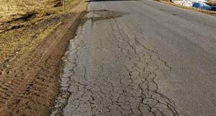

Figure:EdgeCracks

**Causes**

1. Lackofsupportatedgesofpavement
2. Poordrainagecondition
3. Heavy vegetation
4. Heavytrafficalongsidetheedgeofthepavement

**Repair**

Theinitialstepforrepairingtheedgecracksisremovingthevegetationsfromtheedgesof pavement and fixing all the issues of drainage.

Sealingofcrackscanbedone topreventfurtherdamage.

1. PotHoles:

Potholesarethetypeof flexiblepavementfailurethatcanbeseenassmalldepressionsonthe surface of the pavement and can penetrate deep up to the base course.

Thesearegenerallyassociatedwithinfiltrationandalsoresultsfromalligatorcrackifnottreated properly.

Generally,severealligatorcracksthatareleftuntreatedcreatesmall fragmentsofpavementand when vehicles ride over them results in the formation of potholes.

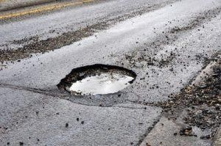

Figure:Pot Hole

**CausesofPotHoles**

1. Pavementfatigue
2. Untreatedalligatorcracks

**RepairofPotHoles**

Thepotholescanberepairedbypatchworkwhichincludesthefollowingsteps:

1. **RepairforConcrete Roads**

Thea.Definingrepairboundaries:

boundaryoftheareatoberepairedmustbefirstdefinedbysurveyingtheregion.

* 1. Sawingoldconcrete:

Usingfull-depthsawcuts,thedamagedareaisfirstisolatedfromtheremaining area.

Full-depthsawcutsfacilitatetheseparation ofdamagedconcretefromtheadjacent concrete with minimal damage.

* 1. Removingoldconcrete:

Theremovalofconcrete canbecarriedouteitherbyliftoutorbythebreakup.

Liftingofsawedconcreteisfaster,requireslesslabourandalsodoesn’tcauseanysignificant damage to the adjacent layers.

Insomecases,liftingofconcrete canberiskyandinsuchasituation thedeteriorated concrete is broken into smaller fragments and removed by backhoe or hand tools.

* 1. Preparingthepatcharea:

Aftertheremovalofoldconcrete,theareatobepatchedisprepared.

Iftheareacontainswater,itmustbepumpedoutandcleanedproperly.

* 1. PlacingandFinishingnewconcrete:

Placingofthenewconcreteisusuallydonebyready-mixtrucksorothermobilebatch vehicles.

Concretemustbeevenlydistributedandspread.

Usingthefinishingtools,theplacedconcreteisfinished.

1. **RepairforFlexiblePavements**
2. Cleantheareaalongtheholewiththebroom.
3. Trimitverticallytoaregulargeometricalshapelikesquareorrectangle.
4. Levelthebottomof theholeandremovelooseaggregateandforeignmaterials.
5. Applytackcoatonbottomandsidesofholes.
6. Now,applythepatchinglayerandcompactitproperlybytapingorroller.
7. Ifthedepth ofthe holeisgreaterthan7.5cm,Patchinglayershouldbeprovidedin2ormore layers where each layer should be tamped or rolled properly.
8. **Depressions:**

Depressionindicatestheareaonthe surfaceof pavementsthathaveaslightlylowerelevation than the surrounding areas.

Theybecomeprominentlyvisibleafterrainfallduetotheaccumulationofwater. These are also referred to as birdbath.

**CausesofDepressions**

1. Uneventhicknessofsubsequentlayers
2. Unequalcompaction
3. Foundationsoilsettlement

**Repairof Depressions**

Incaseofseveredepression,theasphaltsurface hastobereplacedwhile forsmaller depressions patching of the area may be done.

1. **Rutting:**

Ruttingisatypeofpavementfailurethatresultsinthe formationofchannelizeddepressions particularly in the wheel track of pavement.

Twotypesofruttingparticularlythepavementrutting andsubgraderuttingmayoccur.

Withtime,thewheelofheavyvehiclesstartstocompacttheasphaltsurface therebyforming ruts.

**CausesofRutting**

1. Lateralmovementorconsolidationofconsecutivelayersundertrafficload
2. Insufficientlayerthickness
3. Lackofcompaction
4. Impropermix
5. Moistureinfiltration

**Repairof Rutting**

Ifminorruttinghasoccurred,therutcansimplybefilledandprovidedwithanoverlay.

Incaseofsevererutting,thedamagedareamustbeliftedoutandreplacedbyanewlayer.

1. **Corrugation&Shoving:**

Corrugationsrefertothedistressesthatoccuratregularintervalsintheformofridgesand valley on the surface of the pavement.

Theyrunalongthedirectionofthepavementitselfandareusuallylessthan5feet.

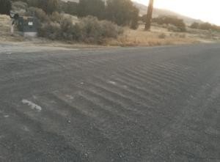Similardistressesthatrunperpendiculartothetrafficisknownasshoving.

Figure:CorrugationandShoving

**CausesofCorrugationandShoving**

1. Weakgranular base
2. Excessivefineaggregate
3. Excessivelyroundedaggregate
4. Extensivelysoftasphalt

**RepairofCorrugationandShoving**

Itmayberepairedbypartialorfull-depthpatchworkasincaseofalligatorcracking.

1. **Ravelling:**

Itisthetypeof pavementfailurethatoccurs duetocontinuousingressofwatertherebycausing degradation of the topmost asphalt layer.

Asravellingprogresses,theaggregateparticlesseparatefromthesurface andleavebehind eroded like patches on the surface of the pavement.

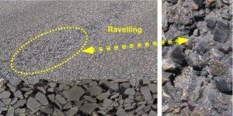

Figure:Ravellinginthepavement

**CausesofRavelling**

1. Excessivelyporousasphalt
2. Theuntimelyplacingofasphalt

**Repairof Ravelling**

Athinhot-mixoverlaymaybeprovided.Sealingofthe affectedareasmayalsobeeffective.

Highway(road)maintenanceisdefinedaspreservingandkeepingtheserviceableconditionshighway asnormalaspossibleandpracticable.Themainobjectivesofroadmaintenancemenaretheallocation ofavailablemaintenanceresourcesaccordingtoactualneedsandpriorities.Ifthemaintenanceworks arenotdone atall ordone faultyor the pavementstructureinadequatefor present-dayandloading.

# CHAPTER-8

## Construction Equipment

HOTMIXPLANT-DRUMMIXPLANT

Asphalt drum mix plant is also called “Hot mix plant”. The ultimate mixer of asphalt, concrete, fine aggregates, coarse aggregates & filler material together gives final result of drum mix plant output. Primarily for road construction, cold aggregate mixer from wet mix macadam plant is allowed to spread to form base & minimum level of road. And then this hot aggregate obtained from Drum mix plantisused mainlyto form finallayerofroad.Basicallythere aretwo different modesof working of plant.

1. BatchTypePlant
2. ContinuousTypePlant

FABHIND Company provides drum mix plant of different capacities ranging from DM:-30-90 TONS. Drummixplantconsistofcoldbinfeeder,dryingdrum,dustcollector,Burner,asphaltstoragetank& asphalt supply system. Drum mix plant is fully computerized plant with automated control panel.

DrumMixPlantTypes

Accordingtoitsstructure&specifications,Drummixplantismainlydividedintotwotypes:

1. MobileDrumMix Plant
2. StationaryDrumMixPlant

Ifclientneedssingleplantformultiplesiteuse&hasfiledtenderofdifferentcitiesthenmobileplant ismorereliableforthoseclients.Ifclientrequiresplantforbiggerprojectatsinglesiteforlongertime then stationary plant is more preferable. Mobile plant is equipped with wheeled structure in single frame to impart mobility easily to the plant, while stationary plant has quite different structure as it needs to be erected using solid foundation.

**HotMixPlantWorking**

DrummixplantworksonsimilarprincipleasAsphaltbatchmixplant,butthemaindifferenceisdrum mixplantdoesnot havetowerconsisting ofvibrating screen,hot bin, Pug mill mixer&hot aggregate elevator.InworkingmechanismofDrummixplant,themixerconsistingofdifferentsizeofaggregates & filler is allowed to dry & mixed with bitumen in drying drum. Hence both work of drying different sized aggregates & mixing them with hot bitumen is carried out in same unit i.e. drying drum, while batch mix plant is equipped with two separate units for carrying out these two activities i.e. drying drumfordryingpurpose&Pugmillmixtureformixingaggregatewithhotbitumen.Thisresultanthot aggregate mixture is transferred into loading trucks to reach at site of road construction.

**DrumMixPlantAdvantages**

Fully automatic plant equipped with control panel for operation. Due to variation in structure it can be moved to different sites. If one needs the aggregate continuously then it can be achieved with asphalt drum mix plant-Continuous model. As all components used are of high quality, less maintenance is needed. Easy to operate & highly reliable.

**Tipper**

Tippers are used for the transport of all these materials in road construction (road-site to dump and burrowor plantto road-site).Indams,hydropowerprojectsand canalwork,nature of workinvolved is essentially removal and relocation of earth on the sites to obtain the desired profile.

BENEFITSOFTIPPERTRUCKS

Liftheavygoodswithease –savingtheeffortofmanpower,tippertrucksdo theworkforyou,soyou don’thave to break a sweat. Depositheavy goods directly on site – thanks to the tipper feature, you candriveyourmaterialsdirectlytotheirrequiredlocationandunloadwithouthavingtodoityourself. Agile manoeuvrability – even with extremely heavy cargo, a tipper truck can transport and provide precise unloading. Cost-effective – hiring one tipper will cost a lot less than hiring several people to lift, carry and deposit heavy materials from one site to another. Variety of tipper options – tippers rangeinsize,from26tonnesto3.5tonnes,andplentyofotheroptionsinbetween–there’saperfect sized tipper for any job.

**Tractors**

Tractors are generally associated with farming as farmers use them alongside machinery to perform implementslikeploughing,tilling,sowing,andharrowing. Inaddition,a tractor isusedforpushing or pulling the machinery, thereby making the farming operations more convenient.

Excavator

Excavators are intermittent types of heavy construction equipment and are widely used in the constructionindustry.Excavatorconsistsofalongarm(boom),dipper,bucket,andacabmountedon a rotating platform known as the “house” which eventually sits atop an undercarriage with tracks or wheels.Itistheoldesttypeofmachinewhichremovesearth.Thegeneralpurposeofanexcavatoris excavation work butother than thatitis also used for differentpurposes like heavy lifting,digging of trenches, holes, foundations, river dredging, cutting of trees, etc.

Bulldozer

Bulldozers are very useful excavation equipment and can be used for the following tasks in construction work such as to clear the site of work, leveling the land, preparing pilot roads through mountainsandhardground,excavatingthematerial,andhaulingforadistanceofabout100meters.

In Bulldozer, most of the work is done by a sharp edge wide metal plate provided at its front. A bulldozer can be used on wet ground and in all conditions of climate.

WheelTractorScrapers

Wheeltractor-scraperalsosometimescalledabellyscraperisatypeofheavyconstructionequipment used for earthmoving. The frontsection consists of a wheeled tractor vehicle. The rear portion has a scraping arrangement consisting of a horizontal front blade, conveyor belt, and a collecting hopper (also known as the bowl).

Thecollectinghoppercanbehydraulicallyloweredandraised.Whenthehopperislowered,thefront edge of the hopper cuts the soil and fills the hopper.

When the hopper is full it is lifted and closed with a vertical blade (known as the apron) and finally, the soil is dumped to the respective place and this whole cycle is repeated.

MotorGrader

Graders also called motor grader is a type of heavy equipment used in construction, especially used for the construction of roads.

It is used to spread loose material, level the soil surface, build earth roads, and shape subgrade. It is either self-propelled or towed by a tractor.

DragLineExcavator

Adraglineexcavatorisanotherheavyequipmentusedinconstructioncommonlyusedforlarge-depth excavationandsurfacemining.Ithasalong-lengthboomandanexcavatorbucketissuspendedfrom the top of the boom using a cable.

PAVER:

The modern system of road and building machines is a complex of high-performance machines and mechanisms, of large and small capacity and productivity. Expansion of paved roads network of use of resource-saving technologies, increasing of pace and quality of work, ensuring reliability and durability of highways have a major impact on the development of road construction machinery. Modernpavermachinesareusedtolayasphaltonroads,bridges,parkinglotsandothersuchplaces. Itlaystheasphaltflat and providesminorcompaction beforeitiscompactedby aroller. Themodern pavermachinescomewithhydraulicloadinglegswhichextendtoallowforeasyloadingandtransport, coupled with the ability to change widths quickly. Discussed below are the different types of pavers machines used in road construction.

**Modernconstructionequipmentforroad INTRODUCTION**

Construction equipment have evolved as per changing requirements in the industry. Earlier for one jobmanyequipmentwererequiredbutnowoneequipmentcandomultiplejobs.Appropriateuseof equipment contributes to completion of project on time, work speed, quality, and most importantly economy.Itisnotalwayspossibleforthecontractorundergoingconstructionworkstoowneachand everytypeofconstruction equipmentrequiredforthe projectdue to complexityofproject,shortage ofskilledorefficientmanpower,projectinvolvinghandlingoflargequantityofearthmaterials,coping up with the time schedules,etc. However,one can purchase or hire the equipmentas per suitability. If the equipment has to be used frequently and for a long duration of time then it proves to be economicaltopurchasetheequipment.Onthecontrary,iftheequipmenthastobeusedoccasionally and for a short duration of time, it proves to be economical to get it hired.

**CLASSIFICATIONOFEQUIPMENTS**

Variousequipmentinvolvedinconstructionworksare-

1. **ExcavatingEquipment**
   1. **PowerShovel**
   2. **Hoe**
   3. **Dragline**
2. **HaulingEquipment**
3. **Earth-movingEquipment**
4. **HoistingEquipment**
5. **MobileCranes**
6. **TowerCranes**
7. **CrawlerMountedCranes**
8. **PassengerHoist**
9. **BuildersHoist**
10. **DredgingEquipment**
11. **ConveyingEquipment**
12. **CompactingEquipment**
13. **PumpingEquipment**
14. **PileDrivingEquipment**
15. **MaterialTestingEquipment**
16. **DrillingEquipment**
17. **Aggregate,concreteandHMA(HotMixAsphalt)productionEquipment.**

ExcavatingEquipment-Theseequipmentarecommonlyusedfordigging,excavatingandplacingearth materialstoadistantplace,toremovesnow,liftingpipes,gradingtheground,etc.Itconsistsofalong bucket arm attached to a cabin where the operator operates and can rotate by 3600 This is a large piece of equipment which is used for big jobs and it runs on tracks. It can also be used with different attachments, such as a clamshell attachment to pick up dirt and debris.

PowerShovel–Itisabucket-equippedmachine,usuallyelectricallypowered,usedfordigging,loading fragmentedrockorearthandforextractionof minerals.Mainpartsincludethetracksystem,cables, rack, stick, boom foot-pin, saddle block, boom, boom point sheaves, bucket and cabin.

Dragline–Itissonamedasits prominentoperationinvolvesdragging thebucketagainstthe material to be dug. It consists of long light crane boom where the bucket is loosely attached to the boom through cables. They are useful for digging below its track level and effective while handling softer materials. Here the basic parts include boom, hoist cable, drag cable, hoist chain, bucket and drag chain. It has long reach and also used for excavating canals and then depositing on embankments without use of hauling units.

Hoe–Itisalsoknownas back shovel or pull shovel.Itisusedtoexcavate beneath the naturalsurface onwhichitrests.Itisused forworkslikeexcavatingtrenches,diggingpitsforbasements,anditisalso used forgradingworkswhich needs precision in case of controlofdepths. Here the basic parts include boom, jackboom, boomfootdrum, boomsheave, sticksheave, bucket, bucketsheave and stick.

Dragline–Itissonamedasits prominentoperationinvolvesdraggingthebucketagainstthe material to be dug. It consists of long light crane boom where the bucket is loosely attached to the boom through cables. They are useful for digging below its track level and effective while handling softer materials.Herethebasicpartsincludeboom,hoistcable,dragcable,hoistchain,bucketanddrag

chain. It has long reach and also used for excavating canals and then depositing on embankments without use of hauling units.

Hauling Equipment– The equipment used for transporting material are known as hauling equipment orhaulers.Theymaybeoperatedonrailwaysorroadwayswhichinvolveoperationslikecarriageand disposal of earth materials, haulage of big construction equipment and transportation of building materials. It is also classified as dump trucks and dumpers.

Earth Moving Equipment-These equipment include excavators, loaders, motor graders, trenchers, backhoes and bulldozers. They are used to shift large amounts of dig foundations, landscape areas and dirt.

HoistingEquipment–Hoistingreferstotheliftingofa weightfromonelocationtoanotherlocationat a reasonable distance. These include jacks, winches, cranes and chain hoists. Crane is the only single piece machine capable of providing three-dimensional movement of a weight.

Mobile Cranes– Such type of cranes is mounted on mobile units which is either of wheel type or crawler type. Truck cranes are such having high mobility whereas the crawler mounted cranes move quite slowly. Crawler mounted cranes can move on rough terrain.

TowerCranes–Thesecranesarederrickcranemountedonasteeltower.Theyareusedforindustrial and high-rise residential buildings especially for assembly of industrial plants consisting of steel structures.Suchcranesresembletrussstructureswhicharemadebyweldingofsteelbarsandchannel sections. Basic parts include carriage, slewing platform, jibs and tower with operator’s cabin.

Crawler Mounted Cranes– These are the cranes which are placed on a set of rugged tracks that provides movement and stability for carrying heavy crane equipment. These crawler cranes are suitable for the rough surface area .Even though these cranes have no outriggers, they can operate lifts with minimal setup. Also, in addition to that they can move around easily. Crawler cranes can move around even with a heavy load.

Dredging Equipment– The choice of the dredging equipment for executing a dredging operation depends on conditions such as the weather, accessibility to the site and wave conditions, anchoring conditions, required accuracy and many more. They can dig hydraulically or mechanically. Hydraulic digging involves using of working of a water flow which is erosive in nature. It is mostly done in cohesionlesssoilssuchassilt,sandandgravel.Whereasmechanicaldiggingbyteethorcuttingedges of dredging equipment or knives is applicable to cohesive soils.

Conveying Equipment– Such equipment carry material in continuous stream with its distinct feature suchasendlessbeltor chain.Theyareused for transportingmaterialfromoneplacetoanotherover a structure which is stationary. They can proceed work horizontally, vertically or in inclined position. They are used in mining and construction industries.

Compacting Equipment– They can be of type such as smooth-wheel rollers, sheep-foot rollers and pneumatictyperollers.Suchequipmentsareusedtoexpelairfromasoilmasssoastoachieveahigh density. Smooth-wheel rollers are suitable for gravels and sand. Pneumatic-tired rollers are suitable forclayswithreasonablyhighmoisturecontent. Andsheepsfootrollersarethesuitablefor clayswith low moisture content.

Pumping Equipment– Pumping equipment are used to remove water from a volume of liquid, solid materialorsoil.Pumpsremoveliquidfromavolumeofliquid.Theycanbeusedforkeepingwaterout of foundations, pits, tunnels, and other excavations and many more.

Pile Driving Equipment– Such equipment units involve lifting the piles from ground while taking in positiontoaspecifieddepth.Heredrivingisaccomplishedbyhammeronpiletop.Equipmentsareso designed so as to remain economic while driving. Major pile driving equipment includes pile driving rigs and pile driving hammers.

Material Testing Equipment– It is frequently used in the quality control processes which are related with the analysis of soil, concrete, asphalt, bitumen, cement, mortar, steel, aggregates, and other materials used in construction. The mechanism in which the equipment performs analysis varies according to the material to be analysed. These testing instruments are capable of analysing the hardness, moisture content, permeability and other mechanical properties.



**LECTURE NOTES**

**ON**

**LAND SURVEY-II**

**Compiled by**

# Mr. RAJESH KUMAR BEHERDALAI

**Lecturer, Department of Civil Engineering,**

**GANDHI ACADEMY OF TECHNOLOGY AND ENGINEERING**

**CONTENT**

|  |  |  |
| --- | --- | --- |
| **Chapter No.** | **Topics** | **PageNo.** |
| 01 | TACHEOMETRY | 3-11 |
| 02 | CURVES | 12-95 |
| 03 | BASICSONSCALEANDBASICSOF MAP | 95-97 |
| 04 | SURVEYOFINDIAMAP SERIES | 97 |
| 05 | BASICS OF AERIAL PHOTOGRAPHY,PHOTOGRAMMETRY,DEM AND ORTHO IMAGE GENERATION | 98-99 |
| 06 | MODERNSURVEYINGMETHODS | 100-116 |
| 07 | BASICSONGPS&DGPSANDETS | 117-118 |
| 08 | BASICSOFGISANDMAPPREPARATION USING GIS | 118-119 |

### CHAPTER-1

#### General

Tachometry is the branch of angular surveying in which the horizontal and vertical distances of points are obtained by optical means as opposed to the ordinary slower process of measurements by tape or chain. The method is very rapid and convenient. Although the accuracyofTachometry in general compares un-favourably with that of chaining, it is best adapted in obstacles such as steep and broken ground, deep ravines, stretches of water or swamp and so on, which make chaining difficult or impossible.

The primaryobject oftachometry is the preparation of contoured maps or plans requiring both horizontal as well as vertical control. Also, on surveys of higher accuracy, it provides a check on distances measured with the tape.

#### Tacheometer:

1. Atacheometerisnothingmorethanatheodolitefittedwithstadiahair.
2. The stadia hairs are keptinthe sameverticalplaneas the horizontalandverticalcross hair.
3. Forshortdistanceupto100m,ordinarylevelingstadiamayused.
4. Accordingtomeasurementprocesssystem,itisclassifiedundertwocategories

*i.e.*1.Stadiahairsystem

2.Tangentialsystem

1. Thestadiahairsystemagaindividedintotwocategories

*i.e.*1.Fixedhairmethod

2.Movablehairmethod

#### Fixedhairmethod:

In this method, the distance between the upper hair and lower hair, i.e. stadia interval *i*, on the diaphragm of the lens system is fixed. The staff intercept *s*, therefore, changes according to the distance *D* and vertical angle θ.

#### Movablehairmethod:

Inthismethod,thestadia interval‘*i*’canbechanged.Thestadiahairscanbemovedverticallyup and down byusing micrometer screws. The staff intercept *s*, in this case, is kept fixed. Two vanes (targets) are fixed onthe staff at a fixed interval of 2 m or 3 m.

The fixed hair method is the one which is commonly used and, unless otherwise mentioned, stadia method means fixed hair method. Movable hair method is not in common use due to difficulties in determining the value of *i* accurately.

#### PrincipleofStadiaMethod

The stadia method is based on the principle that the ratio of the perpendicular to the base is constantinsimilar isoscelestriangles.Infigure(a),lettworays*OA*and*OB*beequallyinclined to the central ray *OC*. Let *A2B2*, *A1B1*and *AB* be the staff intercepts.

Evidently,

OC2

OC1

OC 1 β

= = constantk= 

=

cot

A2B2 A1B1 AB 2 2

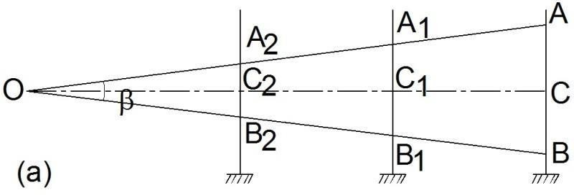

We willderive distance and elevation formulae for fixed hair method assuming line ofsight as horizontalandconsideringanexternalfocusingtypetelescope. InFigure below, *O*istheoptical centreoftheobject glass. Thethreestadiahairsare*a*,*b*and*c*andthecorrespondingreadingson staff are *A*, *B* and *C*. Length of image of *AB* is *ab*. The other terms used in this figure are

*f*=focallengthoftheobjectglass,

*i*=stadiahairinterval=*ab*, *s* = staff intercept = *AB*,

*c*= distancefrom*O*tothe verticalaxisoftheinstrument,

*d*=distancefrom*O*tothestaff,

′

*d*′=distancefrom*O*tothe planeofthediaphragm,and

*D*=horizontaldistancefromtheverticalaxistothestaff.

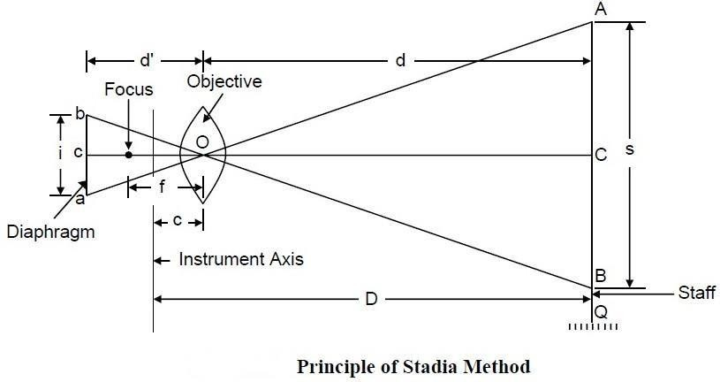

s

Fromsimilar∆,*AOB*and*aOb*,we get

d=s

d′ i

Andfromlensformula,

1 1 1

ƒ=d′+d

Combiningthetwoequations,weget ƒs

d=i+ƒ

Adding*c*toboththesides ƒs

D= +(ƒ+c)

i

OrD=Ks+C

where the constant *K*isequalto (*f* /*i*).It iscalled **multiplying constant**ofthetacheometer and is generally kept as 100. The constant *C* is equal to (*f* + *c*). It is called **additive constant** whose valuerangesfrom30cmto50cmforexternalfocusingtelescopesand10cmto20cmfor

internalfocusingtelescopes. Fortelescopes fittedwithanallacticlens,*C*equalszero.

#### AnallacticLens

Thebasicformulafordeterminationofhorizontaldistanceinstadiatacheometryis

ƒs

D = +(ƒ+c)

i

OrD=Ks+C

Due to the presence of the additive constant *C*, *D* is not directly proportional to *s*. This is accomplished by the introduction of an additional convex lens in the telescope, called an *anallacticlens*,placedbetweentheeyepieceandobject glass, andatafixeddistancefromthe latter.

Theanallactic lens isprovided inexternalfocusingtelescope. Itsusesimplifiesthereductionof observations since the additive constant (*f* + *c*) is made zero and the multiplying constant *k* is made100.However,thereisobjectiontoitsusealso asit increasestheabsorptionoflight inthe telescope thereby causing reduction in brilliancy of the image. Anallactic lens is not fitted in internal focusing telescopes.

#### DeterminationofTacheometricConstants

The stadia interval factor (K) and the stadia constant (C) are known as tacheometric constants. Beforeusingatacheometerforsurveyingwork,it isrequiredtodeterminetheseconstants.These can be computed from field observation by adopting following procedure.

**Step1:**SetupthetacheometeratanystationsayPona flatground.

**Step 2 :** Select another point sayQ about 200 maway. Measure the distance between P and Q accuratelywithaprecisetape.Then,drivepegsatauniforminterval,say50 m, alongPQ.Mark the peg points as 1, 2, 3 and last peg -4 at station Q.

**Step3:**Keep the staffonthepeg-1,and obtainthestaffinterceptsays1.

**Step4:**Likewise,obtainthestaffinterceptssays2,whenthestaffiskeptatthepeg-2,

**Step5:**Formthesimultaneousequations, D1= K. s 1+ C (i)

and D 2= K.s2+C (ii)

SolvingEquations(i) and (ii),determinethevaluesofKand CsayK1and C1.

**Step 6 :** Formanother set of observations to the pegs 3 & 4, Simultaneous equations can be obtainedfromthestaffinterceptss3ands4atthepeg-3andpoint Qrespectively.Solvingthose equations, determine the values of K and C again say K2and C2.

**Step7:**Theaverageofthevaluesobtained insteps(5) and(6),providethetacheometric constants K and C of the instrument.

#### Stadiatacheometry

**Case1When staffheldverticaland withlineofcollimationhorizontal**

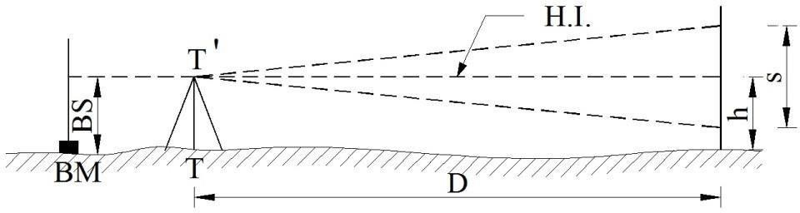

Whenthelineofsightishorizontal,thegeneraltacheometric equationfordistanceisgivenby

ƒs

D= +(ƒ+c)

i

Themultiplyingconstant(ƒ) is100,andadditiveconstant(ƒ+c)isgenerallyzero.

i

RL of staff station P = HI – h Where HI = RL of BM + BS h = central hair reading

BS= Backsight

HI=height ofinstrument

#### Case2When staffheldverticaland withlineofcollimationinclined

1. *ConsideringAngleof elevation*

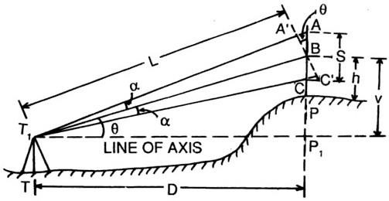Let

*T* = Instrument station *T1*=axisofinstrument *P* = staff station

*A,B,C* =positionofstaffcutbyhairs

*S=AC* =staff intercept

*h*=centralhairreading

*V*=verticaldistanceinstrumentaxisand

centralhair

*D*=horizontaldistance betweeninstrument andstaff *L* =inclined distance between instrument axis and B θ =angle of elevation

α=anglemadebyouterandinnerrayswithcentralray

A′C′isdrawnperpendiculartothecentralrayT1B Now , internal distance, L =ƒ(A′C′) + (ƒ + c)

i

Horizontaldistance,D=Lcosθ

=ƒ(A′C′)cosθ+(ƒ+c)cosθ *(1)*

i

NowA′C′istobeexpressedintermsof*AC*(i.e.S)

*In*∆sABA′andCBC′

<ABA′=<CBC′=θ

<AA′B=900+α

<BC′C=900−α

Theangleαisverysmall

<AA′Band <BC′C maybetakenequalto900So A′C′ = AC cosθ = S cosθ

Fromequation*(1)*

D=ƒ(Scosθ)cosθ+(ƒ+c)cosθ

i

ƒ

D=×Scos2θ+(ƒ+c)cosθ

i

AgainV=Lsinθ

ƒ

={×Scosθ +(ƒ+c)}sinθi

=ƒ×Scosθsinθ+(ƒ+c)sinθ

i

V=ƒ×S×sin2θ+(ƒ+c)sinθ

i 2

AlsoV=Dtanθ

RLoƒ staƒƒstationP=RLoƒaxisoƒinstrument+V −ℎ

1. *ConsideringAngleof depression*

InthiscasealsotheexpressionsforDandVaresame.Thatis

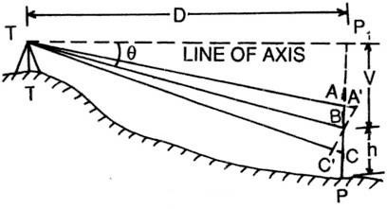

D=ƒ×S cos2θ+(ƒ+c)cosθ

i

V=ƒ×S×sin2θ+(ƒ+c)sinθ

i 2

RLoƒ staƒƒstationP=RLoƒaxisoƒinstrument−V −ℎ

#### Problem

Atacheometerwasset upatastationCandthefollowingreadingswereobtainedonastaff vertically held.

|  |  |  |  |  |
| --- | --- | --- | --- | --- |
| Inst. station | Staff station | Verticalangle | Hairreadings | Remarks |
| C C | BM D | −5020′  +8012′ | 1.500, 1.800, 2.450  0.750, 1.500, 2.250 | RLofBM =  750.50m |

Calculatethehorizontaldistance CD and RLofD,whenthe constantsofinstrumentare100and

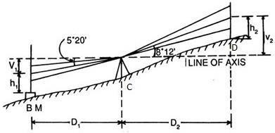0.15 .

Solution

Whenthestaffis heldvertically, thehorizontalandverticaldistancesaregivenbytherelations ƒ

D=i

×Scos2θ+(ƒ+c)cosθ

V=ƒ×S×sin2θ +(ƒ+c)sinθ

i 2

Hereƒ=100and(ƒ+c)=0.15

i

In thefirstobservation,S1=2.450−1.150=1.300 m

θ1= 5020′(depression)

sin10040′

0 ′

V1=100×1.300× 2 + 0.15× sin520=12.045m

In thesecondobservation,S2=2.250−0.750=1.500m

θ2=8012′(elevation)

sin16024′

V2=100×1.500×

+0.15×sin8012′=21.197m

2

D2=100×1.50×cos28012′ +0.15×cos8012′=147.097m

RLoƒ axisoƒinstrument=RLoƒBM+ℎ1+V1

=750.500+1.800+12.045=764.345m

RLoƒD=RLoƒaxisoƒinstrument+V2−ℎ2

=764.345+21197−1.500=784.042m

So,the distance CD=147.097mandRLofD= 784.042m

### CHAPTER-2

#### Introduction:

Curvesarerequiredto be introducedwhere it is necessaryto changethedirectionofmotion from one straight sectionofa highwayor arailwayto another. These are provided due to the nature of terrain or other avoidable reasons to enable smooth passage of vehicles.

#### CLASSIFICATIONOFCURVES

For survey purposes, curves are classified as horizontal or vertical, depending onwhether they are introduced in the horizontal or vertical plane.

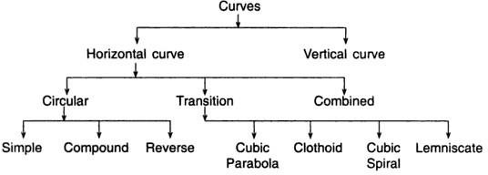

#### HorizontalCurves

Horizontalcurvescanbecircularornon-circular(transitional)curves.Differenttypesof horizontal curve are shown in figure below.

##### SimpleCircularCurve

Whenacurveconsistsofasinglearcwithaconstant radiusconnectingthetwo straights or tangents, it is said to be a circular curve.

##### CompoundCurve

When a curve consists of two or more arcs with different radii, it is called a compoundcurve. Suchacurve liesonthesamesideofacommontangent andthe centres ofthe different arcs lie on the same side of their respective tangents.

##### ReverseCurve

Areverse curve consistsoftwo arcbending inopposite directions. Their centres lie onopposite sidesofthe curve. Their radiimay be either equalor different, andthey have one common tangent.

##### TransitionCurve

Acurve ofvariable radius isknownasatransitioncurve. It isalso called a easement curve. Such a curve is provided between a straight and a circular curve, or between branches of a compoundorreversecurvetoavoidanabruptchangeindirectionwhenthealignment

changes.Inrailways,suchcurveisusedonbothsidesofacircularcurvetominimize superelevation.

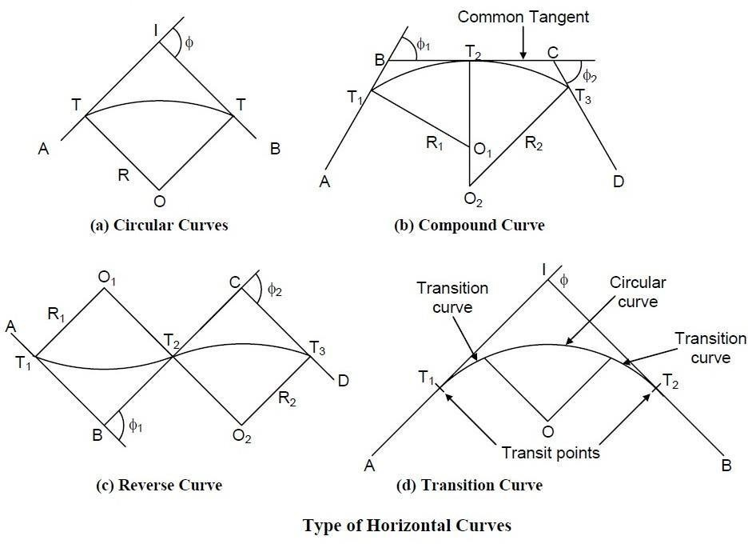

#### SIMPLECIRCULARCURVE

Figure shows a simple circularcurve withtwostraightlines *AI* and *IB*intersectatthe point*I*. Thecurve*T*1*CT*2ofradius*R*isinsertedtomakeasmoothchangeofdirectionfrom*AI*to*IB*.A

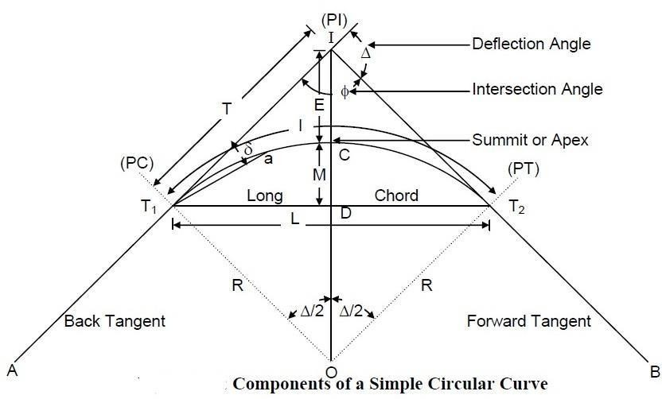simple circular curvehasvarious

components

whose

definitions are given below.

#### DefinitionofVariousComponents Back Tangent

Thetangent(*AT*)previoustothecurveiscalledthebacktangentorfirst tangent.

1

#### ForwardTangent

Thetangent(*TB*)followingthecurveiscalledtheforwardtangent orsecondtangent.

2

#### PointofIntersection

Ifthetwotangents*AT*

1

and*BT*

2

areproduced,theywillmeetinapoint*I*calledthepointof

intersection(PI)orvertex.

#### PointofCurve(PC)

Itisthebeginningofthecurve(*T*1)wherethealignmentchangesfromatangenttoacurve.

#### PointofTangency(PT)

Itistheendofthecurve(*T*2)wherethealignmentchangesfromacurvetotangent.

#### IntersectionAngle

Theanglebetweenthetangent*AT*1and*BT*2iscalledtheintersectionangle(ф).

#### DeflectionAngle

Theangle∆throughwhichthe forwardtangent deflects iscalledthedeflectionangleofthe curve. It may be either to the left or the right.

#### DeflectionAngletoanyPoint

Thedeflectionangleδtoanypoint *a*onthecurve istheangleatPCbetweentheback tangent and the chord *T*1 *a* from PC to point on the curve.

#### TangentDistance(T)

ItisthedistancebetweenPCtoPI(alsothedistance fromPItoPT).

#### ExternalDistance(E)

Itisdistancefromthemid-pointofthecurve toPI.It isalsoknownastheapexdistance.

#### LengthoftheCurve (l)

*L*is thetotallengthofthecurvefromPCtoPT.

#### LongChord(L)

Itisthechord joiningPCtoPT.

#### MidOrdinate(M)

Itistheordinatefromthemid-pointofthelongchordtothemid-pointofthecurve. It is also called the versine of the curve.

#### NormalChord(C)

Achordbetweentwosuccessiveregularstationsonacurveiscalled anormalchord.

#### Sub-Chord(c)

Sub-chordisanychordshorterthanthenormalchord.Thesegenerallyoccur atthebeginningor at the end of the curve.

#### Right-hand Curve

Ifthecurvedeflectstotheright ofthedirectionoftheprogressofsurvey, it iscalled the right-hand curve.

#### Left-handCurve

Ifthecurvedeflectstotheleft ofthedirectionoftheprogressofsurvey, it iscalledthe left- hand curve.

#### ElementsofSimpleCircularCurve Length of the Curve (l)

Length*l* =*TCT*=*R*∆,where ∆isinradians

1 2

o

=(π*R*)∆/180,where∆isindegrees.

#### TangentLength(T)

Tangentlength,*T* =*TI=IT*

1 2

=*OT*tan∆/2*=R*tan∆/2

1

#### LengthoftheLongChord(L)

*L* =*TT*=2*OT*sin∆/2

12 1

=2 *R*sin∆/2

#### ApexDistance orExternalDistance(E)

*E*=*CI*=*IO*–*CO*

=*R*sec∆/2–*R*

= *R*(sec ∆/2–l)

=*R*exsec∆/2

#### Mid-ordinate(M)

*M*=*CD* =*CO*–*DO*

= *R*–*R*cos ∆/2

= *R*(1–cos∆/2)*=R*versin∆/2

#### Problem:

o

Twotangents intersect at a chainage of1250.50 mhaving deflectionangle of60 . Ifthe radius of the curve to be laid out is 375 m, calculate the Length ofthe curve, Tangent distance, Length of the long chord, Apex distance, Mid-ordinate, Degree of curve and Chainage of P.C. and P.T.

#### Solution:

o

Lengthofthe curve,*l*=(πR)∆/180,where ∆isindegrees.

o o

=πΧ375×60/180

=392.69m

TangentLength,*T*=*R*tan∆/2

o

=375×tan60/2

=216.50m

Lengthofthelongchord,*L*=2*R*sin∆/2

o

= 2×375×sin60/2

=375.00m

Apexdistance,*E*=*R*(sec∆/2*–*1)

o

= 375×(sec60/2–1)

=58.01m

Mid-ordinate, *M*=*R*(1–cos∆/2)

o

= 375×(1–cos 60/2)

**=** 50.24m

o

DegreeofArc,*D* =1718.9/R

*a*

=1718.9/375

o

=4.58

ChainageofPC = Chainageof*I*–*T*

=1250.50–216.50

=1034.00m

ChainageofPT= Chainage of*I*+*l*

=1250.50+392.69

= 1634.19m

#### Designation ofCurve

The *sharpness* ofthe curve is designated either by its *radius* or by its *degree of curvature*. The degree of curvature has several slightly different definitions. According to the *arc definition* generallyused inhighwaypractice, the degreeofthecurve(Do) isdefinedasthecentralangleof

a

thecurvethatissubtendedbyanarc *AB*of30mlength.

Ifthedegree ofcurve (Do)istakenindegrees,foracurve ofradius*R*meter, then

a

o

Dao:30=360:2π*R*

or Do=10800/2π*R*

a

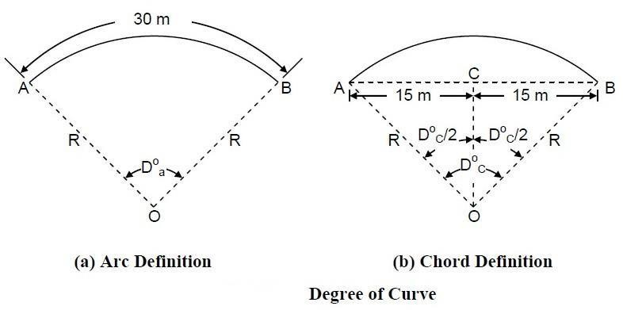=1718.9/*R*(approximate)

According

to the*chord*

*definition*

generally usedinrailwaypractice,thedegreeofthecurve(Do)isdefined asthe centralangleofthe curve

c

that is subtendedbyitschord*AB*of30mlength.

sin(Do/2)=*AC*/*AO*

c

=15/*R*

*R*= 15/sin (Do/2)

c

Radiusofcurvaturevaries inverselyasthedegreeofcurve. Asharpcurve hasa larger degreeof curve whereas a flat curve has a smaller degree of curve.

#### SETTINGOUTSIMPLECIRCULARCURVE

Acircularcurvecanbesetoutinthe fieldbylinear methodandangular method.Theseare described below.

* 1. Linearmethodisalso calledchainandtapemethod.Inthismethod,onlytapeand chains are used and no angular measurement is carried out.
  2. Inangular methodorInstrumentalmethod, atheodolite, tacheometeroratotalstation instrument is used for angular measurement.

#### LinearMethod

Listedbelowaresomeofthe linear methodsofsettingout simplecircularcurve followedby their description :

1. Offsetsfromthelong chord
2. Successivebisectionofchord
3. Offsetsfromthetangents
4. Offsetsfromthe chordsproduced

#### OffsetsfromtheLongChord

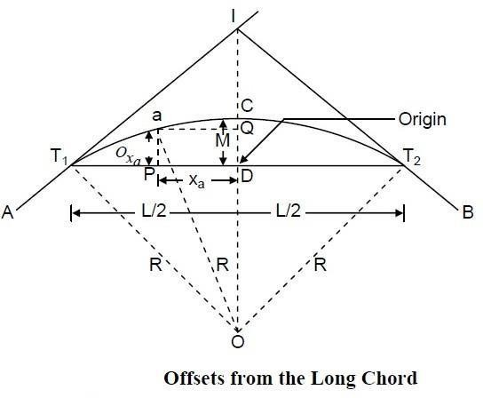The method is suitable for setting out circular curves of small radius, such as those at road intersections in a city or in boundary walls. In Figure below, the offset Oxato the point *a* on the curveistheperpendiculardistanceofpoint*a*from the long chord *TT* , at a distance xafrom*D* along

12

thelongchord.Consideringtheoriginat*D*,Oxais the *y*-coordinate of point *a*.

From∆OT1D,

(DO)2=(T1O)2−(T1D)2

Or (OC−DC)2=(T1O)2−(T1D)2

2 2 L2

Or (R−M) =R—()

2

—()

Or M = R −√R2 L2 2

DrawalineQaparallelto DT1cuttingDCat Q From ∆ O a Q

OQ=√(Oa)2−(Qa)2=√R2−xa2OQ= OD + DQ = OD + Oxa

OQ=OD+Oxa=√R2−xa2

Oxa=√R2−x2−aOD

Oxa=√R2 −x2a−(R−M)

O =√R2−x2−√R2−()L2

x a

a 2

2

2 L2

IngeneralOx= √R −x2−√R

—()

2

The long chord is divided into equal parts of suitable length. The offsetOxacorresponding to the distances xafrom *D* are calculated for different points on the long chord. These offsets are measured perpendicular to the long chord with the help of an optical square and points are located. Joining these points will produce the desired curve. The points on the right side of *CD* are set out by symmetry.

#### SuccessiveBisectionofChords

Themethodbeingapproximateissuitable for smallcurves. Itinvolvesthe locationofpointson the curve by bisecting the chords and erecting perpendiculars at the midpoint of the chords.

InFigure,*TT*isthelongchordand*D*isitsmidpoint.*C*isthepointofintersectionofthe

12

perpendicularlineat*D*,withthecurve. *Dc*isthemid-ordinate,whichisequalto

∆ L2

M=R(1−COS())=R−√R2−()

2 2

At*D,*aperpendicular offset equalto*M*iserectedandtheposition*C* is located.Nowconsider the chords *TC* and *TC*, locate their midpoints *d* and *d* respectively. Erect two perpendiculars at *d*

1 2 1 2 1

and*d*andmeasuretheoffsetsequalto*dc*and*dc*,respectively.Theoffsets*dc*and*dc*are

2 11 22 11 22

computedfromthefollowingformula:

∆d1c1= d2c2= R(1− COS())

2

Now,bythesuccessivebisectionofthesechords,morepointscanbelocatedinasimilar manner.

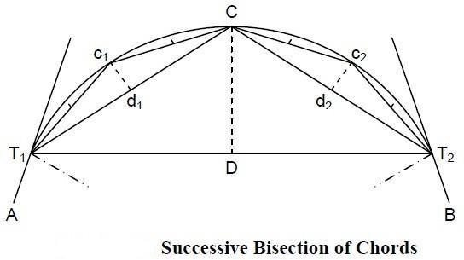

Afterlocating*T* and*T,*themidpoint*D*of*TT* isobtained,bymeasuring*TT.*The

1 2 12 12

perpendicularoffset*DC*issetoutat*D*withanopticalsquareandpoint*C*islocated.Measure

*TC*,and *TC*,andlocatetheirmidpoints*d*and *d*.Theperpendicular offsets*dc*and *dc*areset

1 2 1 2 11 22

outat*d*and*d*,andthepoints*c*and*c*areestablishedonthecurve.Theprocessiscontinuedtill

1 2 1 2

sufficientnumbersofpointsonthecurveare fixed.

#### Offsetsfromthe Tangents

This method is used when the deflection angle and the radius of curvature botharecomparatively small. In this method, the curve is set out by measuring offsets from the tangent. The offsets from the tangent can be either perpendicular or radial to the tangent.

#### PerpendicularOffsetsMethod

Letthepoint *a*beonthecurveandtheperpendicularoffset fromthetangent *T*1toit at *P* be Oxa*.* Let the distance of *P* from*T*1 be xa. Draw a line *Qa* perpendicular to *T*1*O,* intersecting *OT*1 at *Q*.

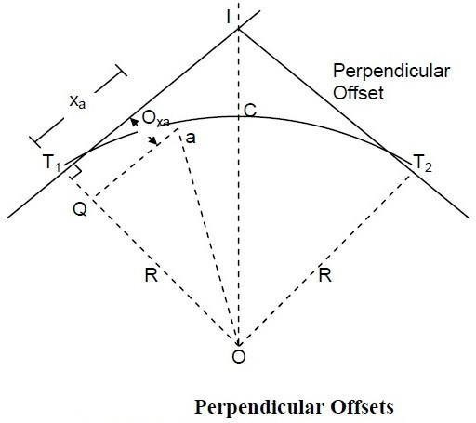From∆*QaO*

OQ=√(Oa)2−(Qa)2

R−Ox=√R2−xa2

a

R−Ox=R−√R2−xa2

a

IngeneralOx =R−√R2−x2

Beforesettingouta curve,atableofoffsetsfordifferentvaluesof*x*(e.g.,10 m,20m,30m, etc.)ismade.Thenfrom*T*thedistancesx1,x2,x3etc.,aremeasuredalongthetangentandthe

1

correspondingoffsetsaremeasuredontheperpendicularstothetangentwiththehelpofan optical square.

Sincetheoffsetsofpointsequidistantfrom*T*and*T,*areequal,thesametableisusedforoffsets

1 2

fromboththetangents.

#### RadialOffsetsMethod

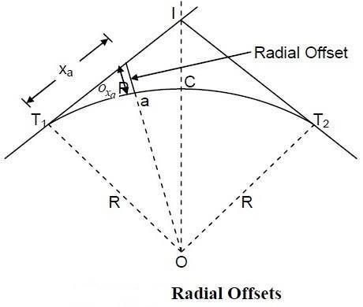Let the radialoffset tothe point *a*onthe curve beOxafromthepoint*P*atadistanceofxafrom

*T*.

1

From∆*OPT*

1

OP=√(OT1)2+(T1P)2

R+Ox=a√R2+xa2Oxa=√R2+xa2−R

IngeneralOx=√R2+x2−R

#### OffsetsfromtheChordProduced

The method hastheadvantagethatnot allthe land betweenthetangentspoints*T*1and*T*2needbe accessible. However to have reasonable accuracy the length of the chord chosen should not exceedR/20.Themethodhasadrawbackthat errorinlocating iscarried forwardtootherpoints. This method is based on the premise that for small chords, the chord length is small and approximately equal to the arc length.

For setting outthe curve, it isdivided into anumberofchordsnormally20 to 30min length. For the continuous chainage required along the curve, the two sub-chords are taken, one at the beginning and the other at the end of the curve. The first sub-chord length is such that a full number of chainage is obtained on the curve near *T*1 and the second sub-chord length near *T*2.

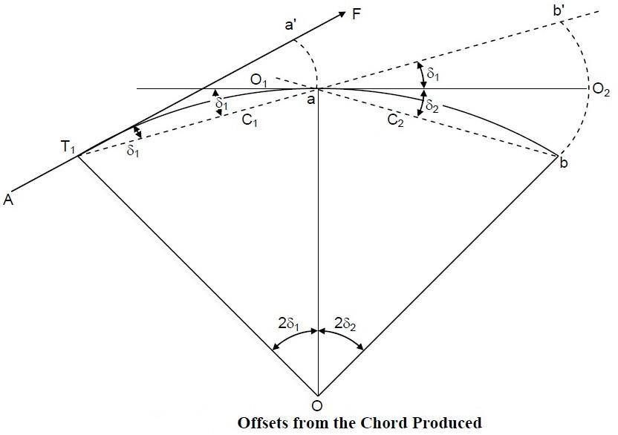Fromthepropertyofacircle,iftheangle<FT1a=◻1The angleat thecentre<

T1Oa=2◻1

C1=cℎordT1a≈arcT1a

=2◻1R

Or ◻1=C1

2R

ThefirstoffsetO1=C1◻1C1 C2

O= C = 1

1 12R 2R

Thefirstchord*C*iscalledthesub-chord.Thelengthof thesub-chordissoadjustedthatthe chordlengthwhenaddedtothechainageof*T*makesthechainageofpoint*a*asfullchain.

1

SubsequentchordlengthsC2,C3,C4 arefullchains.T1aisthen producedtob′suchthata

fullchainab′=C2,afullchain. The second offset

O2=C2(◻1+◻2)

C1 C2

=C2(

C2R

+2R)

= 2(C+C ) 2R 1 2

Similarly O=C3(C+C)

3 2R 2 3

ThelastoffsetO=Cn(C +C)

n 2R n–1 n

whereCn–1isafullchainandCnisthelastsub-chordwhichisnormallylessthanonechain length.

`

#### AngularMethod

Followingaresomeoftheangularmethod usedtosetout asimplecircularcurve:

1. Tapeandtheodolitemethod
2. Twotheodolitemethod
3. Tachometricmethod
4. Totalstation Method

#### TapeandTheodoliteMethod

Inthismethod,atapeisusedformakinglinearmeasurementsandatheodoliteisusedfor making angular measurements. The curve can be set out by the following procedures :

*Rankine’sMethod*

Themethod isknownasRankine’s methodoftangentialangleorthedeflectionangle method. The method is accurate and is used in railways and highways.

Let*Tab*beapartofacircularcurvewith*T*,theinitialtangentpoint.Thus,*Ta*isthefirstsub-

1 1 1

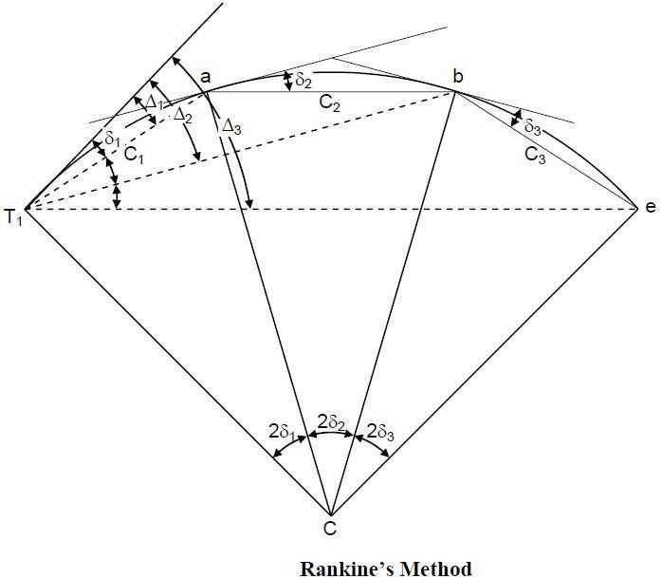chordwhichisnormallylessthanonechainlength. From the property of a circle

C1= 2◻1R

C1

◻1=2Rradian C1 1800

=

2R π

=C1180×60minutes 2R π

=1718.87

C1

Rminutes

Therefore to locate the point *a* with the help of a theodoliteandtape,theinstrumentisset

at*T*andthelineofsightisputatanangleofδ=∆ascomputedabove.Thenwiththehelpofa

1 1 1

tapeandrangingrod,thetapeisputalongthelineofsightanddistance*C*isthenmeasuredto

1

locatepoint*a*alongthelineofsight.

Similarly,

C2

◻2=1718.87Rminutes

Sincethetheodoliteremainsat*T*,*b*issightedfrom*T*bymeasuring◻1+◻2=∆2fromthe

1 1

tangentline.Thepoint*b*islocatedwiththehelpofatapeandrangingrod.Thetapewiththe

rangingrodissoadjustedthatthe tapemeasures*ab*=*C*andtherangingrodliesalongtheline

2

ofsight*Tb*

1

Similarly,

∆3=◻1+◻2+◻3=∆2+◻3

∆n=◻1+◻2+◻3+………+◻n=∆n–1+◻n

Inpractice,*C*isthefirstsub-chordand*C*thelastsub-chord.

1 n

C2=C3=⋯=Cn–1arefullchainlengths.Asacheckthedeflectionangle∆nforthelastpoint

∆

Tisequaltowhere∆istheangleofintersection.

2

2

#### FieldProblemsinSettingOuttheCircularCurves

Thefollowingaresomeofthefieldproblemsinsettingoutthecircular curves.

1. Point ofcurveinaccessible.
2. Pointoftangencyinaccessible.
3. Pointofintersection inaccessible.
4. Curvetangentialtothreelines.
5. Bothpointofcommencementandpoint ofintersectioninaccessible

#### Pointofintersectioninaccessible

Ifthe point of intersectionP.I. is inaccessible then to set out acurve, the following procedure is followed:Firstlocatepoints*P*and*Q*on*IT*and*IT*respectively,thenmeasureanglesαandβ

1 2

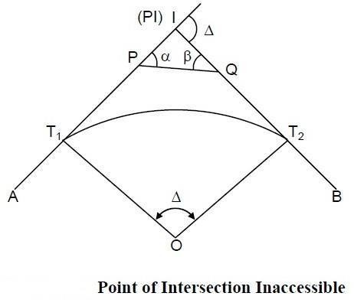withthetheodoliteandlength*PQ*withatape.

Then ~~IP~~=

sinβ

PQ sin∆

Or IP=PQsinβ

sin∆

Similarly

IQ=

PQsinα sin∆

CalculatePT1=IT1−IPQT2

=IT2−IQ

Thus, *T*and *T*canbelocatedfrom*P*and *Q*respectivelyand the curvecan be plottedfrom*T*.

1 2 1

#### TRANSITIONCURVE

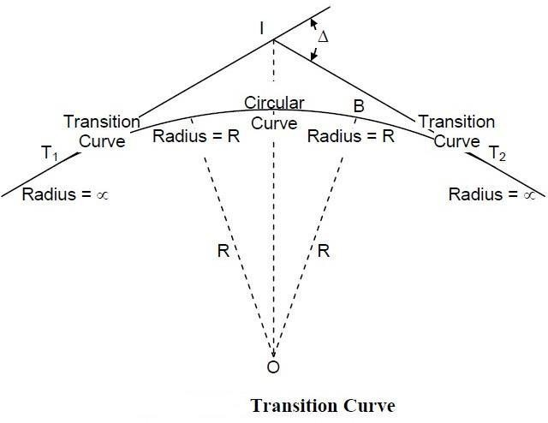Atransition or easement curve is a curve ofa varying radius introduced between a straight and a circular curve, or between branches of a compound curve or reverse curve. The introduction of a transition curve between the straight and the circular arc, as indicated in Figure below, permits the gradualelevation ofthe outer edgeor gradual introduction of*cant or super-elevation* (raising the outer edgeover the inner). At the same time, it also permits gradualchange ofdirection from straight to the circular curve and vice-versa.

Ona straight track,itstwo edgesareatthe samelevel.Onacirculararctheouteredge is elevated depending on the radius of the curve and the speed to the vehicles expected, to avoid over turning of the vehicles due to centrifugal force acting on themwhile moving oncircular path. Also, thereisanabrupt changeindirectionwhen the alignment changes from straight to circular curve and vice-versa*.*

In railways, such a curveis provided on both sidesof acircularcurvetominimise

super-elevation.Excessivesuper-elevationmaycausewearandtearoftherailsectionand discomfort to passengers.

#### AdvantagesofaTransitionCurve

Theintroductionofatransitioncurvebetweenastraight andacircularcurvehasthefollowing advantages :

1. Thechancesofoverturningofthevehiclesandthederailment oftrainsarereduced considerably.
2. Itprovidescomforttothepassengersonvehicleswhilenegotiatingacurve.
3. Thesuper-elevationisintroducedgraduallyinproportiontotherateofchangeofcurvature.
4. Itpermitshigherspeedsatcurves.
5. Itreducesthewearontherunninggears

#### CharacteristicsofaTransition Curve

1. Itshouldbetangentialtothestraight.
2. Itshouldmeetthecircularcurvetangentially.
3. Itscurvatureshouldbezeroattheoriginontangent.
4. Itscurvatureshould beequaltothatofthecircularcurveatthejunctionwiththecircular curve.
5. Therateofchangeofcurvaturefromzero totheradiusofthecircular curve should bethe same as that of increase of cant or super-elevation.
6. Thelengthofthetransitioncurveshouldbesuchthat fullcantorsuper-elevationisattained at the junction with the circular curve.

CHAPTER-3

Scale is a fundamental concept of geography and is as essential for understandingEarthanditsenvironmentsasitisforimplementingpublicpolicy.

Its precise definition is often debated by geographers, in part, because various subfieldsofgeographyusescaleindifferentways.Generally,scaleis aformofsize.

## MaporCartographicScale

Map or cartographic scale is the ratio of a distance on Earth compared to the same distanceonamap.Therearethreetypesofscalescommonlyusedonmaps: written or verbal scale, a graphic scale, or a fractional scale. A written or verbal scale uses words to describe the relationship between the map and the landscape it depicts such as one inch represents one mile. A map reader would use a ruler to measure the distances between places. A graphic scale is a bar marked off like a ruler with labels outlining the distances the segments represent. Just as you would with a written or verbal scale to measure distance with this type of scale you would use a ruler. Finally, a fractional scale, typically represented as a ratio (1/50,000 or 1:50,000), indicates that one unit (inch, centimeter, football field or pitch, etc.) on

the map represents the second number of that same unit on Earth. So if theratiowas 1:50,000onecentimeter onthemapwould represent50,000 centimeters (500 meters) in real life. The whole map, at this ratio,

wouldencompassatypicalcountyintheUnitedStates.

Somewhat counterintuitively we describe detailed maps of smaller areas as largescalemapsandglobalmapsassmallscale.This isbestillustratedwith the

fractionalscalesystem.Alarge-scalemaphasasmallerratio(1:10,000or 1:25,000) and would have more details such as streets and building footprints. Whereas a small-scale map has a larger ratio (1:500,000 or 1:1,000,000) and illustrates an entire state, province, or country with just the larger cities or towns and

majorhighways.Mapsarenotcompletewithoutascale.Itiskeytomaking an accurate and understandable map.

## SpatialScale

Thereare threemoregeneralways to describescaleas well: local, regional, andglobal. Local-scaleis aspecificplace with uniquephysicalfeaturessuch as climate, topography, and vegetation.

Regions,however,varyconsiderablyinsize. Theyaregenerallylargerthan one place, such as a town or city, and may include several towns or

multiplestatesorprovinces.Therearethreetypesofregions:formal,functional,and vernacular.Theeasiesttoidentifyisaformalregionasithasrecognizedboundaries or borders and often governments. An example would be the German state of Bavaria or the Sahara Desert. A functional, or nodal, region is characterized by a common point or trait and is frequently used to describe economic areas such as the metropolitan area around Washington, D.C. in the United States. Finally, a vernacular or perceptual region is one that has characteristics that are perceived to be different from that of the surrounding areas. An example would be

theAppalachianMountainsintheUnitedStates.Certaineconomicactivities andculturalcharacteristicsareattributedtoanareathatencompassesnine

U.S.statesthatthemountainrangecovers.

Global-scale, of course, covers all of Earth. Studying patterns at thisscale is critical duetoglobalization.Astheworldbecomesmoreinterconnectedinformation,goods, and ideas are traded at faster and faster rates changing the way we communicate and live.While most feel globalization has not destroyed the uniqueness of specific places,forcespromotingglobalizationoftencomeintoconflictwiththosefocusedon preserving local traditions. Additionally, in some cases, globalization has increased the wealth gap between wealthy and poorer nations.

Examiningpatterns indifferent scales iscriticaltounderstandingtheproblem and its effects,whichoftenvarybylocation.Inthestudyofclimatechange,choicesmadeat

the local level, such as burningfossil fuels for power, can have larger impacts at the regional level (e.g., acid rain) or the global level where we see the increase in atmospheric carbon dioxide leading to rising temperatures. The results of the rising levelsofcarbondioxidehavedifferentimpactsondifferent localities.Coastalregions battle rising sea levels and the ground is shifting below Arctic communities as

thepermafrostmelts.Inordertoappropriatelyunderstandandaddresscomplex issues like climate change, we need to examine it and devise solutions at multiple scales.

Chapter-4

SurveyofIndia,TheNationalSurveyandMappingOrganizationofthecountryundertheDepartmentofScience& Technology, is the OLDEST SCIENTIFIC DEPARTMENT OF THE GOVT. OF INDIA.

It was set up in 1767 and has evolved rich traditions over the years. In its assigned role as the nation's Principal Mapping Agency, Survey of India bears a special responsibility to ensure that the country's domain is explored and mapped suitably, providebasemapsforexpeditiousandintegrateddevelopmentandensurethatallresourcescontributewiththeirfull measureto the progress, prosperity and security of our country now and for generations to come.

CHAPTER-5

Photogrammetry,digitalorthophotography,orthophoto & orthoimage

An orthophoto or orthoimage is an image that is free of distortion (it has been ortho-rectified) and which is characterizedbyauniformscaleover itsentiresurface. Wecanconsider bysimplifyingthat it is likeifeachelement shown on the image has been photographed directly from the vertical over it.

Inother words,anorthophoto isakind ofscaled photographic map, onwhich it isperfectlypossible to perform measurementsasifit wereastandard map. It ispartofthephotogrammetryfield and isgenerallyperformed by Unmanned Aerial Vehicles (UAV).

Theorthoimagecanbeoverlaidwithother mapscontainingother urbanortechnicalelements likeapowersupply network, adam, a road, a cable television network, a construction project, etc. Photogrammetry allows to obtain useful maps containing a lot of information helping making decisions.

Orthophotosaremuchfaster and easier to createthanestablishingofanewareaconventionalmapandtheycanbe reproduced on a regular basis thanks to the cost efficiency and quick operability of drones.

Thesephotographsareshot byair andtheeasewithwhichourUnmannedAircraft Systems(UAS) canperformlow altitude slow flight is particularly adapted for their acquisition.

Theprecisionofanorthophoto isdirectlyproportionaltotheresolutionofthe imagecapturedbytheembedded digital camera on board.

Withthe automated navigation flight,the RemotelyPiloted Aircraft System(RPAS) willflyover theareato explore inasystematized waycoveringitcompletely.Apercentageofoverlapbetweenthepictureswillbringoutthe reliefs,

thesamewaythanthehumanstereoscopicvisiondoes.The flight planused bytheoperatorwillbeuploaded onthe drone on a case by case basis and will be adjusted to correspond to each specific photogrammetry mission.

Dependingonthenavigationpath,thedronewillscantheareaonparallelaxesandwithashift ofa fewdegreesto precisely reach this stereoscopic human vision effect through the onboard camera.

Onceontheground,theimagesareanalyzed,processed andcorrectedinorderto eliminatedistortionsincluding the effect of the relief displacement. It calculates the Digital Elevation Model (DEM which is a topographic representation of an area) in order to correct them and adjust any associated terrain deforming errors.

Used in several fields, such as the urban & land use planning, administrative departments management, communication,agriculture, archeologyandothers, photogrammetryallowstheidentificationofobjectsand geometric shapes projecting their measurements on the horizontal plane (Planimetrics).

### CHAPTER-6

#### Micro-opticTheodolites:-

Micro-optic theodolites can read angles to an accurancy of 10” or even less. The es-sential principle is illustrated in Fig.9.1. The special features of such theodolites are as follows.

* + 1. Conventional metal circles are replaced by glass circles on which the graduations are etched by photographic methods. The graduations can be made finer and sharper by this technique. Boththe horizontaland verticalcircles are made ofglass and generally graduated to 10.
    2. Light passing through the circle at the point of the reading is taken through a set of prisms to the field of view of the observer. For passing light through glass circles, sunlight is reflected through a reflecting prism and passed through the circle. In case night operation is required, the battery-operated light provided in the instrument can be used.
    3. Both the horizontal and vertical circles are seen at the same in the field of view. This is an advantage, as the readings of both the circles can be taken at the same time. Some manufacturers make a switching arrangement so that the horizontal or vertical circle reading can be seen along with the micrometer reading.
    4. The optical micrometer is used to read fractions of the main scaledivision. Depending upon the reading system, angles can be read up to 10’ or less.
    5. The circles are generally graduated to 10’ or 20’ of the arc. The micrometer can be read after coinciding the index with the nearest main scale division. The fractions are then read from the micrometer scale, which is also seen in the field of view.
    6. A small, separate reading telescope is provided besided the main telescope. It eliminates the need to move while bisecting an object and taking the reading.
    7. In most instruments, diametrically opposite ends of the circle are brought together in the field of view.

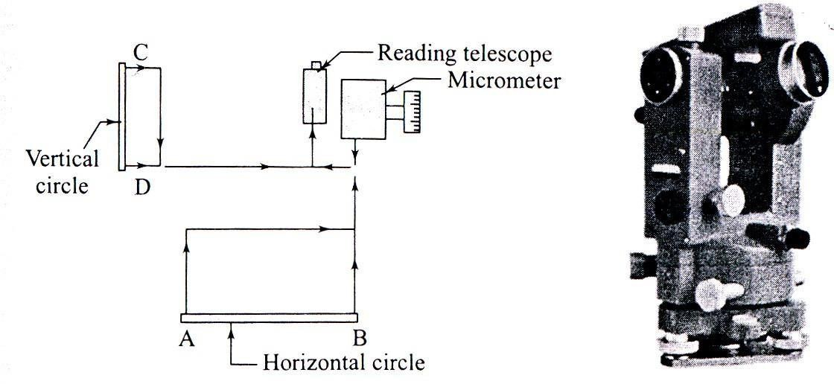

Fig.9.1

#### Digitaltheodolites:-

Digital theodolites are very fine instruments for angle and distance measurements. The instruments are light weight and are simplar to electronic theodolites in construction.

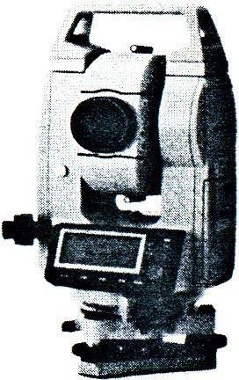The instrument is set up over a station as in the case of normal theodolites. They will have extendable tripod legs which can be adjusted for comfortable viewing. The centering and leveling operations aredone with a circular vial for coarse setting one has to press only a measure button to get the readings of anglesand distances. Some models also have a laser pointer for easy alignment in critical casesand for staking out operations. With the arrival of total stations, these theodolites have less demand though they are cheaper compared to a total station.

Thefollowingaretypicalfeaturesinadigitaltheodolite:

* Anglemeasurement–byabsoluteencodingglasscircle; Diameter – 71 mm
* Horizontalangle-2sides;verticalangle–oneside; Minimum reading – 1”/5”
* Telescope– Magnification– 30x;Length– 152mm;

objectivelens–45 mm Fig.9.2

* Fieldofview -1030’Minimumfocusdistance–1m
* Stadiavalues:Multiplyingconstant–100;additiveconstant-0
* Laserpointer–coaxialwithtelescope;633nmclassIIlaser;Method–focusingfor alignment and stake out operations.
* Displayonbothsides;7-segmentLCD unit
* Displayandreticleilluminated
* Compensator-tiltsensor;verticaltiltsensitivity+3’
* Opticalplummet–magnification– 3x;fieldofview-30;focusingfrom0.5mtiinfinity
* Levelsensitivity–Platevial–40”/2mm;circularvial– 10’/2mm
* Powersupply–4 AAsizebatteries;Operatingtimes– Theodoliteonly– 140 hours
* Laseronly–80hours;Theodolite+ laser–45hours
* Weight–4.2kg.

#### ElectronicDistanceMeter(EDM):

EDM equipment can be classified based upon the type of wave used, into M (microwave) DM and EO (electro-optical) DM equipment. The first type uses low-frequency short radio waves while the second type uses high-frequency light waves. They cal also be classified basedupon the range as follows.

* 1. Short-rangeequipment suchastelepromptersandmekenometerswitharangeofupto 3 km.
  2. Medium-rangeequipmentsuchasgeodimeterswitharangeofupto25km.The range is about 5 km during the day and can go upto 25 km at night.
  3. High–rangeequipment witharangeofupto150km. Tellurometersanddistomats come under this category.

The accuracy varies with the range. Short-range equipment has an accuracy of ± (0.2 mm) + 1 mm/km. Medium-range equipment has anaccuracyof± (5 mm+ 1 mm/km) while high-range equipment ha san accuracyof± (10 m+ 3 mm/km). Distomats have replaced other formsofequipment dueto their compact design, easeofoperation, and precision.

Alltypesofequipmentusingelectromagnetic wavesperformthefollowingfunctions.

1. Generationoftwowaveformsforcarrier andmeasurementfunctions.
2. Modulationanddemodulationofwaves.
3. Measurementofphasedifference.
4. Computationanddisplayofdistanceortheresultsofmeasurement.

#### 8.2TotalStations

One of the recentdevelopments in surveying equipmentis the integration of distance- and angle-measuring components in one piece of equipment. A total station is the integration of an electronic theodolite with the EDM equipment. Many companies market totalstations. Though the technology details used by different manufacturers may be different, they all have common features, which will be discussed below.

A digital theodolite is combined with one of the many forms of EDM equipment toobtain a very versatile instrument that can perform the required functions very easily.

#### DigitalTheodolite:

The electronic or digital theodolite was discussed in Chapter 4. We will just recapitulate some salient points. These instruments have glass circles, which are encoded in the incrementalor absolute mode. These are read byanoptical scanning systemand the reading is converted into angles and displayed or storedbythe instrument.Allthe instruments areprovided withanoptical plummet for centering and a compensator system(single-axis or dual-axis) to take careofthe tilt ofthe and the displayed angles and distances are previously corrected for such minor errors. The user can choose the required accuracy of angular measurement. These theodolites are normally operated by a rechargeable battery pack. The charged batteries can work for 40-80 hours. Some instruments need a prisms. Even reflecting tapes are used. A digital theodolite comes with the following facilities.

1. Zero-setting
2. Bidirectionalmeasurement
3. Precisionsetting
4. Horizontalandverticalangles
5. Slantdistanceand horizontaldistance
6. Differenceinelevations
7. Entryanddisplayofdata
8. Displayandstorageofresult
9. Datamanagementsystemanddatatransferfacility

A total station has all the above facilities and in addition measures horizontal distance using a built-in EDM module. Total stations come with a lot more facilities of data storage and manipulation. The following are the salient features of a total station.

**Angle measurement:-**Horizontal and vertical angles are measured to anaccuracy of 1”-5”.The angles are displayed onthe displayunit ofthe console. Manyinstruments have console units on both sides of the instrument.

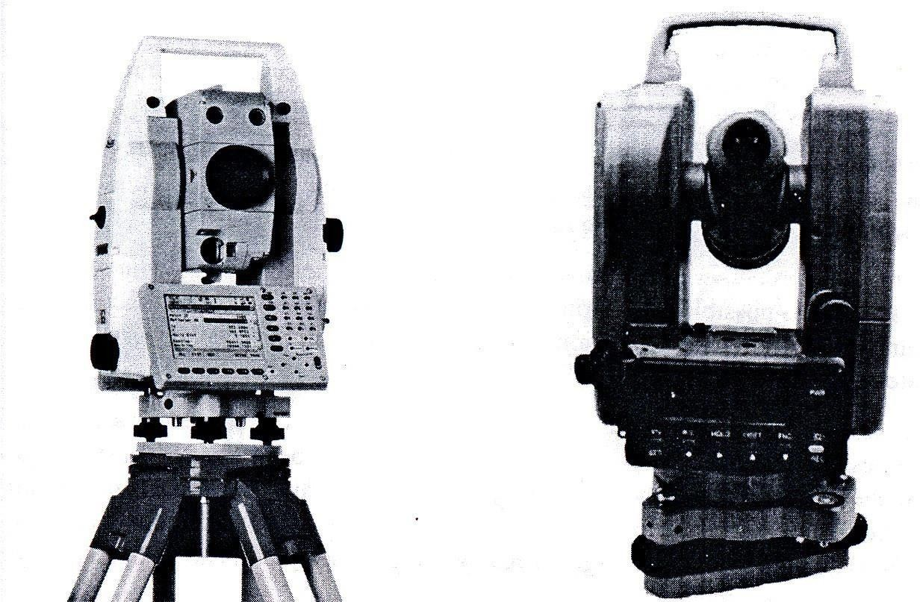

Fig.9.3

**Distance measurement:-** This is done with an EDM module functioning coaxially with the telescope tube. The distance measured is the slant distance if the stations are at different elevations. Reflecting multiple prisms are commonly used as targets, even though reflectorless distance measurement has also been made possible. The instrument uses the vertical angle measured by the theodolite and calculates the horizontal distance measurement can be done in different modes such as standard or coarse mode,precision mode, and fast mode, and fast mode. The precision and time taken vary depending upon the mode.

**Microprocessor and software:-** The onboard software in total stations can per form many functions. The processor is per-programmed, and in some cases can be programmed by the user to perform many useful functions with the measured data. The details may very with the manufacturers but some of the common features are as follows.

**Automatictargetrecognition:-**Mostof themodern total stationshavethefacilityof automatic target recognition(ART). InATR, the telescope has to be roughly pointed towardsthe target while the measurement key is pressed. The instrument automatically points to the target before measurement. The instruments have motorized endless drives to facilitate ATR.

**Reflectorless distance measurement:-**Until recently, total stations had to be used with special multiple prisms as targets for EDM. The new versions of total stations can measure distances without a prism target. This means that distances to points where a target cannot be erected can now be measured easily without any extra survey effort. This has been made possible by a red laser, which can direct to a point on any surface.

**Computation of reduced levels:-** The reduced levels are measured from slope distance and vertical angle. Data input enables the user to input the height of instrument, height of target prism, and the RL of the station occupid. The instrument calculates the RL of the target station and displays the same.

**Orientation:-** The instrument automatically orients to any direction specified by the user. If the coordinates of two points are input, the horizontal circle will be oriented to measure the bearing of the line automatically.

**Automated processes:-**Automatic computation of coordinates of points,areas, offsets,etc. is possible witha totalstation. More and more on-board functions are being incorporated in total stations. Setting out points on the ground using coordinates or directions is possible.

**Wirelesskeyboardandremoteunit:-**Manynewtotalstationssomewithaseparate wireless keyboard. The input of datato the station becomes veryeasywitha handheld keyboard. Another development is the availability of a remote unit so that the person at the prism can operatethe totalstation for almost all the functions. As there is no need to bisect a target orread the angle, the system can be operated by one person positioned near the target.

**Data management system:-** Total stations have a very efficient data management system. Data transfer to datarecorders, computers, orflashcards ispossible. The in-built memorycanstore up to 10,000 blocks of data.

**Graphic display:-**Manynewinstrumenthave extremelypowerfulgraphicdisplay programmes. With large display panels, the data can be plotted and displayed.

#### Workingwithtotalstation:-

Total stations are manufactured by many leading manufacturers of Survey equipment. Leica geosolutions, Topcon, Pentax, Nikon tripod data systems, Stonex are some of the major manufacturers of total stations. While specific details may vary with the manufacturers, some features are common to all of them.

A total station, as mentioned earlier, is a versatile equipment for surveying operations. Theequipment detailsand operationscanbeunderstoodbyreferring totheuser manualprovided with the equipment.

#### 8.3AerialSurveying

The procedure for aerial surveying includes reconnaissance of the area, establishing ground controls, flight planning, photography, and then paperwork including computation and plotting.

Reconnaissance is undertaken to study the important featuresof the ground for reference purposes.Groundcontrol is requiredin order to obtain asetofpointsknown positionbasedon

which other points are located and plotted. The number of ground control points depends upon the extent of area covered, scale of the map to be prepared, flight plan, and the process of preparing the maps. A minimum of three control points must appear in each photograph. These points are established by triangulation or precise traversing.

Flight control is achieved by flight planning, which takes into account the extent of the area, type of camera and its focal length, scale of the photographs, altitude speed of aircraft, and the overlaps of the photograph. The area covered by each photograph. Time interval between exposures and the number of photographs quired are decided based upon such flight planning.

#### Stereoscopes:-

There are many types of stereoscopes- mirror stereoscope, lens stereoscopes, scanning mirror and zoom stereoscopes. Lens and mirror stereoscopes are handy and commonly used.

**Mirror stereoscope :-**The schematic diagram of the mirror stereoscope is shown in fig.9.4 (a). The mirror stereoscope consists oftwo viewing eyepieces. A stereoscopic pair ofphotographs is placed at adistance fromthestereoscope.Thephotographsareadjusted sothatonephotographis seen through one eyepiece. The instrument has four mirrors, two mirrors attached to each eyepiece. As the viewer looks through the stereoscope, he/she sees the image of the same object (the overlapping part) on the two photographs and this gives a stereoscopic view by fusion. The terrain is seen in relief due to this.

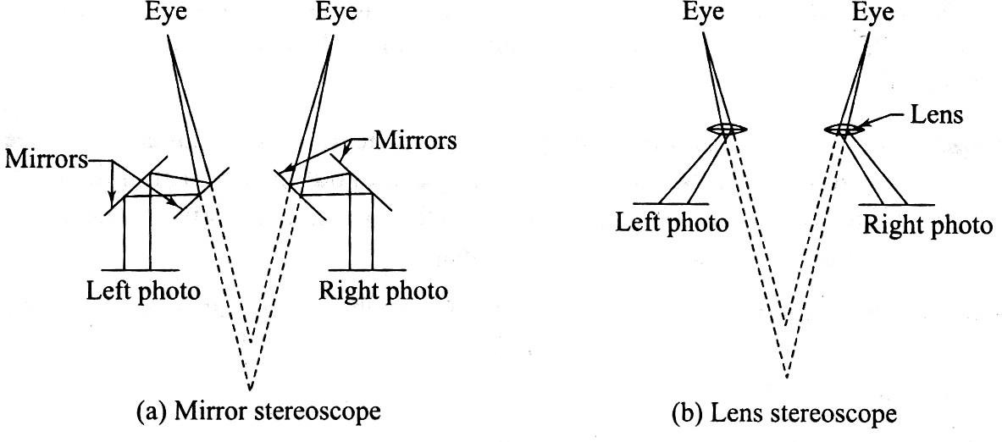

Fig.9.4

**Lens stereoscope:-** A lens stereoscope has two eyepieces through which the observer sees the photographs, providing the experience of stereoscopic or spatial view. The lenses helpto magnifythe image as seenbyeacheye. The distance betweenthe eyepieces is adjustable and can be set by the observer as per requirement. This distance is approximately equal to the distance betweenhumaneyes. The lenses tend to magnifythe object and its height. Lens stereoscopes are more compact than mirror stereoscopes.

#### Photo-interpretation:-

Photo-interpretation is the key to effective use of photographs. It refers to the accurate identification ofthe features seen in photographs. Objects seen in photographs are often not easy to recognize, and it takes some amount of skill on the part of the interpreter to correctly identify the objects and judge their significance. It is more difficult to identify objects in vertical photographs than in tilted photographs owing to the familiarity of view in oblique photographs. Colour photographs are easier to interpret than black and white photographs due to tonal variations. A stereoscopic pair is easier to interpret due to the depth available in the photographs when seen through a stereoscope. Considerable amount of practice and experience is required to correctly interpret photographs.

Interpretation of aerial photographs is required extensively in developmental project design and execution. It has been successfully applied in a variety of fields. The success of project planning depends on the effective and efficient interpretation of photographsbyengineers and others and others. A good deal of patience and ingenuity is required to interpret photographs.

#### GeneralFeaturesofPhotographicImages:-

The knowledge of some of the basic characteristics of the image in aerial photographs helpshelps one to interpret these images. Photo-interpretation requires large-scale photographs. The success of the interpretation depends upon the experience of the person in addition to the conditions under which the photographs should be studied in the correct orientation with respect to the light conditions at the time ofphotography. Some ofthe basic featuresofphotographs that help in identification are discussed here.

**Size:-**The size of an object in the photograph is sometimes helpful in interpretation. Knowing the photograph scale, it is possible to have an idea about the size knowing the correct size, one may not confuse among objects having similar shapes such as a river, road, canal, or drain.

**Shape:-** The shape of an object is helpful in identification. Regular shaped objects are generally man-made. Shape relates to the general outline or form of the object. A railway line and a roadway can be distinguished from their form.Objects of the same size can be distinguished from their shape.

**Texture:-** it is simply the variation in tone ofthe photograph. It is produced bya combination of factors such as size, shape, tone pattern, and shadow. Vegetation and other ground features canbe distinguished by the tonal changes.

**Pattern:-** It is the spatial arrangement of objects in a particular set. A habit can be easily distinguished by the arrangement of roads, houses, etc. because of the pattern.

**Shadow:-** The shadow of an object formed during photograph is sometimes helpful in identification, as it shows the outline of the object.

**Tone:-** It is produced by the amount of light reflected back by the object to the camera. If the particular tones associated with specific objects are known, it is easy to identify them.

**Location:-** The location of an object in the photographs helps in identifying the object itself. Knowing the objects or areas surrounding the object, one can identify the main object. Refer Chapter 24 for more on visual image processing.

#### Applicationsand AdvantagesofAerialSurveying:-

Ashas beendiscussed inthe preceding sections, aerial surveying finds manyapplications in map preparation and map revision for large areas. Modern plotting machines and mostly automated operations have simplified the process of preparing maps from aerial photographs. Aerial surveying also finds extensive application in urban planning and development, transportation network design and calculations, disaster management, forestry,mining operations, reservoirs, agriculture, etc.

With advancements in technology, aerial photography has given way to aerial image processing. High-resolutiondigitalimage(soft image) canbe madeand processedusingsoftware to prepare excellent maps. All forms of rectification and corrections can be done automatically before converting the data into a map. Digital photogrammetric equipment and software have developed sufficiently to facilitate the preparation of very accurate maps.

#### AerialPhotogrammetry:-

Terrestrial photogrammetry virtually went out of use with the advent of aerial surveying techniques. Aerial photogrammetry makes use of cameras fitted in an aircraft to photograph an area from an overhead position. The principle of stereoscopic vision is used in studying and interpreting aerial photographs. Therefore overlapping photographs are taken in the direction of flight as well as in the lateral direction as the aircraft flies along a parallel path. It must be understood that while a map is an orthographic projection by projecting points perpendicular to theplaneaphotographisaperspectiveprojection,asallthe light rays for forming the imagepass through a point.

#### BasicTerminology:-

An aerial photograph is a record of the ground features at a point in time. Aircraft fitted with cameras moves along predetermined paths and takes photographs at planned intervals. The following are the basic terminology used to describe aerial photography.

**Altitude:-**Heightoftheaircraftabovethe ground.

**Flyingheight:-Height**oftheaircraftaboveachosendatum.

**Exposure station:-** Positionofthe aircraft atthetime ofexposureofthe film. It isessentiallythe position of the optical centre of the camera lens when film I exposed.

**Airbase:-**Distancebetweentwoconsecutiveexposurestations.

**Tilt and tip: -** Tilt is inclination ofthe optical axis ofthe camera about the line of flight. In ф is the tilt. Tip is the inclination of the camera axis about line perpendicular to the line of flight.

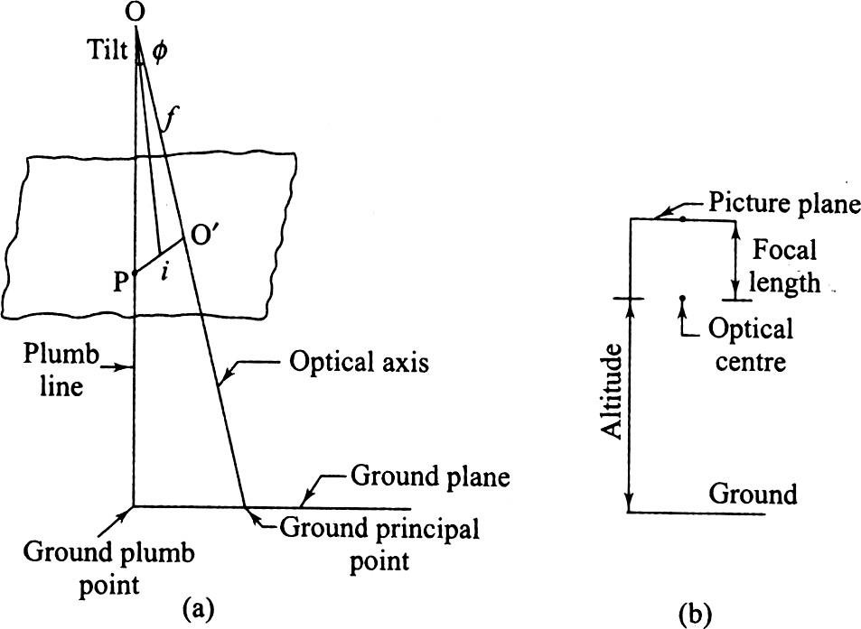

Fig.9.5

**Pictureplane:-**Planethatcontainstheimageatthetimeofcameraexposure.

**Groundplane:-Horizontal**surface fromwhichheightscanbemeasuredandwhichcanbe used as a datum surface.

**Principalpoint:-**Point ofintersectionoftheopticalaxisofthecamerawiththephotographic plane. O is the optical centre and O′ is the principal point. When the optical axis is extended downwards,thepoint ofintersectionwiththesurface isknownasthe*principalgroundpoint.*

**Isocentre: -** Point on the photograph at which the bisector of the angle of tilt meets the photographicplane.‘i’isthe isocentre,at adistanceof*f*cosфalongtheprincipalline,where*f* is the focal length of the camera.

**Plumb points: -** The points at which the vertical line through the optical centre meets the photographicplaneandtheground surface. Theplumbpoint ontheground surface isalso known as ground nadir point. The plumb point on the photograph is known as nadir point.

**Homologous points: -** Points on the ground and their representations in the photo graph in perspective projection.

#### 9.4 RemoteSensing

Remote sensing, as the name implies refers to collecting data from a remote location without being in physical contact with the object. Remote sensing is not as uncommon as wemay think. We havemany remote sensing activities in day-to-day life. When we see an object and recognize its colour as red, we are using the concept ofremote sensing. Similarly, our sense of smell alsohelps us to use remote sensing. Some of the commonmethods of remote sensing are described below.

#### Activeandpassivesystemofremotesensing:

In an active system of remote sensing, the sensing equipment emits radiation, which is reflected back from the object. Radar is a typical example of such a system. Radar equipment transmits radiation and the reflected radiation is analysed to determine the distance and presence of any object in the ranging area.

In a passive system of remote sensing, the instrument does not generate and emit radiation. The radiation reflected fromanexternal source is made available tothe object. We use the passive system exhaustively in the form of the sun’s radiation. Taking a photograph using light from the sun is an example. Photographic cameras, still or motion picture, and television cameras use the passive system of remote sensing.

#### Applications/UsesofRemoteSensing

Remote sensing has applications in a wide spectrum of areas.Remote sensing can beused for taking sound decision for planning many human development activities. It is also possible to take preventive action as in the case of forest fire and natural disasters, Weather forecasting is another important application. Some of the application areas are given below.

**Land use and land coveranalysis:-** Perhaps one ofthe prime uses ofsatellite remote sensing is in the study of land use and cover. Land cover through vegetation and specific crop areas can be studied using remote sensing data. Forest cover is an important aspect, which has been studied: the depletion of forest areas has been identified with the help of remote sensing.It is also possible to study crop diseases over large areas.

**Mineral exploration:-** It will be possible to use satellite data ana discover the presence of valuable minerals and ores that are vital to economic development. Non-renewable energy resources, such as fossil fuels, can be identified using remote sensing data.

**Environmental studies:**- Global weather phenomena are a major area for study using remote sensing data. Global warming and ozone layer depletion can be continuously monitored using remote sensing. Similarly, oceanographic studi4es also provide valuable information about the various characteristics of oceans around the world. Assessing water resources, their extent and depletion, snow cover studies, etc have proved to be valuable.

**Archaeology:-** Archaeological studies can make use of remote sensing data. The underlying old settlements can be recognized from remote sensing data and appropriate action can be taken to excavate and study the various aspects of old civilizations.

**Disaster management:** - This is another important application area of remote sensing. It has beenpossible to predict earthquake hazards bydetecting unusualmovements in the earth’s crust. Floods .landslides, forestfires, etc can be detected on time and appropriate action can be taken for preventive action in disaster management.

**Geomorphology:** - Geological studies can provide valuable data on faults, tectonic movements, rock type identification, etc using remote sensing data.

**Topography and cartography:** - This is another application related directly to surveying. Remote sensing can be used to accurately locate points with reference to ground surveys are difficult or time consuming. This data can be used to prepare maps or revise existing maps.

**Other applications:** - Remote sensing data is now being used to studytroop movements, etc for defense purposes. Other applications include urban planning studies, traffic studies, and assessment of earth’s resources for various purposes, and so on.

#### ImageInterpretation:-

Image interpretation is the process of extracting useful information from remote sensing data. Both qualitative and quantitative information can be extracted from maps .Earlier, the data wasin analog form which is generally interpreted by humans Today, the data is generally is digital form which can be interpreted by humans of processed by computers. The correct interpretation

ofremote sensing data is veryimportant if it is to be useful for the various purposes for which it has been obtained.

#### VisualImageProcessing:-

The remotesensing data cancome ineither ofthe two forms – rawdataorprocesses after certain corrections. Visual images can be monochromatic or grey scale images or colour composites or colour photographs. The objective of visual interpretation is to obtain qualitative information about objects seen in the image. This includes finding their size, location, and relationship with otherobjectsthe wayour eye perceivesanobject isdifferent fromthe wayremote sensing datais obtained. first, the image is taken from an aerial platform- anaircraft or a satellite. The view fromabove will be quite different fromthe view seen fromthe ground. Second, the sensors used for imaging record radiations from many parts of the electromagnetic spectrum including the visible band. This makes the imagery look different from what we see otherwise. Third, resolutionobtainedand scaleofthe image maybe quiteunfamiliar totheeye. Finally, theground relief featuremaynot be evident in two-dimensionalphotographor image. Stereoscopesare used to view photo pairs having common imagery to get a feeling of depth.

Thefollowingthreeprocessesareinvolvedinimageinterpretation:

(1)Imagereadingisthefirst stepinimageinterpretationandinvolvesidentifyingobjectsinthe image by their size, shape, pattern, etc.

1. Measurement fromimagesistheextractionofinformationsuchaslength,width,height,and other parameters like density or temperature from data keys as reference.
2. imageanalysisistheunderstandingofthe informationextractedandcomparingwithground reality or the status of the features as existing at the time of imaging.

Visual interpretation as it is done using photographs has to besupported by ground investigation for correctness of the interpretation. This becomes very necessary as the image may have many features which are not immediately understandable by the interpreter. Multiple images in multiple scales and multi- spectral images have to be interpreted and verified before reaching any conclusion.

#### ElementsofvisualInterpretation:-

Some key elements that assist the interpreter in studying and extracting information about the objects in the image are the following:

**Location: - It** refers to the information about the objects in the image in terms of any of the coordinate systems used suchas latitude, longitude, and elevation. Ifsome points areavailable in the image with known coordinates, then the coordinates for other points or objects can be obtained by measuring distances from the known points. Actual ground surveys can also be performed using easier methods that use GPS or by traditional methodsof surveying that use total station to get coordinates. Computer processing of the image after rectification can also be employed to get information about coordinates.

**Size: -** The size ofanobject seen in an image depends upon the scale ofthe image. Knowing the scale of the image, the length, width, perimeter or area can be used to extract information about the subject. The absolute size of an object along with its relative size is also important in distinguishing between features having the same shape. The size can help distinguish between objects of the same shape such as a building or a football field.

**Shape:-** The shape of an object is distinguishable in the image and can help the interpreter to identify the object. Objects of regular shapes such as rectangles square, circle or oval are generally man-made structures. Irregular boundaries of an object generally mean that the objectis of natural origin such as forest area or a lake. Since the imaging is done from above, it is necessary to know how an object looks from the top.

**Shadow:-** Shadows are generally not desirable in images as they change the nature of the image that would have been seen otherwise. However, shadows help in finding the heights of tall structures like towers and multi-storey buildings. Shadows are created due to low sun angles. In addition to aiding in ascertaining the height of objects, shadows also provide a profile view of objects which is helpful in identification.

**Tone: -** It is the relative brightness or colour intensity of the image. A black and white photographisa greytone image withbrightnessranging fromblack to white. The remotesensing sensor receives and displays a band of the spectrum of electromagnetic radiation and this is displayed as continuous shadesofgreywhichgivesdifferent tones inthe image. Tones areuseful

features of interpretation because different objects give unique tonal qualities due to their reflectance. Tonal differences can occur due to different bands in multi-spectral images. Experience and a clear eye help to distinguish the tonal variation.

**Color :-** Color images are obtained from colour films. Colour photographs or images hold a lot more informationthanblack and white greytone images. Fromthe naturalcolourofthe image in the film many features like vegetation can be identified. Colour can change depending upon the type of filmand filters used. Colour corrections can be done to images to give true colours ofthe objects.

**Texture:-** It can be defined as the characteristic placement and variations in definite patterns for objects in the grey tone image. Textures are classified as smooth or coarse. This is due to the visual impression created bythe tonalchanges. Coarse textures are dueto sudden changes due to abrupt changes intone insmallpatchesgiving a mottled appearance. Smoothtexturecomes from very little changes in tone. Texture helps to identify objects in an image due to characteristic textures of objectse, especially vegetation and forest trees.

**Pattern: -** It refers to the randomness or regularity of similar objects in the image. The pattern seen in the image is helpful in identification. Arrangement of trees in a forest is random, while trees in a orchard are placed in an orderly way. Same is true of houses in a neighborhood or buildings in a developed area. Such patterns canbe identified and the objects recognized from the pattern.

**Elevation: -** As mentioned in Chapter 22, stereoscopes are used in association with photo pairsto have a view of the difference in elevation of objects. The overlapping areas of the images in photo pairs are useful in finding the elevations of points and also to have an idea about the relative heights of different objects seen in the image.

**Interpretation keys: -** These are used to help in visual interpretation of images. The keys are prepared by experienced interpreters who from past experience and ground verification prepare keys based on major elements of identification. Keys can be prepared for specific uses such as forestry, urban studies, network studies, and so on.

# Chapter-7 BASIC ON GPS & DGPS AND ETS

TheGlobalPositioningSystem (GPS)isanavigationsystem usingsatellites,areceiverandalgorithms to synchronize location, velocity and time data for air, sea and land travel**.**

GPS was introduced in 1978 with the launch of the first global positioning satellite. It was controlledandusedsolelybytheU.S.governmentuntilthe1980s.Thefullfleetof24active satellites controlled by the

U.S.didnotcomeintouseuntil1994.

Because theGPSsatellitesystem isownedbytheU.S.government,anditcanselectivelydeny or limitaccesstothenetwork,othercountrieshavedevelopedtheirownGPSsatellitenetworks. These include:

* China'sBeiDouNavigationSatelliteSystem
* Russia'sGlobalNavigationSatelliteSystem(GLONASS)
* TheEuropean Union'sGalileo positioningsystem
* India'sIndianRegionalNavigationSatelliteSystem(IRNSS),alsoknownasNAVIC

TheGPSprojectwasstartedbytheU.S.DepartmentofDefensein1973,withthefirstprototype spacecraft launched in 1978 and the full constellation of 24 satellites operational in 1993.

The satellite system consists of a constellation of 24 satellites in six Earth-centered orbital planes,eachwithfoursatellites,orbiting at13,000miles(20,000km)aboveEarthandtraveling at a speed of 14,000 km/h.

GPSworks through a techniquecalled trilateration. Usedto calculate location, velocityand elevation, trilaterationcollects signals from satellites to outputlocation information. Itis often mistaken for triangulation, which is used to measure angles, not distances.

Satellites orbiting the earth send signals to be read and interpreted by a GPS device, situated on or near the earth’s surface. To calculate location, a GPS device must be able to read the signal from at least four satellites.

Each satellite in the network circles the earth twice a day, and each satellite sends a unique signal, orbital parameters and time. At any given moment, a GPS device can read the signals from six or more satellites.

### WorkingofGPS

Whenasatellitesendsasignal,itcreatesacirclewitharadiusmeasuredfrom theGPSdevice to the satellite.

Whenweaddasecondsatellite,itcreatesasecondcircle,andthelocationisnarroweddownto one of two points where the circles intersect.

Withathirdsatellite,thedevice’slocationcanfinallybedetermined,asthedeviceisatthe intersection of all three circles.

That said, we live in a three-dimensional world, which means that each satellite produces a sphere, not a circle. The intersection of three spheres producestwopointsof intersection, sothe point nearest Earth is chosen.

Hereisanillustrationofsatelliteranging:

### ERRORSINGPS

ThemajorsourcesofGPSpositionalerrorare:

* AtmosphericInterference
* Calculation androundingerrors
* Ephemeris(orbitalpath)dataerrors
* Multi-path effects

### USESOFGPS

Therearefivemainusesof GPS:

1. Location—Determiningaposition.
2. Navigation—Gettingfromonelocationtoanother.
3. Tracking—Monitoringobjectorpersonalmovement.
4. Mapping—Creatingmapsoftheworld.
5. Timing — Making it possible to take precise time measurements.SomespecificexamplesofGPSusecases include:
   * **EmergencyResponse:**Duringanemergencyor naturaldisaster,firstrespondersuse GPS for mapping, following and predicting weather, and keeping track of emergency personnel.IntheEUandRussia,the eCallregulationreliesonGLONASStechnology(a GPS alternative) and telematics to send data to emergency services in the case of a vehicle crash, reducing response time. Read more about GPS tracking for first responders.
   * **Entertainment:**GPScanbeincorporatedintogamesandactivitieslike

*PokémonGo*andGeocaching.

* + **Healthandfitness:**Smartwatchesandwearabletechnologycantrackfitnessactivity (such as running distance) and benchmark it against a similar demographic.
  + **Construction, mining and off-road trucking:** From locating equipment, to measuringandimprovingassetallocation,GPSenablescompaniestoincreasereturn on their assets. Check out our posts on construction vehicle tracking and off-road equipment tracking.
  + **Transportation:**Logisticscompaniesimplementtelematicssystemstoimprovedriver productivity and safety. A truck tracker can be used to support route optimization, fuel efficiency, driver safety

andcompliance.

CHAPTER-8

A geographic information system (GIS) is a system designed to capture, store, manipulate, analyze, manage,andpresentall typesofgeographicaldata.Thekeywordtothistechnologyis**Geography**–this means that some portion of the data is spatial.In other words, data that is in some way referenced to locations on the earth.

Coupled with this data is usually tabular data known as attribute data.Attribute data can be generally definedasadditionalinformation abouteachofthespatialfeatures.Anexampleofthiswouldbeschools. The actual location of the schools is the spatial data.Additional data such as the school name, level of education taught, student capacity would make up the attribute data.

ItisthepartnershipofthesetwodatatypesthatenablesGIStobesuchaneffectiveproblemsolvingtool through spatial analysis.

GISismorethanjustsoftware.Peopleandmethodsarecombinedwithgeospatial softwareandtools,to enable spatial analysis, manage large datasets, and display information in a map/graphica

**WhatcanwedowithGIS?**

GIS can be used as tool in both problem solving and decision making processes, as well as for visualization of data in a spatial environment.Geospatial data can be analyzed to determine (1) the location of features and relationships to other features, (2) where the most and/or least of some feature exists, (3)thedensityoffeaturesinagivenspace, (4) whatishappeninginsideanareaofinterest(AOI),

(5)whatishappeningnearbysomefeatureorphenomenon, and(6)andhowaspecificareahaschanged over time (and in what way).

1. **Mapping wherethingsare.**Wecanmap thespatiallocationofreal-worldfeaturesandvisualizethe spatial relationships among them. Example: below we see a map of frac sand mine locations and

sandstoneareasinWisconsin.Wecanseevisualpatternsinthedatabydeterminingthatfracsand mining activity occurs in a region with a specific type of geology.

1. **Mappingquantities.** Peoplemapquantities,suchaswherethemostandleastare,tofindplacesthat meet their criteria or to see the relationships between places.

Example:belowisamapofcemeterylocationsinWisconsin.Themapshowsthecemeterylocationsas dots (dot density) and each county is color coded to show where the most and least are (lighter blue means fewer cemeteries).

1. **Mappingdensities.**Sometimesitismoreimportanttomapconcentrations,oraquantitynormalized by area or total number.Example: Below we have mapped the population density of Manhattan (total population counts normalized by the area in sq. miles of census tracts.)
2. **Finding whatisinside.**WecanuseGIStodetermine whatishappening orwhatfeaturesarelocated insideaspecificarea/region.We candeterminethecharacteristicsof"inside" bycreatingspecificcriteria to define an area of interest (AOI). Example: below is a map showing a flood event and the tax parcels and buildingsin thefloodway.Wecan usetools like CLIPto determine which parcels fall insidethe flood event. Further, we can use attributes of the parcels to determine potential costs of property damage.

Referencebook:

Surveyingvil-l,ll,lll

By:B.C.Punmia

Atextbookofsurveyingandlevelling By: R. Agor

SurveyingandLevelling

N.N. Basak